**Ruby Class Homework Autumn 1 week 2**

A

Homework due: Tuesday 24th September 2024

|  |  |  |  |
| --- | --- | --- | --- |
| **Next week we are learning:** | | | |
| Maths | Literacy | Science | RE |
| We will be starting our unit on Place Value. We will be looking at partitioning two-digit numbers into tens and ones and then using a part-whole model. | We will be practicing different elements of story writing. | We will be looking at the life cycle of plants. | We will be starting our unit on Creation. First, we will be looking at the symbolism of light in different religions. |

|  |
| --- |
| ***Spellings:***  Practise spellings ready for weekly spelling test- see below for your child’s spelling group – These groups are subject to change as they are based on their current spelling ages.  ***Reading:***  Read every day for 15 minutes.  Please log this in Reading Records.  Children must write a small comment in their journals everyday about their book.  ***Maths:* Partitioning two-digit numbers using part-whole models.**  ***Challenges are optional –*** although please have a go if you can |

**Spellings:**

|  |  |  |
| --- | --- | --- |
| **Group 1** | **Group 2** | **Group 3** |
| sit  sip  nip  pan  tip  dip  sad  man  map  pad | grew  best  brown  sport  green  broom  said  have  some  come | house  money  stalk  threw  when  giant  called  lived  pretty  because |

**Maths:**

Can you write these numerals as words?

**1 _____________ 8 _____________**

**11 ________________ 14 ________________**

**15 ________________ 20 _______________**

Complete the part-whole models.

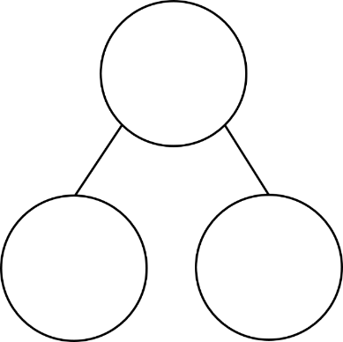

3 tens

76

three ones

70



_6

2

__

20

92

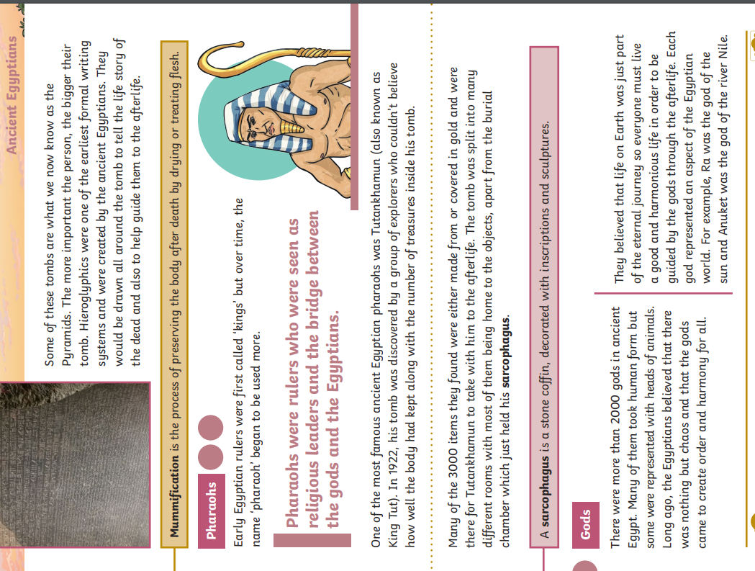

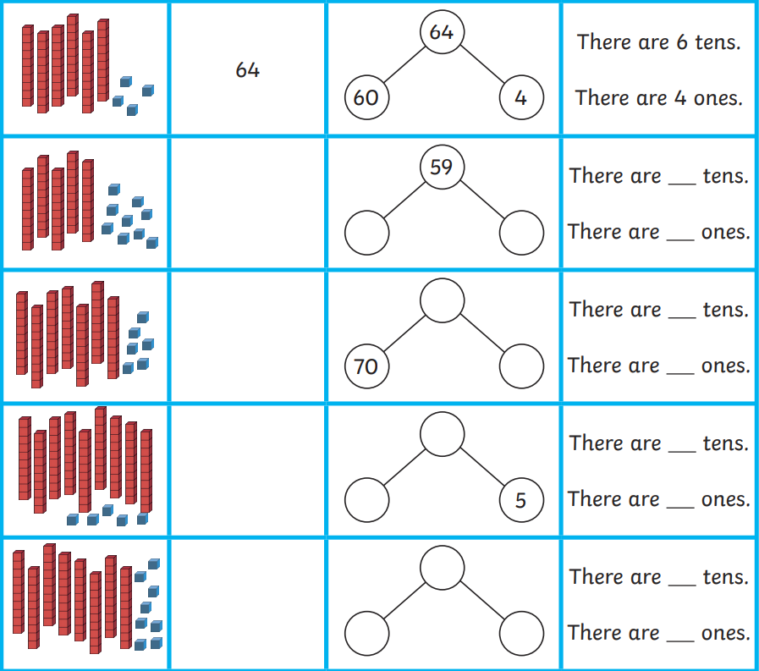

Spot the mistakes. Can you explain why?



53

5

35

3

Challenge:

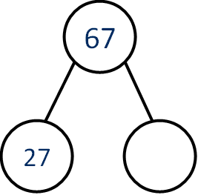Partition 67 in four different ways.

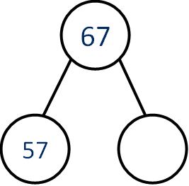

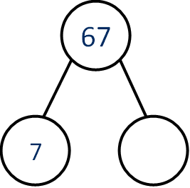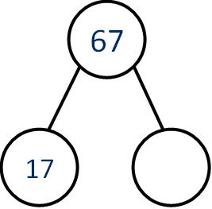

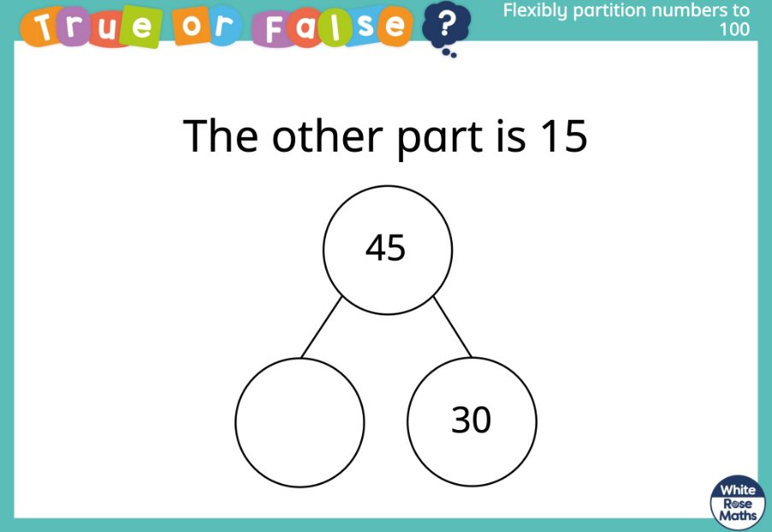True or false?