**Emerald Class Homework Autumn 2 week 1 – Y4**

Homework due: Tuesday 12 November 2024

|  |  |  |  |
| --- | --- | --- | --- |
| **Next week we are learning:** | | | |
| Maths | Literacy | Science | RE |
| We will be finishing our addition and subtraction unit | We will be will be starting our Mighty Oak public speaking elements | We will be starting our topic on Earth and Space | We will be continuing our unit of Creation focussing the conflicting and comparative views |

|  |
| --- |
| Some Useful Websites  Nrich.maths.org - https://nrich.maths.org/  Coolmath-games.com - https://www.coolmathgames.com/  Woodlands Junior School - https://www.primaryhomeworkhelp.co.uk/  BBC Bitesize - https://www.bbc.co.uk/bitesize/primary  Counton.org - https://count-on.co.uk/  Purple Mash also have some lovely Maths and spellings activities  Or use other websites/ways that you enjoy 😊.  ***Spellings:***  Practise spellings ready for weekly spelling test- see below for your child’s spelling group – These groups are subject to change as they are based on their current spelling ages.  ***Reading:***  Read every day for 30 minutes. Please log this in Reading Records.    ***Maths: 4 digit word based problems***  ***English – Reading Comprehension***  ***Please complete both the reading and maths work***  ***Optional challenge of year 4 SPaG*** |

Spellings:

|  |  |  |
| --- | --- | --- |
| **Group 1** | Group 2 | Group 3 |
| Gently  simply  humbly  nobly  horribly  terribly  possibly  incredibly  comfortably  probably | expansion  extension  comprehension  tension  corrosion  supervision  fusion  conclusion  persuasion  suspension | Wrestle  Wrapper  island  aisle  debris  mortgage  castle  yacht  guarantee  guilty |

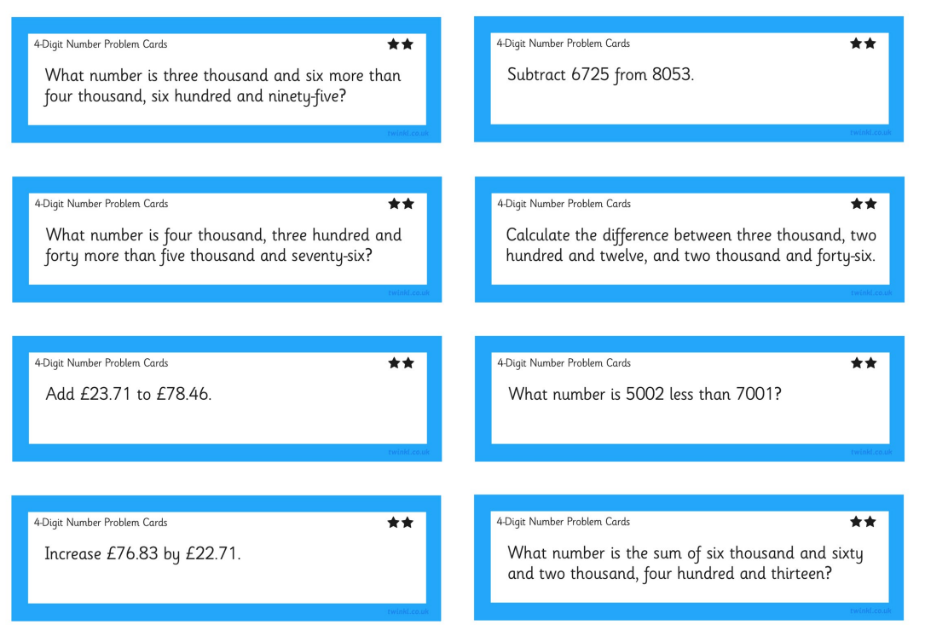

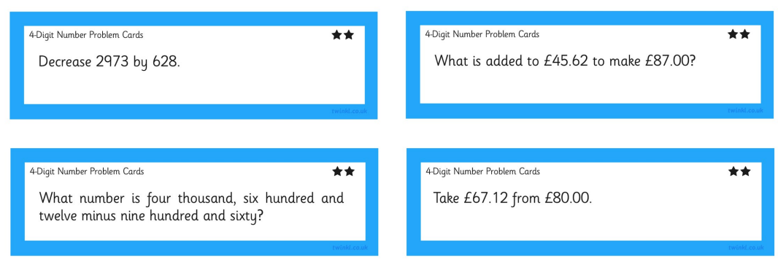



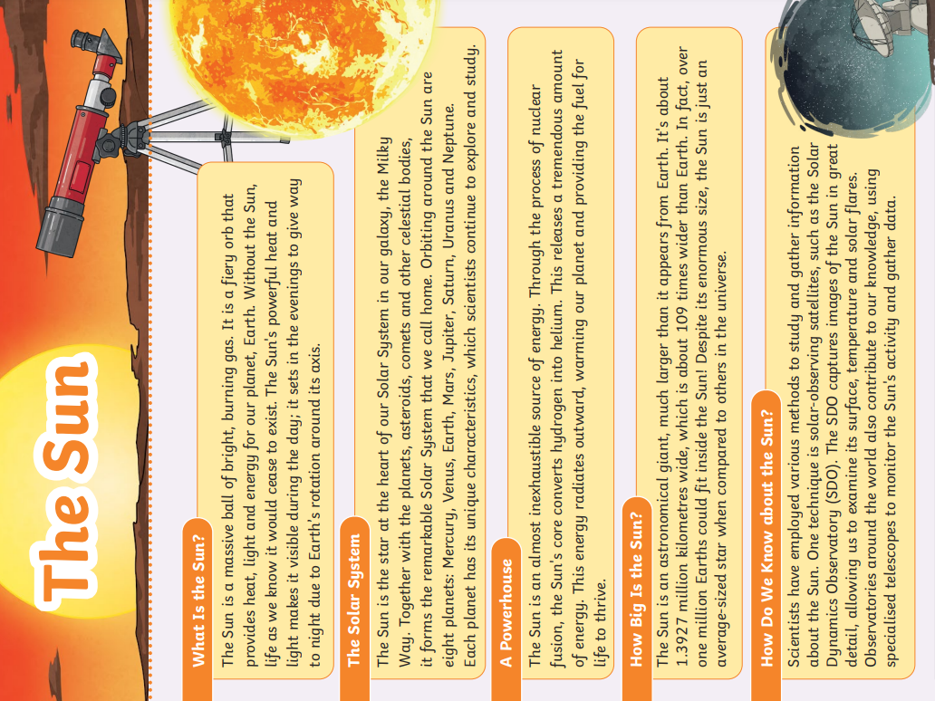

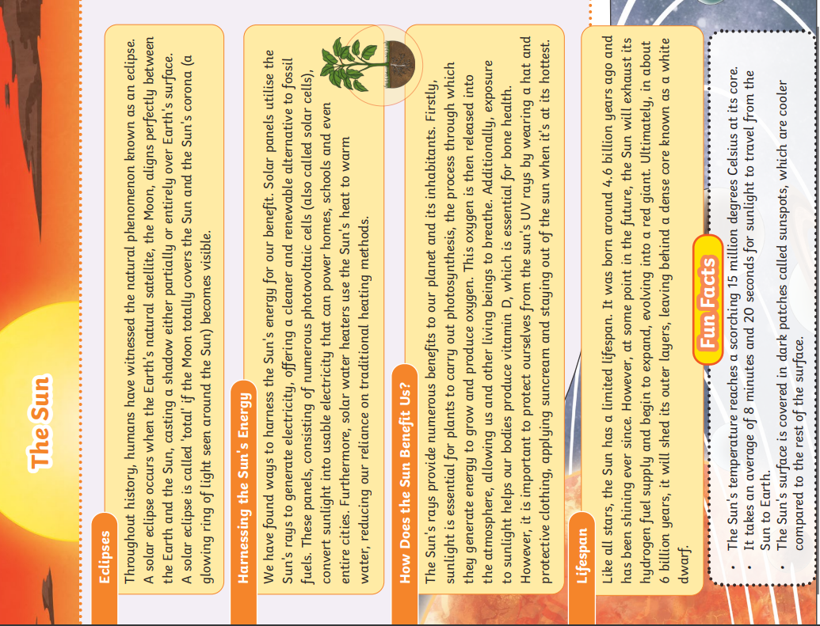

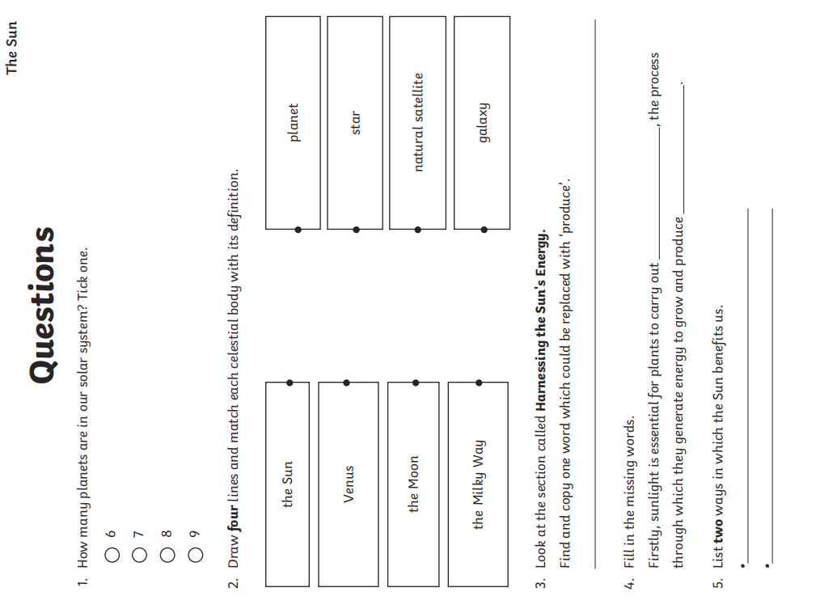

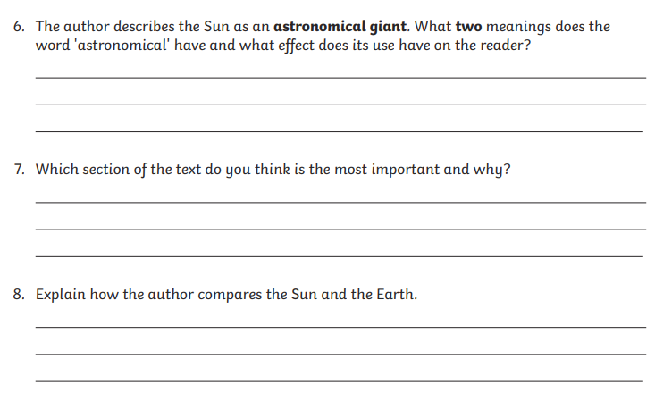

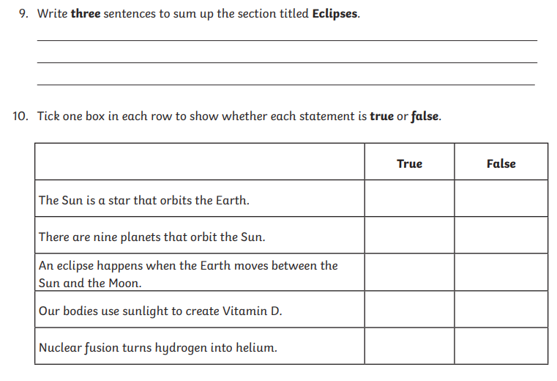

Optional challenges –

