## Ruby Class Homework Autumn 2 week 2

B

Homework due: Tuesday 19th November 2024

|  |  |  |  |
| --- | --- | --- | --- |
| **Next week we are learning:** | | | |
| Maths | Literacy | Science | RE |
| We will be starting our new unit ‘addition and subtraction’.  We will be looking at related facts, focusing on adding subtracting across 10. | We will be looking at features of a recount. | We will be looking at identifying objects as living, dead and never alive. | We will be looking at the birth of Jesus and the meaning of incarnation. |

|  |
| --- |
| ***Spellings:***  Practise spellings ready for weekly spelling test- see below for your child’s spelling group – These groups are subject to change as they are based on their current spelling ages.  ***Reading:***  Read every day for 15 minutes.  Please log this in Reading Records.  Children must write a small comment in their journals everyday about their book.  ***Maths*** Using number bonds to add efficiently.  ***Challenges are optional –*** although please have a go if you can. |

**Spellings:**

|  |  |  |
| --- | --- | --- |
| **Group 1** | **Group 2** | **Group 3** |
| pain  snail  sail  mail  grain  foil  boil  point  spoil  went | playing  played  jumping  jumped  turning  turned  wishing  wished  went  they | race  face  space  cell  city  fancy  bicycle  spicy  when  they |

**Maths:**

Write these numerals in words:

11 _________

12 _________

13 _________

14 _________

Find the missing numbers.

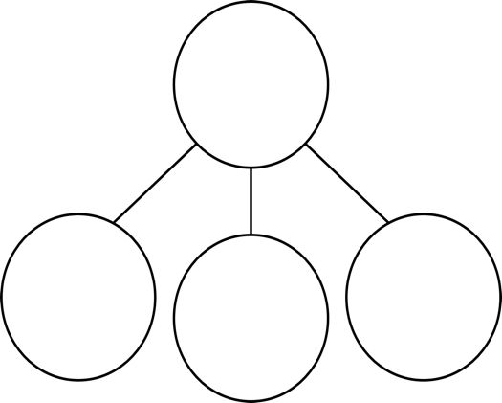

**8**

**9**

**2**

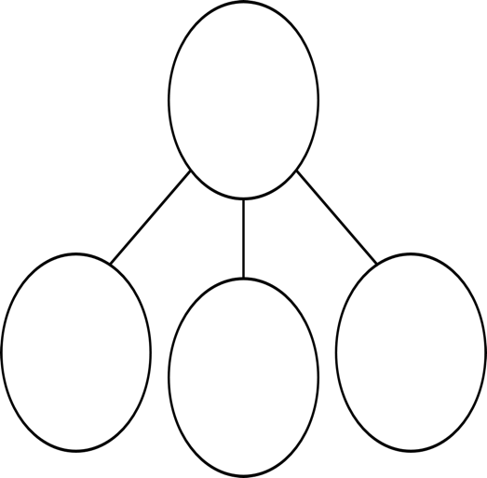

3

7

5

Challenges:

