**Emerald Class Homework Autumn 2 week 4 – Y4**

Homework due: Tuesday 3rd December 2024

|  |  |  |  |
| --- | --- | --- | --- |
| **Next week we are learning:** | | | |
| Maths | Literacy | Science | RE |
| We will be continuing unit on Multiplication and division | We will be will be continuing our unit on creating a Biography | We will be continuing our topic on Earth and Space | We will be continuing our unit on Judaism and its links to Christianity |

|  |
| --- |
| Some Useful Websites  Nrich.maths.org - https://nrich.maths.org/  Coolmath-games.com - https://www.coolmathgames.com/  Woodlands Junior School - https://www.primaryhomeworkhelp.co.uk/  BBC Bitesize - https://www.bbc.co.uk/bitesize/primary  Counton.org - <https://count-on.co.uk/>  <https://www.topmarks.co.uk/>  Purple Mash also have some lovely Maths and spellings activities  Or use other websites/ways that you enjoy 😊.  ***Spellings:***  Practise spellings ready for weekly spelling test- see below for your child’s spelling group – These groups are subject to change as they are based on their current spelling ages.  ***Reading:***  Read every day for 30 minutes. Please log this in Reading Records.    ***Maths: multiplication and division - remember to use the inverse to help work out calculations***  ***Part + part = whole***  ***Whole – part = part***  ***English – year 4 SPaG*** |

Spellings:

|  |  |  |
| --- | --- | --- |
| **Group 1** | Group 2 | Group 3 – ment words |
| snail  pale  plane  plain  crayon  mermaid  drain  holiday  runaway  brain | basically  frantically  dramatically  magically  tragically  comically  actually  accidentally occasionally  eventually | equipment environment government parliament enjoyment document management movement replacement statement |

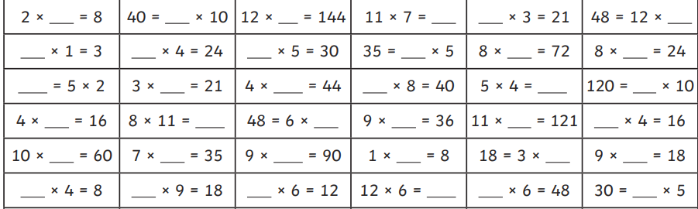

Pick 10 questions and write a division calculation for each one – remember to start with the whole

2 x 3 = 6 3 x 2 = 6 6 ÷3 = 2 6 ÷2 = 3

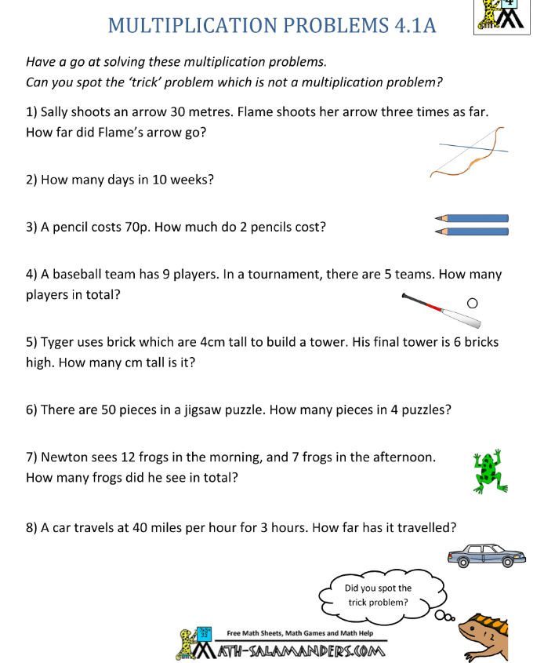

Challenges –

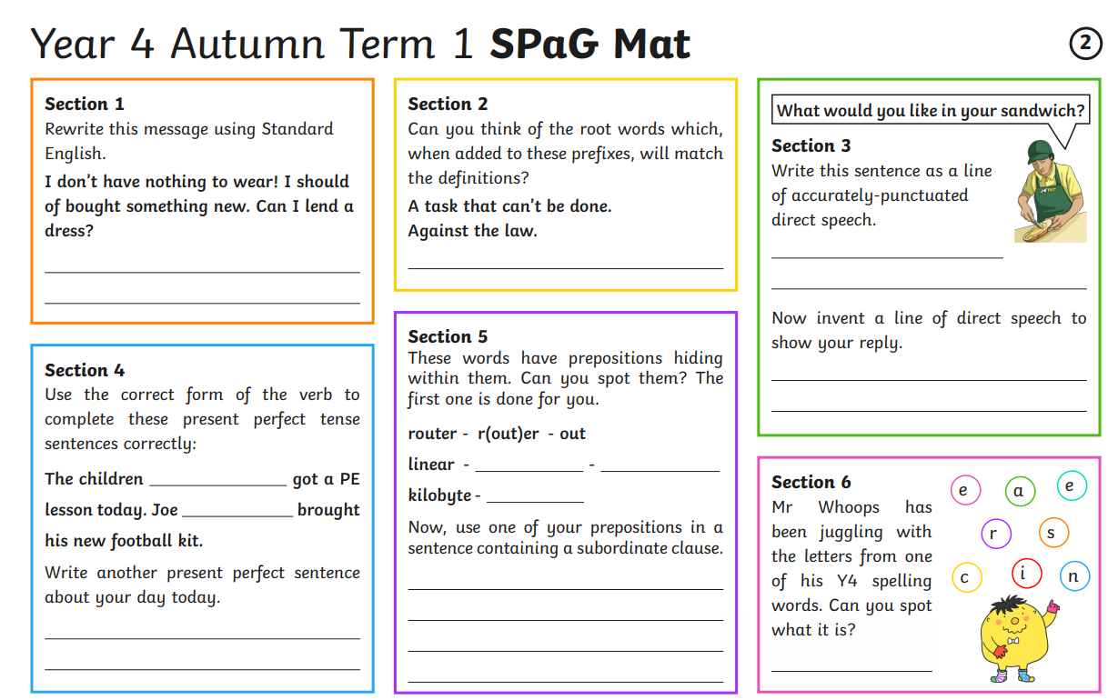

Prepositions – are positional language such as beside, below, under etc

Prefixes go before the root words for example

Done – undone do – undo

<https://learnenglish.britishcouncil.org/grammar/english-grammar-reference/present-perfect>

