Ruby Class Homework Spring 2 week 4
A

Homework due: Tuesday 25th March 2025
Next week we are learning:

Maths | Literacy | Science | RE
We will be looking at division. We will be building our fluency in 2-, 5- and 10-times tables. | We will be learning about narratives. We will be writing our own defeat the monster stories. | We will be celebrating science week with the theme adapt and change. | We will be looking at the theme of salvation in Christianity. This week we will be exploring the significance of the Easter story.

Spellings:
Practise spellings ready for weekly spelling test- see below for your child’s spelling group – These groups are subject to change as they are based on their current spelling ages.

Reading:
Read every day for 15 minutes.
Please log this in Reading Records.
Children must write a small comment in their journals everyday about their book.

Maths: halving and doubling

SPaG: Correcting punctuation accurately.

Challenge (optional): Improve the sentence

Spellings:
Group 1 | Group 2
there  where  ask  love  your | try  tried  reply  replied  copy  copier  happy  happier
Use this grid to help practice your spellings.
look | say | cover | write | check

Maths:
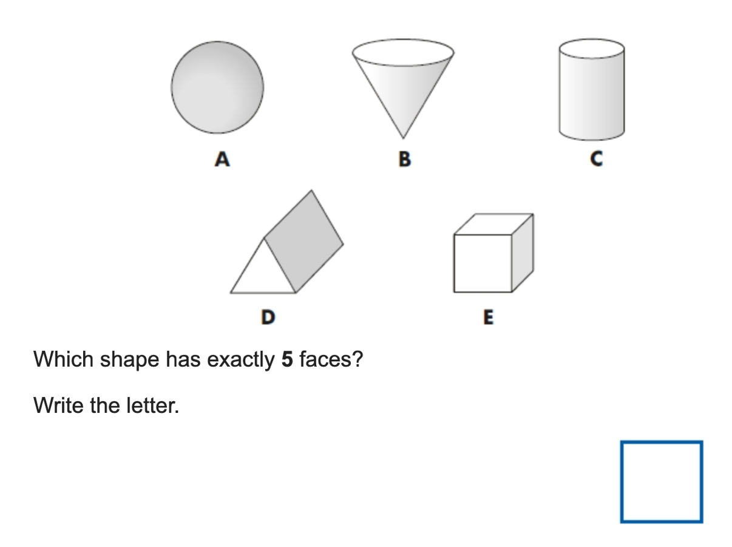
1. ____ + 13 = 20  2. ____ + 16 = 20  3. 3 + ____ = 20  4. 11 + ___ = 20  5. 8 + ____ = 20 | 6. 5 x 2 = ____  7. 10 x 2 = ____  8. 8 x 10 = ____  9. 2 x 5 = ____  10. 2 x 7 = ____
Solve the equations:
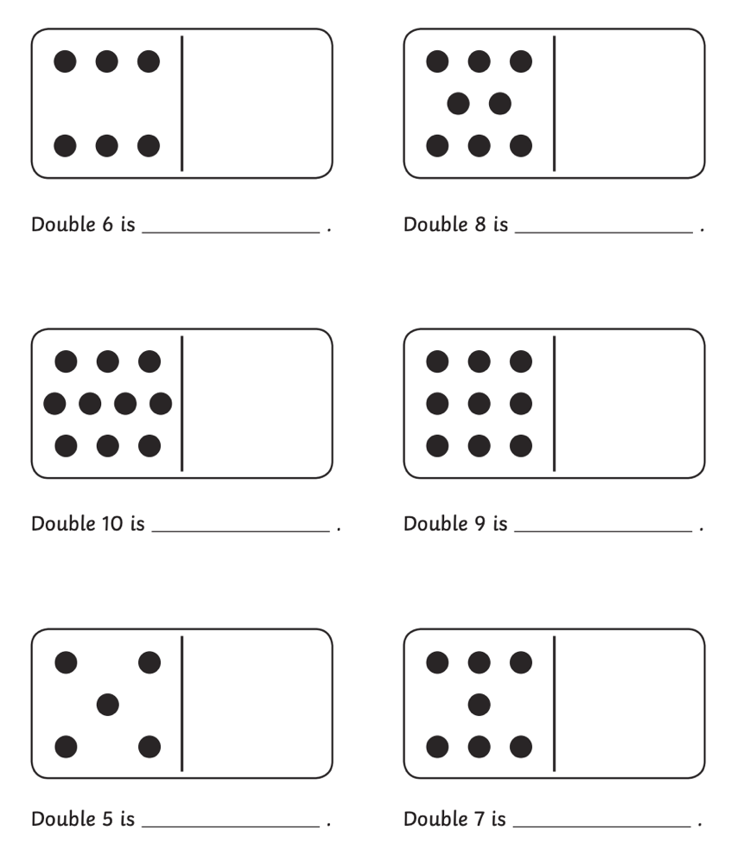

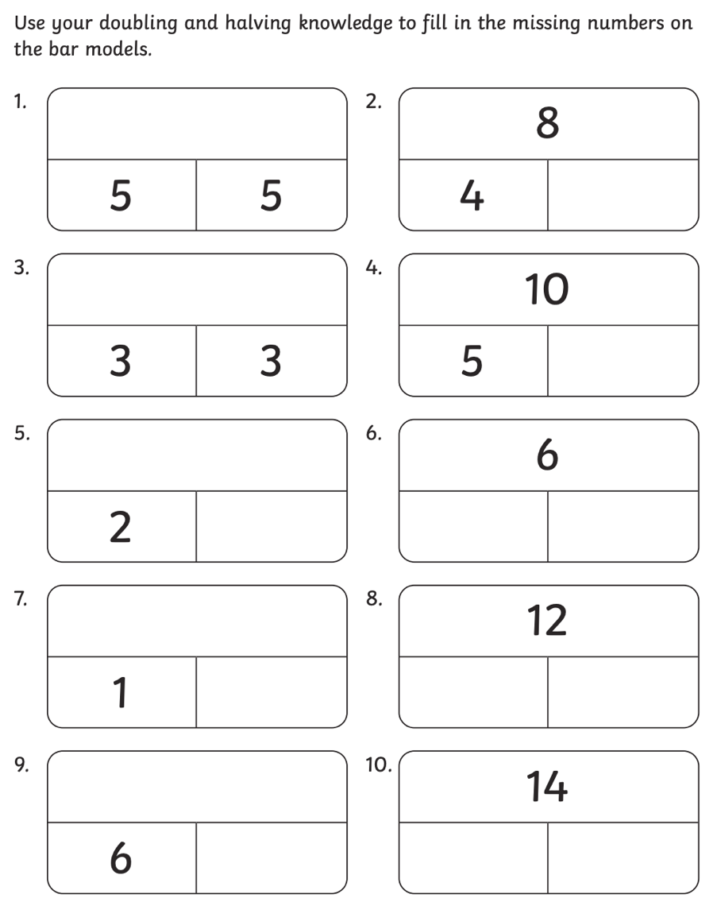

SPaG
Rewrite the sentences below with the correct punctuation.

1. what a fantastic adventure

2. the beasts footprints led Billy through the dark forest

3. what was that mysterious sound

4. The beasts tangled fur was covered in twigs leaves and sticky golden honey.

Challenges:
SPaG
Improve the sentence by adding an adverb and two adjectives.

Billy walked through the forest.

Maths
