Ruby Class Homework Spring 2 week 5
A

Homework due: Tuesday 1st April 2025
Next week we are learning:

Maths | Literacy | Science | RE
We will be looking at division. We will be building our fluency in 2-, 5- and 10-times tables. | We will be learning about narratives. We will be writing our own defeat the monster stories. | We will be celebrating science week with the theme adapt and change. | We will be looking at the theme of salvation in Christianity. This week we will be exploring the significance of the Easter story.

Spellings:
Practise spellings ready for weekly spelling test- see below for your child’s spelling group – These groups are subject to change as they are based on their current spelling ages.

Reading:
Read every day for 15 minutes.
Please log this in Reading Records.
Children must write a small comment in their journals everyday about their book.

Maths: multiplication and division

SPaG: punctuation

Challenge (optional): Improve the sentence

Spellings:
Group 1 | Group 2
two  one  yes  much  Monday | biggest  hottest  fattest  getting  hitting  hopping  jogged  knitted  planned
Use this grid to help practice your spellings.
look | say | cover | write | check

Maths:
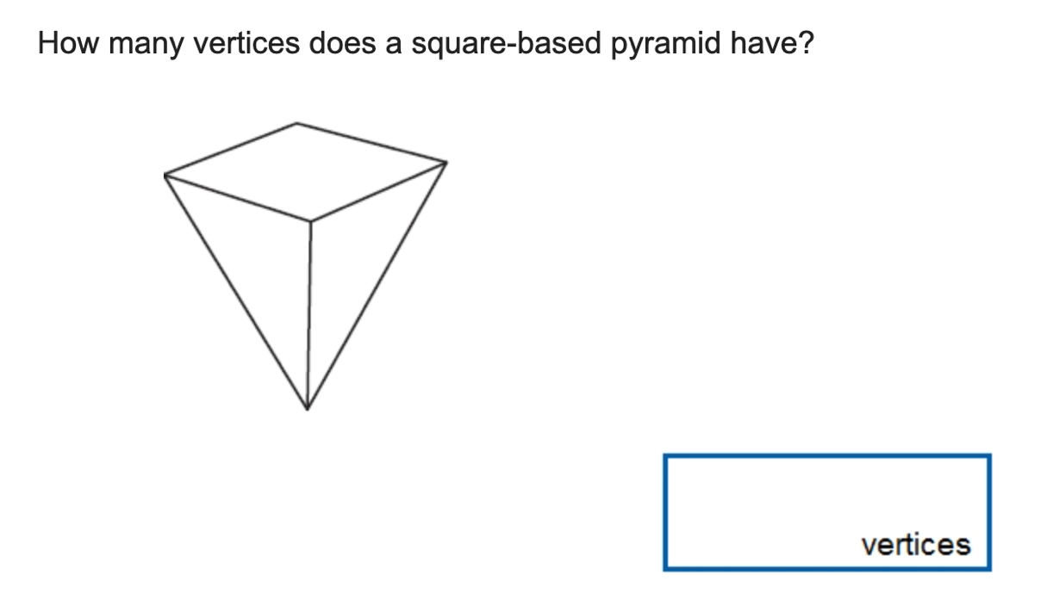
Solve the equations:

1. 3 + 2 + 4 = ____ 6. 42 + 30 = ____

2. 57 = ____ + 7 7. 5 + 5 + 5 + 5 = ___

3. 20 + 40 = ____ 8. 60 ÷ 10 = ____

4. 31 – 4 = ____ 9. 46 + 34 = ____

5. 2 x 6 = ____ 10. 5 x 4 = ____
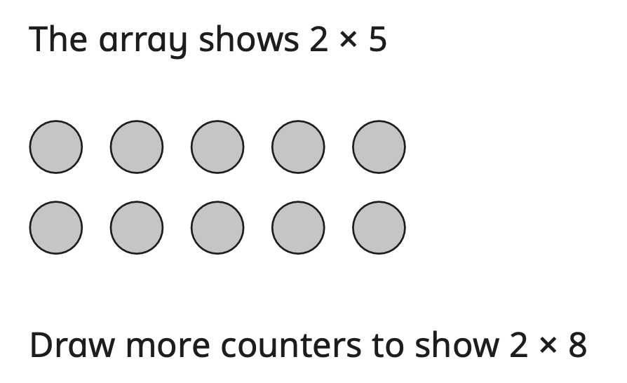

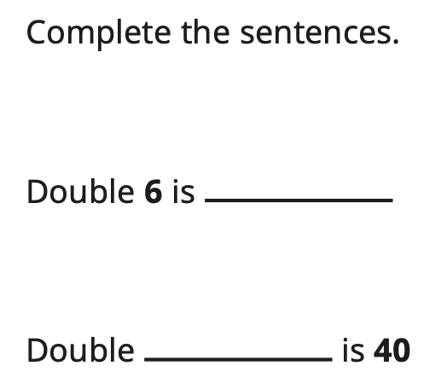

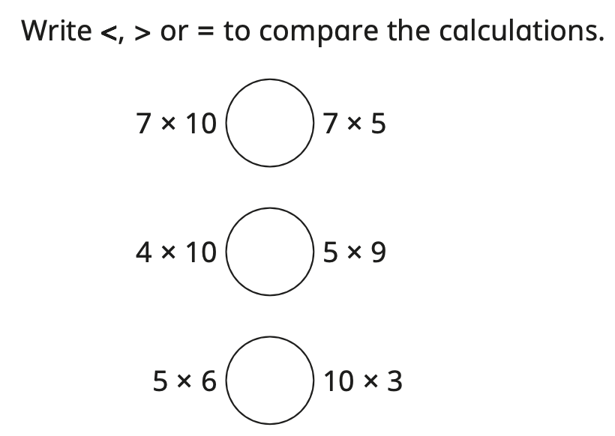

SPaG
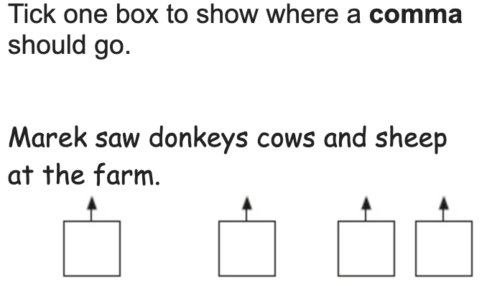

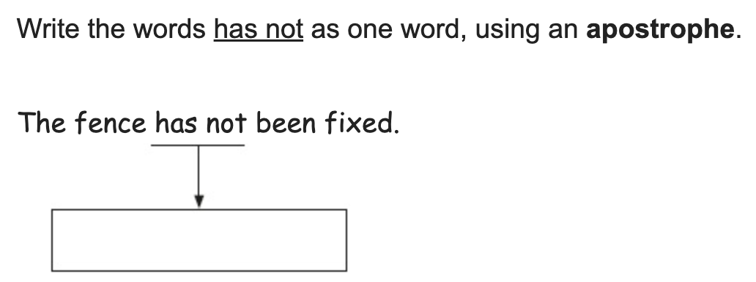

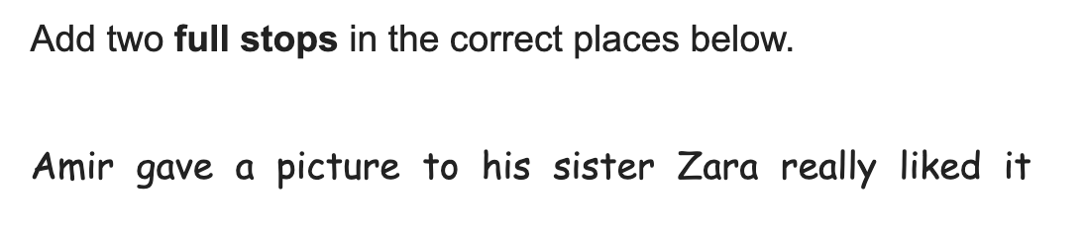

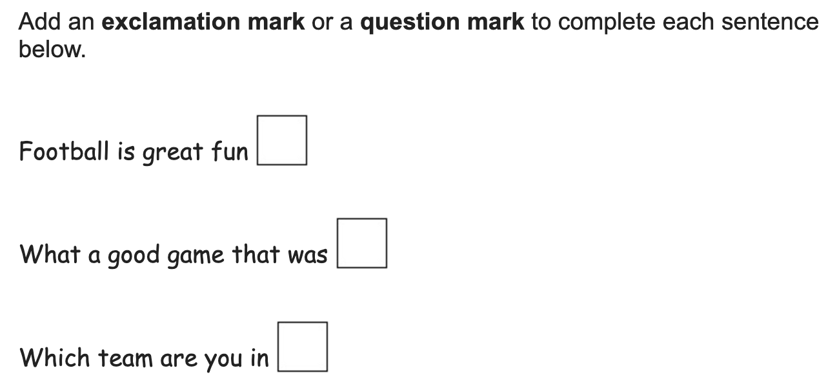

Challenges:
SPaG
Improve the sentence by adding an adverb and two adjectives.

The beast jumped into the pot.

Maths
