**Amber Class Homework Spring term 1 week 4**

Homework due: Tuesday 4th February 2025

|  |
| --- |
| **Reading: Daily for 30 minutes, write up in your Reading Record with a comment about what was read/discussed.**  **Spelling: see below**  **Dividers:**  Complete the dividers game on 2do (purple mash)  **Times tables games:** [**https://www.arcademics.com/games/demolition**](https://www.arcademics.com/games/demolition)On top marks games under division |

**Spellings:**

|  |  |  |
| --- | --- | --- |
| Group 1 | Group 2 | Group 3 |
| various  thought  accidentally  bicycle  continue  medicine  special  therefore | pressure  probably  guide  heard  perhaps  earth  minute  enough | parents  gold  christmas  people  any |

Use this space to practice your spellings!

**Complete the math’s activities -**

The first one has been done for you.

8200

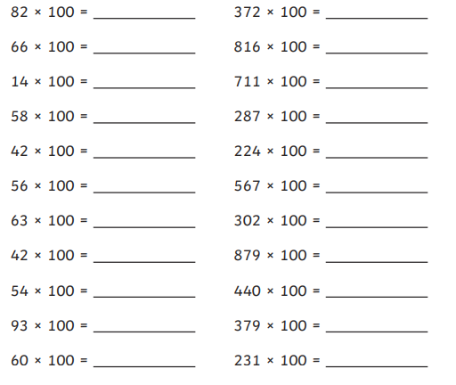

**Maths challenge: Divide by 100**

The first one has been done for you.

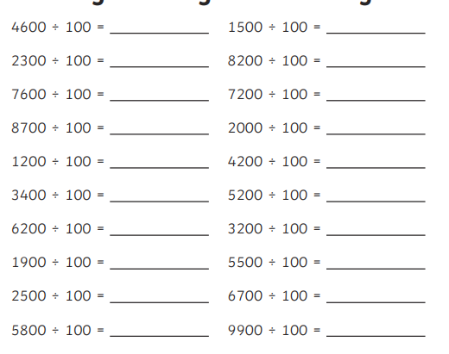

46

**English**

**Example – Guidance box**

Section 1: Conjunctions you could have are:

because, until, and, while

Section 3: Suffix what goes at the end of the word

Section 6: Expanded noun phrase has more than one adjective with a noun.

**Example:** *She ate a bowl of delicious, ice-cold, strawberry ice-cream.*

