**Amber Class Homework Spring term 2 week 1**

Homework due: Tuesday 04th March 2025

|  |
| --- |
| **Reading: Daily for 30 minutes, write up in your Reading Record with a comment about what was read/discussed.**  **Spelling: see below**  **Fractions:**  Complete the fractions quiz on purple mash |

**Spellings:**

|  |  |  |
| --- | --- | --- |
| Group 1 | Group 2 | Group 3 |
| calendar  actually  medicine  special  possession  possible  suppose  particular | minute  mention  complete  believe  breath  busy  possible  weight | children  break  beautiful  grass  old |

Use this space to practice your spellings!

**Complete the math’s activities -**

Can I have the measurements of the lines in centimeters please.

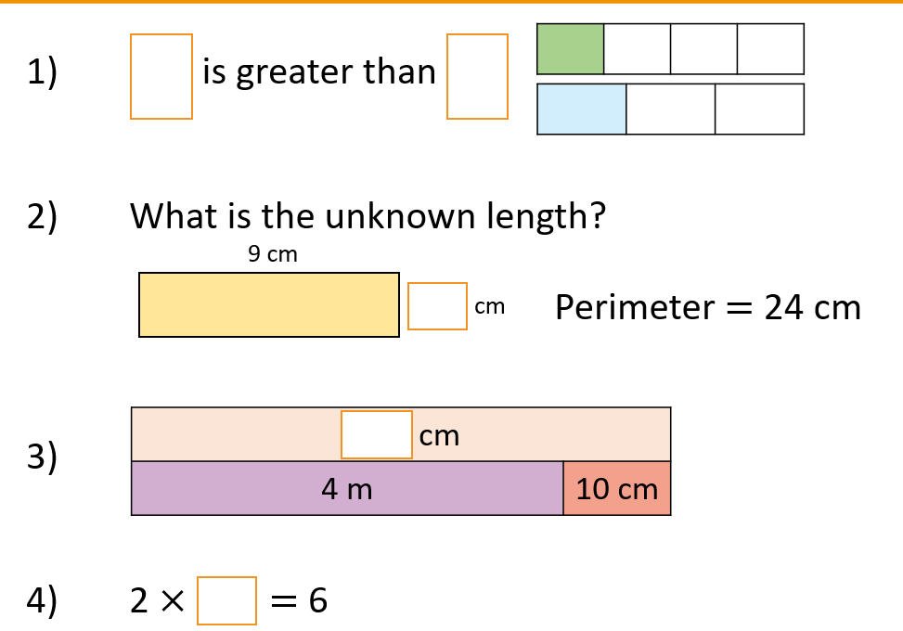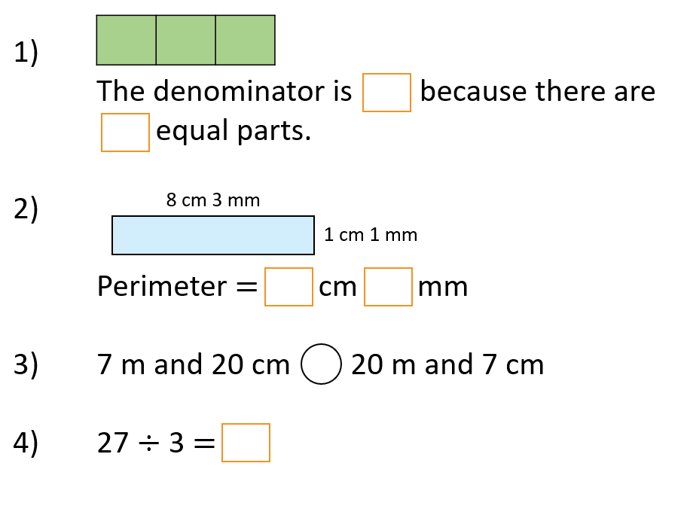

**Maths challenge:**

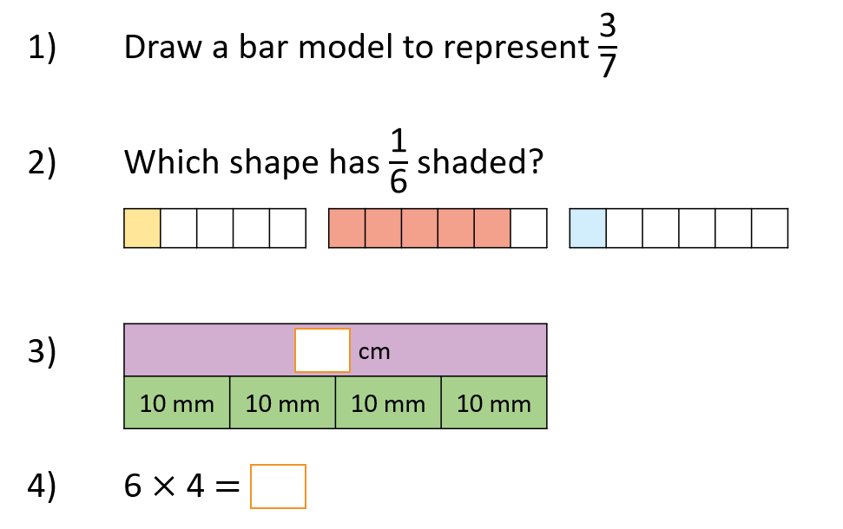

**English / History:** On your 2do’s on purple mash write a newspaper report on why the romans left Britain. Research and then write up ether on purple mash or some facts below.

