**Amber Class Homework Spring term 2 week 5**

Homework due: Tuesday 1st April 2025

|  |
| --- |
| **Reading: Daily for 30 minutes, write up in your Reading Record with a comment about what was read/discussed.**  **Spelling: see below**  Maths Games – Record your score  <https://www.topmarks.co.uk/maths-games/hit-the-button>    [**https://www.topmarks.co.uk/maths-games/measuring-in-cm**](https://www.topmarks.co.uk/maths-games/measuring-in-cm) |

**Spellings:**

|  |  |  |
| --- | --- | --- |
| Group 1 | Group 2 | Group 3 |
| ordinary  various  opposite  surprise  disappear  position  particular  business | famous  answer  forwards  remember  strength  breath  build  busy | christmas  beautiful  floor  improve  should |

Use this space to practice your spellings!

**Complete the math’s activities**

Remember 1kg is the same as 1000g

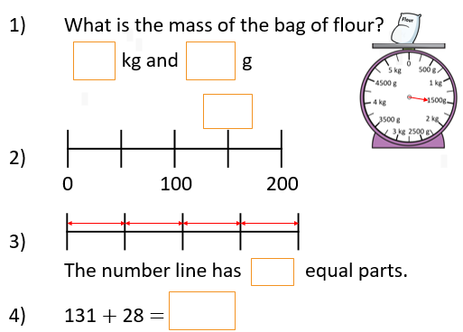

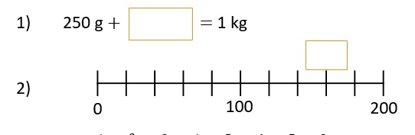

**Maths challenge:**

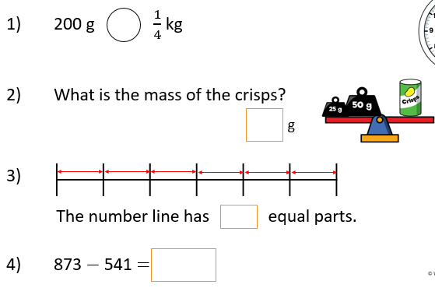

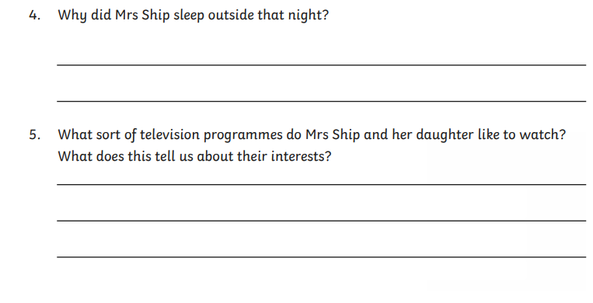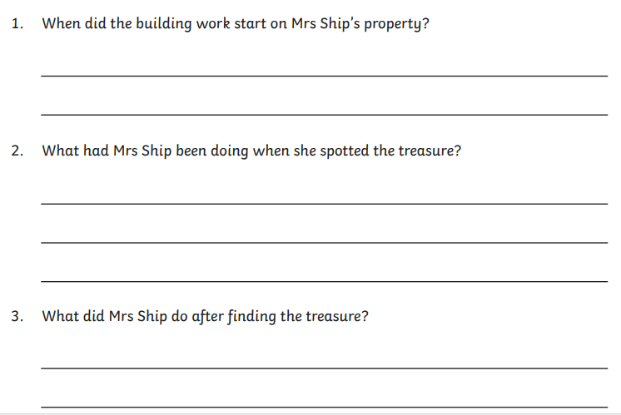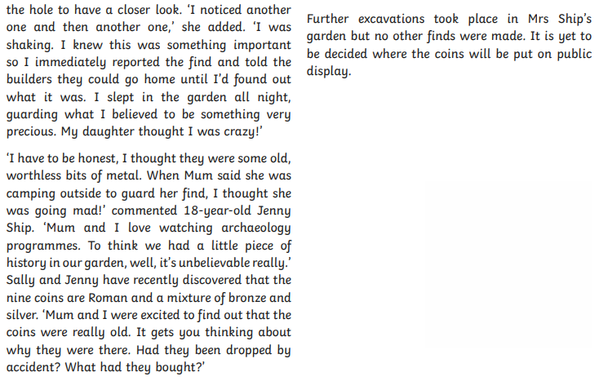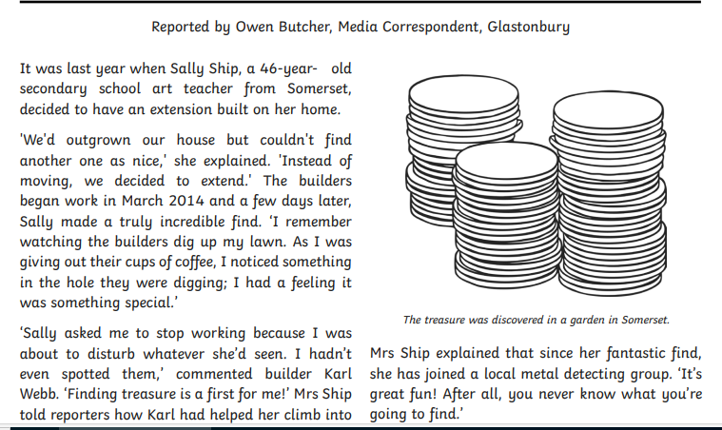**English:** Answer the comprehension questions, underline the key points