Reception homework 7th October 2024

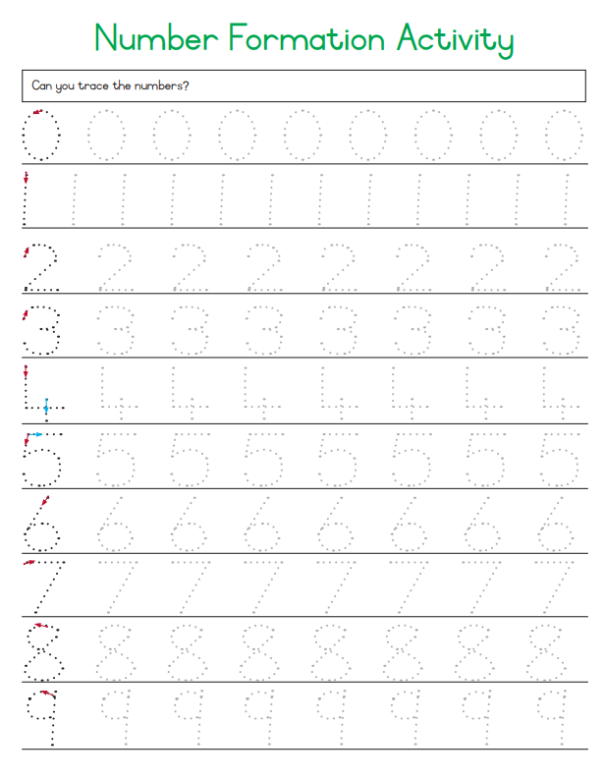

Now have a go at writing numbers 0-9 all by yourself. Good luck!

|  |  |  |  |  |  |  |  |  |  |
| --- | --- | --- | --- | --- | --- | --- | --- | --- | --- |
|  |  |  |  |  |  |  |  |  |  |