Topaz Year One – Homework 13th March 2025

Reading Comprehension

Read the information below by sounding out and blending the words back together and then have a go at answering the questions.

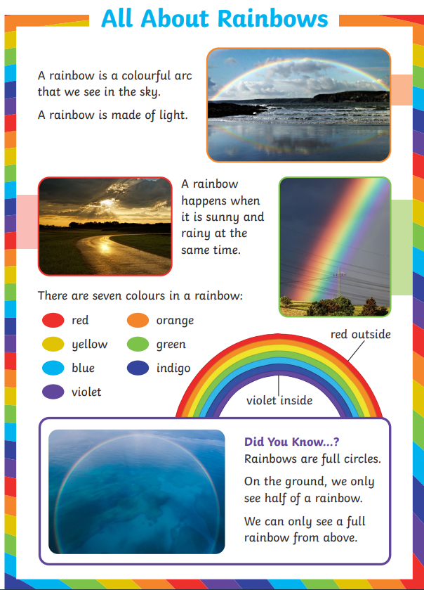

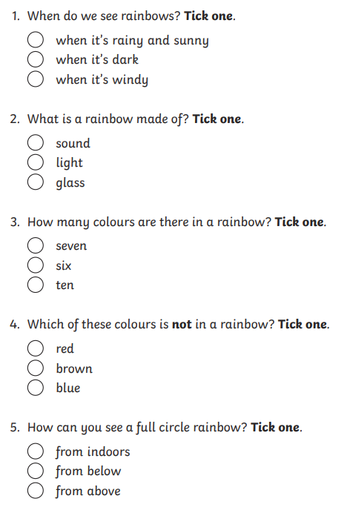

Challenge: you find a mnemonic to help remember the order of the colours of the rainbow, for example: *"****Rinse Out Your Granny's Boots In Vinegar****”* or you could even have a go at making up your own. Write your mnemonic below: