Topaz - Reception Class Homework
Weekly homework
Week 3 – 26th September 2024
Dear parents,
We have really enjoyed introducing our Little Wandle wordless books to the children. It has been great to listen to them talk about the book and volunteer their amazing ideas and opinions. Well done everyone, keep up the great work!

Phonics – Little Wandle

This week your child will have a new Little Wandle ‘wordless book’. As I mentioned before, these wordless books are a crucial part of the process of learning to read and covers important aspects including comprehension, asking and answering questions and predicting what might happen next in a story. Thank you for recording the reading you have done in with your child’s reading record. This really does help us to be able to share your child’s ideas and progress with them. Remember, you don’t have to write lots, just a comment about any questions you may have asked and how your child responded or predictions that your child made about the book. Please do also comment on your child’s sharing book too.

Please remember to return all books on Monday so they can be used during group teaching reading sessions. Many thanks for your support with this.

Maths - number
This week in maths we have continued our work on place value. We have also been working very hard on our number formation skills. For their homework, I would like your child to complete the number formation sheet. Please encourage them to start and finish each numeral in the right place and also ensure that the sizing is also accurate.
Challenge – in class we have also been learning about cardinal numbers. The meaning of cardinal is “how many” of anything is existing in a group and can be found by counting each item in the group to find the total. For their challenge, I would like the children to have a go at counting each group of objects and then write the total in the box, remembering to use accurate numeral foundation.

Literacy – name writing continued

Please continue to encourage your child to have a go at writing their name daily, ensuring that the formation of each letter is accurate. We have been demonstrating to the children the importance of holding their pencil properly in a tripod grip. In class we call this the snapping crocodile grip, so do please encourage your child to show you how they can do this. Embedding good habits from the beginning when learning letter formation is exceptionally important. If you prefer, you can of course place tracing paper over the top of their name card and copy each letter. Once they have gained confidence tracing their name, they can then progress to copying their name on to paper. When writing on paper, please use writing pencil only. Don’t forget to refer to your ‘mark making’ booklet for more ideas for early writing with your child. Please don’t worry if your child makes mistakes are finds it challenging to get the formation accurate. These things will take time. When working in class, we always tell the children that making mistakes is just a way of learning. As long as they try their best then that is always good enough.

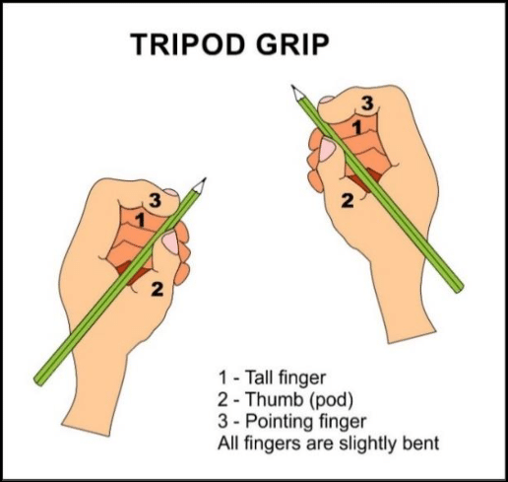

Keep up the good work!

As always, if you have any questions about your child’s learning, please do not hesitate to contact me via the school office.
Many thanks,
Mrs Allan

Next week in class we will be learning
Reading – continuing developing listening and comprehension skills
Writing – Grapheme formation – Christian name continued
Speaking – using descriptive/new vocabulary
Number recognition – number songs to 10
Number formation – numbers 0,1,2,3 and beyond
Understanding the World R.E. – Harvest Festival
How do some Christians celebrate Harvest around the world?
Expressive Art and Design –Crazy Aliens–- mixing media:
(discussing colour, pattern, texture, line and form)
Physical Development – Outdoor PE – Ball skills – throwing and receiving
Indoor PE – Fundamentals - travelling and jumping
Story focus of the week: Man on the Moon
Additional activity: Reception Baseline Assessment

