The words to learn this week are all tricky words. They can’t be sounded out and blended back together. These are words that need to be read from memory.
How to learn your spellings:
1. Read the word 2. Say the word out loud 3. Copy the word 4. Cover the word 5. Write the word from memory 6. Check the word
7. Practice writing the word 2 more times.
Read the Word | Say the word | Copy the word | Cover the word | Write the word | Check the word (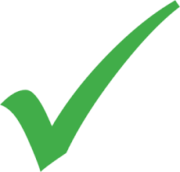) OR write correction | Practice the word | Practice the word
I | I
is | is
the | the
put | put
pull | pull
full | full
as | as
and | and
has | has
his | his

Optional Challenge: use each spelling in a sentence. Say the sentence, write the sentence. Use your phonics to sound out any additional words
I
is
the
put
pull
full
as
and
has
his

