Dinosaur Subtraction
Find the answers to the dinosaur subtraction sums. You will need to count all the dinosaurs first to help solve the subtraction sentence. Please remember to write your numbers neatly.
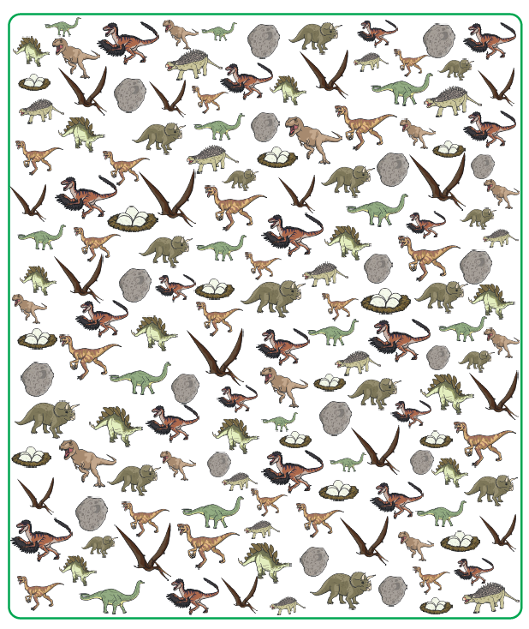

[

Dinosaur Subtraction
Use the number line to help you. Remember when you subtract you bounce backwards, down the number line and your number answer should get smaller.


