Finding a Quarter
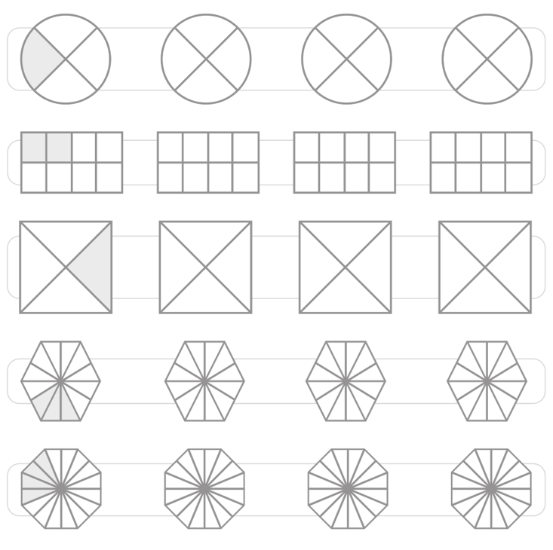
Find different ways to shade a quarter of each shape
Challenge
Look at the shape below. Colour 3 quarters of the shape.

