Year 1 homework 26th June 2025
Telling the time – O’clock.
Add the hands to the clock to show the correct time. Remember the minute hand is longer than the hour hand.
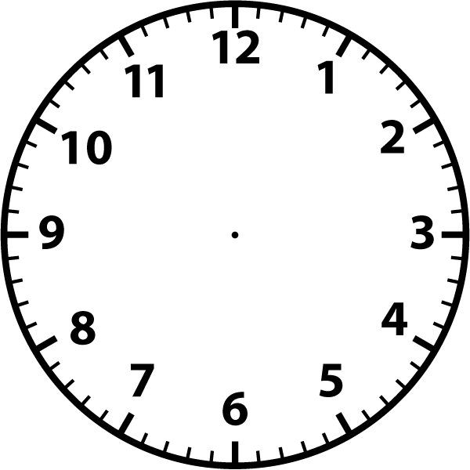
10 o’clock
6 o’clock
7 o’clock
3 o’clock
12 o’clock
4 o’clock

5 o’clock
12 o’clock
9 o’clock
8 o’clock
1 o’clock
2 o’clock

