Remember the order of the months of the year looks like this:
January, February, March, April, May, June,
July, August, September, October, November, December
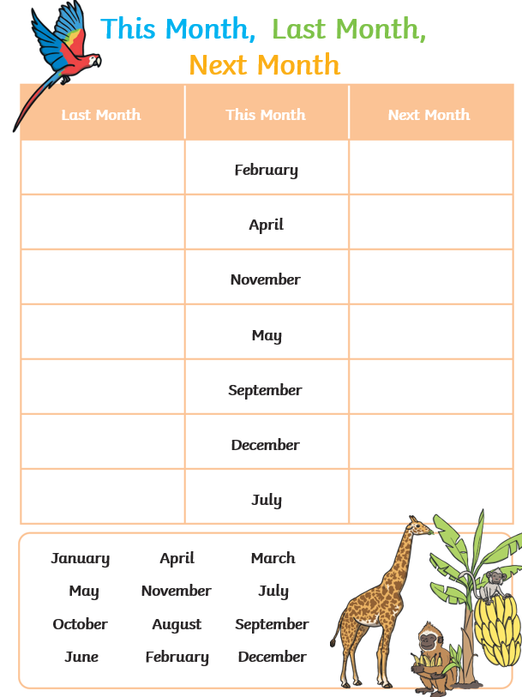
Reception – Homework 10th July 2025
Months of the Year
Sing our months of the year song https://www.youtube.com/watch?v=5enDRrWyXaw and then complete the ‘this month, last month, next month’ challenge.

