Year One Homework 10th July 2025
What's the time?
Read the hands on the clock faces below and write the time each one shows.
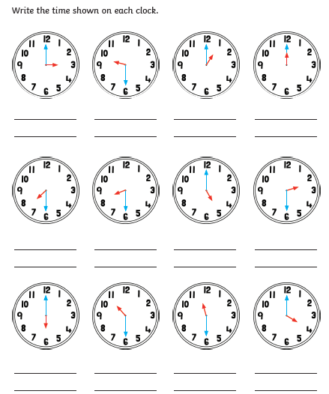

Key Vocabulary: o'clock half past

Read the time shown under each clock. Add the hands to the clock face to show the right time. Please use a ruler to draw the hands.
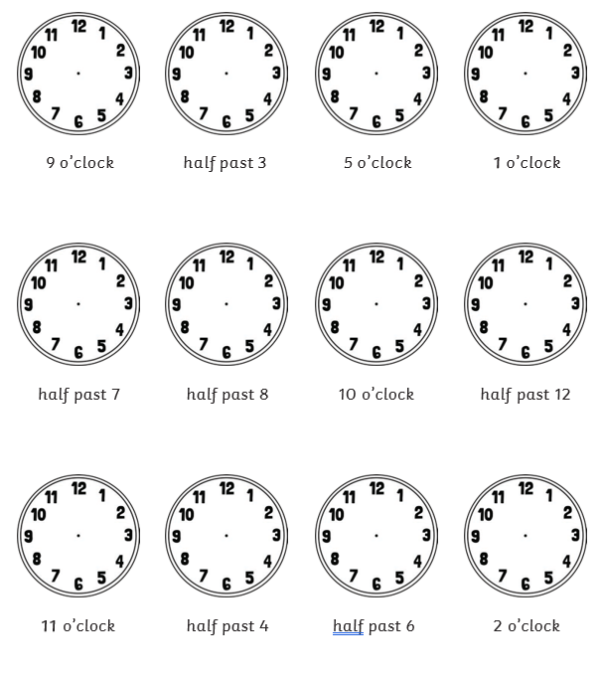
Remember the minute hand is the long hand and the hour hand is the short hand

