Axolotl Class Homework Autumn 1 week 1 – Y3
Homework due: Tuesday17th September 2025
Next week we are learning:
Maths | Literacy | Science | RE
We will be starting our unit on Place Value recapping roman numerals and before numbers up to 1000 and then moving onto a 10,000 | We will be will starting our unit on Anglo Saxons by writing a non-chronology report | We will be starting our topic on the digestive system | We will be starting our unit of Creation focussing on

Log on to timestable.com to practise your maths skills:
Purple Mash also have some lovely Maths and spellings activities

Or use other websites/ways that you enjoy .

Spellings:
Practise spellings ready for weekly spelling test- see below for your child’s spelling group – These groups are subject to change as they are based on their current spelling ages.

Reading:
Read every day for 20 minutes. Please log this in Reading Records.

SPaG: Year 3 SPaG mat

Maths: Place Value
Remember to symbols and their meaning
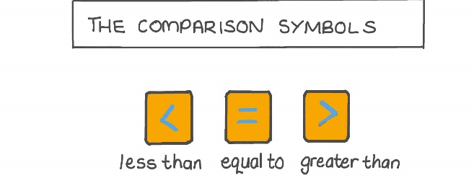

Challenges are optional – although please have a go if you can
Spellings:
Group 1 | Group 2  Homophones and near Homophones | Group 3  Homophones and near Homophones
saw  they  asked  put  there  were  some  come  again  because | here  hear  knot  not  mail  male  ball  bawl  groan  grown | Groan  grown  affect  effect  fair  fare  great  grate  through  threw
……………………………………………………………………………………………………………………………………………………………………………………………………………………………………………………………………………………………………………………………………………………………………………………………………………………………………………………………………………………………………………………………………………………………………………………………………………………………………………………………………………………………………………………………………………………………………………………………………………………………………………………………………………………………………………………………………………………………………………………………………………………………………………………………………………………………………………………………………………………………………………………………………………………………………………………………………………………………………………………………………………………………………………………………………………………………………………………………………………………………………………………………………………………………………………………………………………………………………………………………………………………………..……………………………………………………………………………………………………………………………..
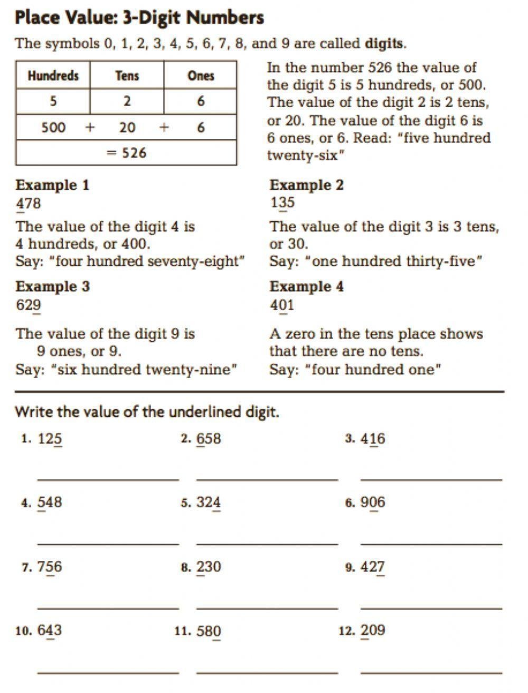

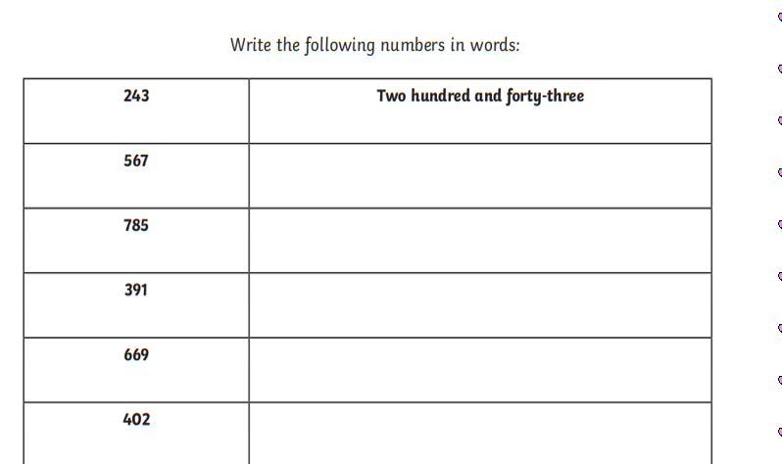

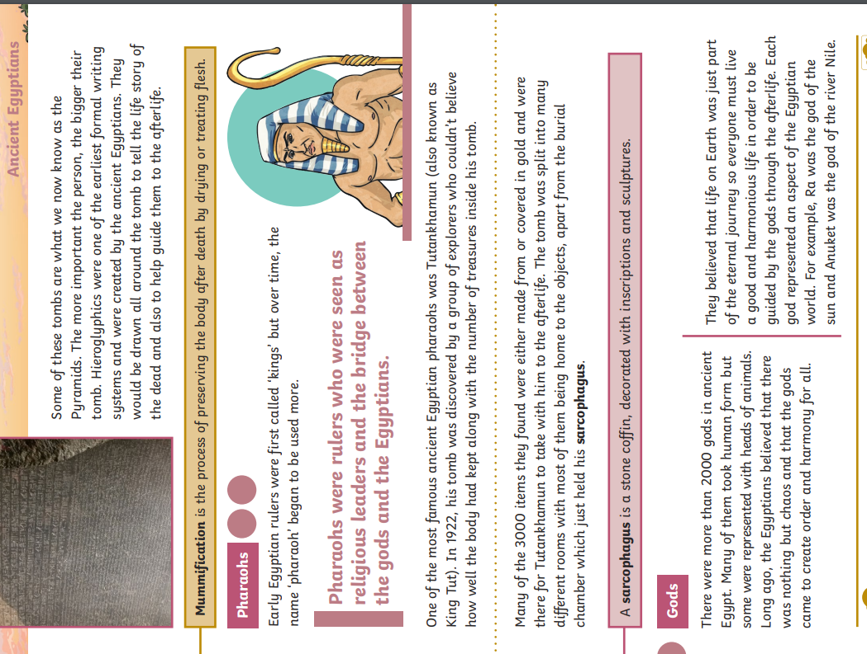
Challenge – optional


