Hedgehog Class Homework Autumn 1 week 4 – Y6
Homework due: Tuesday 30th September 2025
Next week we are learning:
Maths | Literacy | Science | RE
We will be continuing our unit on Addition, subtraction, multiplication and division. | We will be continuing our reading of Goodnight Mister Tom and narrative writing. | We will be expanding our topic on light and how shadows are formed. | We will be identifying how the Bible shapes Christian beliefs of God.

Log on to timetables.com OR Hit the Button to practise your maths skills:
Purple Mash also have some lovely Maths and spellings activities

Or use other websites/ways that you enjoy .

Spellings:
Practise spellings ready for weekly spelling test- see below for your child’s spelling group – These groups are subject to change as they are based on their current spelling ages.

Reading:
Read every day for a minimum of 10 minutes. Please log this in Reading Records.

SPaG: Punctuating narratives correctly.

Maths: Common factors and multiples

Remember to be thinking about your story plan – We will be finalising these this week!

Remember to look after yourself over the weekend and stay safe. If you are feeling overwhelmed, here are some great sites to help you feel a little better!

https://www.bbcchildreninneed.co.uk/schools/primary-school/mindfulness-hub/ ---------- https://www.gonoodle.com/ ----------- Smiling Mind (App)
Spellings:
Group A | Group B | Group C
calendar  caught  pressure  Anderson  favourite  describe  important  remember  naughty  quarter | describe  important  restaurant  awkward  Anderson  lightning  thorough  sincerely  foreign  sacrifice | interrupt  frequently  pronunciation  marvellous  foreign  Anderson  embarrassed  sincerely  determined  restaurant
……………………………………………………………………………………………………………………………………………………………………………………………………………………………………………………………………………………………………………………………………………………………………………………………………………………………………………………………………………………………………………………………………………………………………………………………………………………………………………………………………………………………………………………………………………………………………………………………………………………………………………………………………………………………………………………………………………………………………………………………………………………………………………………………………………………………………………………………………………………………………………………………………………………………………………………………………………………………………………………………………………………………………………………………………………………………………………………………………………………………………………………………………………………………………………………………………………………………………………………………………………………………..……………………………………………………………………………………………………………………………..

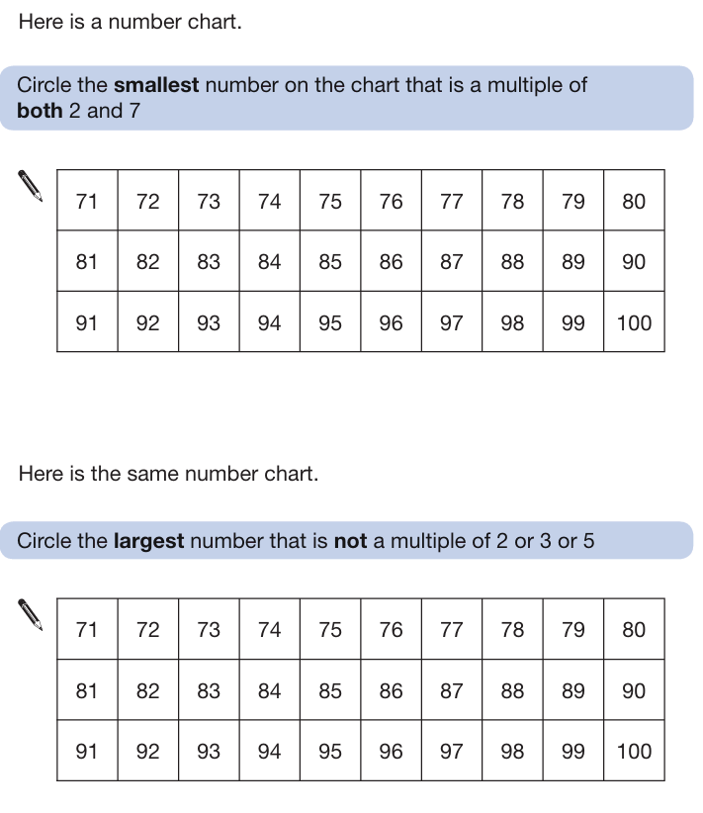
1a)

1b)

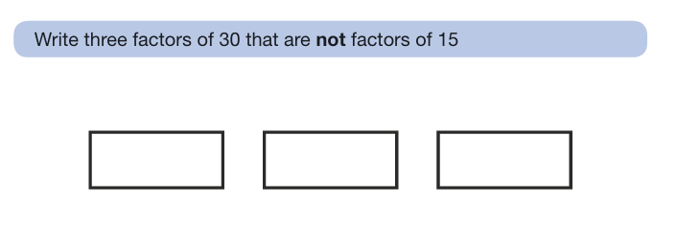
2)

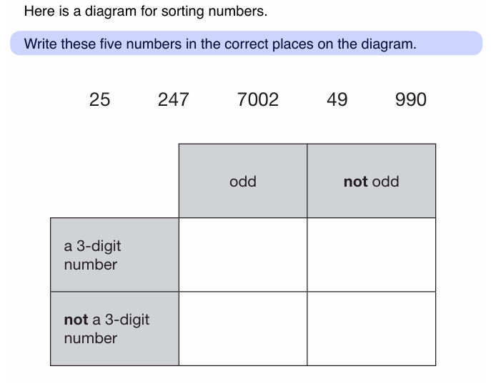
3)

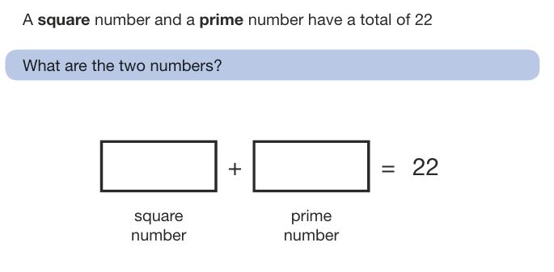
4)

Remember to think about your story plan. We will be writing these this week so remember the structure of a narrative and have a look at some examples online!
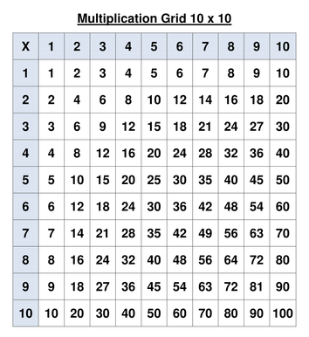
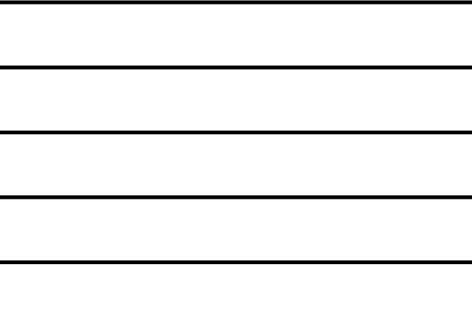
Helpful Resources:
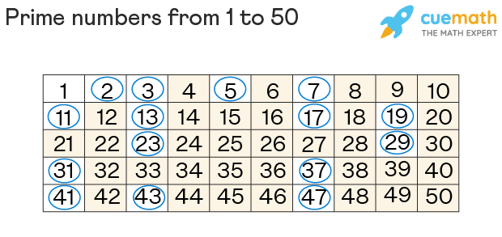

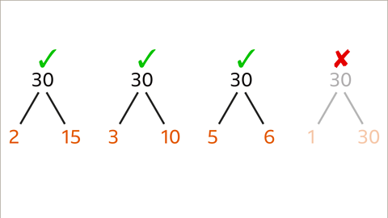
Remember – You can do this! If you are struggling, ask an adult or mark this on your work and we can go over it together in class.
Answers


