Hedgehog Class Homework Autumn 1 week 4 – Y6
Homework due: Tuesday 7th October 2025
Next week we are learning:
Maths | Literacy | Science | RE
We will be continuing our unit on multiplication and division. | We will be continuing our reading of Goodnight Mister Tom and narrative writing. | We will be expanding our topic on light and how shadows change. | We will be exploring the sacraments of Confession and Penance.

Log on to timetables.com OR Hit the Button to practise your maths skills:
Purple Mash also have some lovely Maths and spellings activities

Or use other websites/ways that you enjoy .

Spellings:
Practise spellings ready for weekly spelling test- see below for your child’s spelling group – These groups are subject to change as they are based on their current spelling ages.

Reading:
Read every day for a minimum of 10 minutes. Please log this in Reading Records.

SPaG: Punctuating narratives correctly.

Maths: Long multiplication and squared/ cubed numbers.

Remember to look after yourself over the weekend and stay safe. If you are feeling overwhelmed, here are some great sites to help you feel a little better!

https://www.bbcchildreninneed.co.uk/schools/primary-school/mindfulness-hub/ ---------- https://www.gonoodle.com/ ----------- Smiling Mind (App)

Spellings:
Group A | Group B | Group C
calendar  caught  pressure  Anderson  favourite  describe  important  remember  naughty  quarter | describe  important  restaurant  awkward  Anderson  lightning  thorough  sincerely  foreign  sacrifice | interrupt  frequently  pronunciation  marvellous  foreign  Anderson  embarrassed  sincerely  determined  restaurant
……………………………………………………………………………………………………………………………………………………………………………………………………………………………………………………………………………………………………………………………………………………………………………………………………………………………………………………………………………………………………………………………………………………………………………………………………………………………………………………………………………………………………………………………………………………………………………………………………………………………………………………………………………………………………………………………………………………………………………………………………………………………………………………………………………………………………………………………………………………………………………………………………………………………………………………………………………………………………………………………………………………………………………………………………………………………………………………………………………………………………………………………………………………………………………………………………………………………………………………………………………………………..……………………………………………………………………………………………………………………………..
1) Calculate the following, you must show your working out!
a) 451 x 4 =

b) 208 x 12 =

c) 913 x 53 =

d) 1012 x 1000 =

e) 4² =

f) 3³ =

See next page

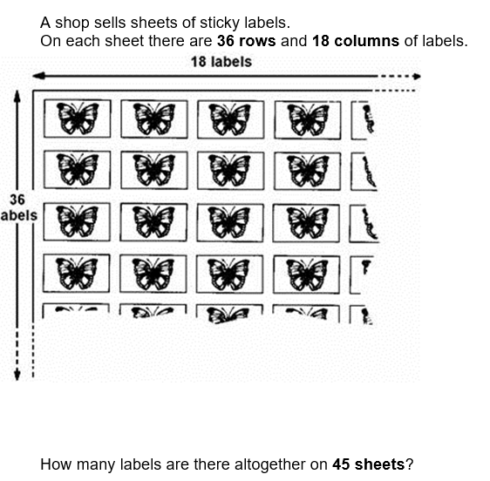
2)

Wellbeing focus – List some things that you are proud of this week! This can be however big or small!
Remember – Miss Hume is very proud of every one of you and how hard you have already worked this term!
1.
2.
3.
4.
5.

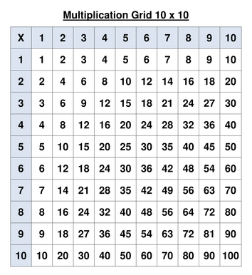
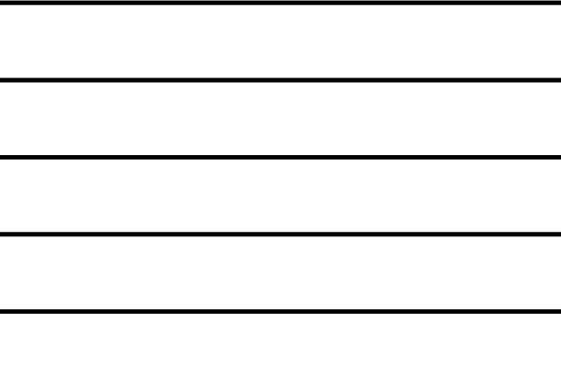
Helpful Resources:
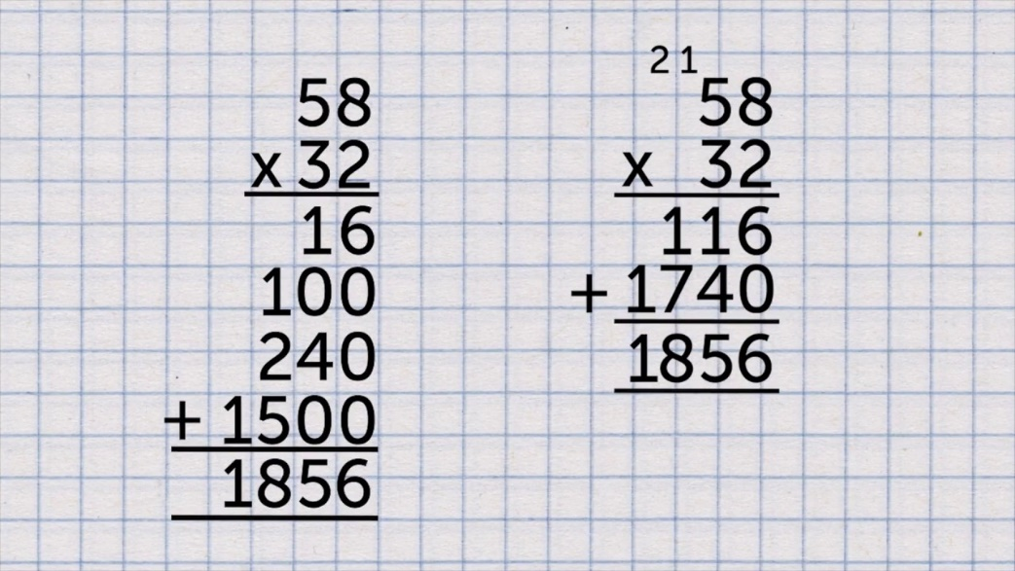

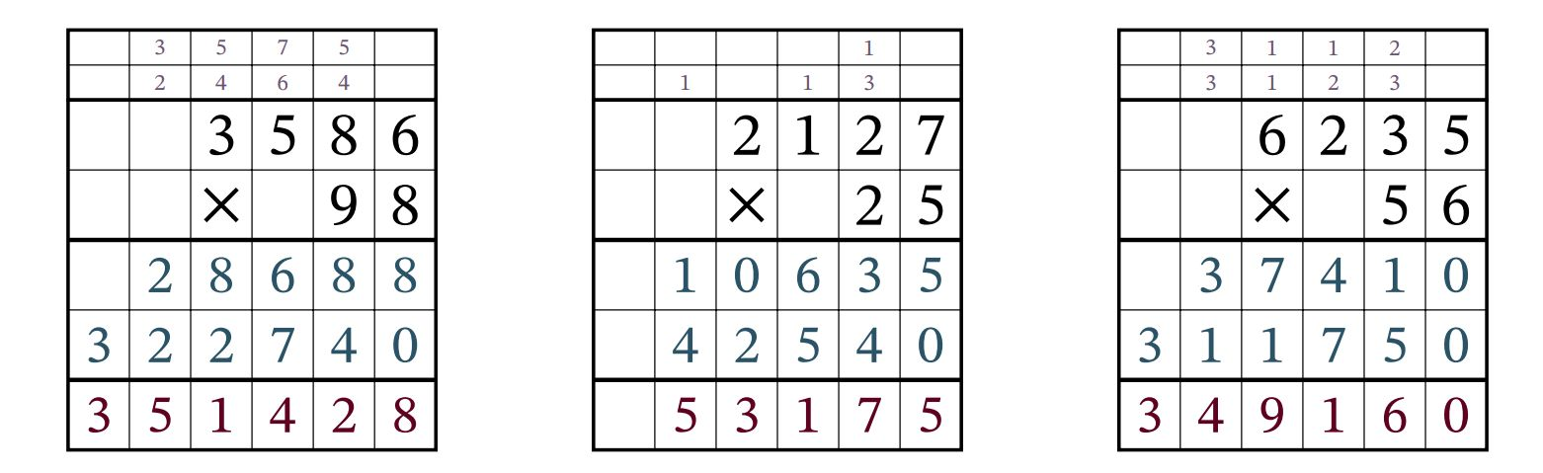

Remember – You can do this! If you are struggling, ask an adult or mark this on your work and we can go over it together in class.

