Name: ………………………………………………………..
Hedgehog Class Homework Autumn 1 week 4 – Y6
Homework due: Tuesday 14th October 2025
Next week we are learning:
Maths | Literacy | Science | RE
We are expanding our division knowledge into long division methods. | We will be starting to practise newspaper writing. | We will be introducing our new topic of electricity. | We will be exploring the sacraments of Confession and Penance.

Log on to timetables.com OR Hit the Button to practise your maths skills:
Purple Mash also have some lovely Maths and spellings activities

Or use other websites/ways that you enjoy .

Spellings:
Practise spellings ready for weekly spelling test- see below for your child’s spelling group – These groups are subject to change as they are based on their current spelling ages.

Reading:
Read every day for a minimum of 10 minutes. Please log this in Reading Records.

SPaG: Prefixes and Suffixes

Maths: Short division

Remember to look after yourself over the weekend and stay safe. If you are feeling overwhelmed, here are some great sites to help you feel a little better!

https://www.bbcchildreninneed.co.uk/schools/primary-school/mindfulness-hub/ ---------- https://www.gonoodle.com/ ----------- Smiling Mind (App)
Spellings:
Group A | Group B | Group C
accident  address  believe  favourite  grammar  imagine  separate  through  natural  explanation | accident  address  century  environment  interrupt  marvellous  soldier  bruise  disappear  explanation | accompany  ancient  bargain  conscience  desperate  hindrance  language  yacht  interrupt  explanation
……………………………………………………………………………………………………………………………………………………………………………………………………………………………………………………………………………………………………………………………………………………………………………………………………………………………………………………………………………………………………………………………………………………………………………………………………………………………………………………………………………………………………………………………………………………………………………………………………………………………………………………………………………………………………………………………………………………………………………………………………………………………………………………………………………………………………………………………………………………………………………………………………………………………………………………………………………………………………………………………………………………………………………………………………………………………………………………………………………………………………………………………………………………………………………………………………………………………………………………………………………………………..……………………………………………………………………………………………………………………………..
1) Calculate the following, you must show your working out! Use remainders!
a) 72 ÷ 8 =

b) 356 ÷ 4 =

c) 913 ÷ 11 =

d) 641 ÷ 8 =

e) 4³ =

f) 307 ÷ 4 =

See next page

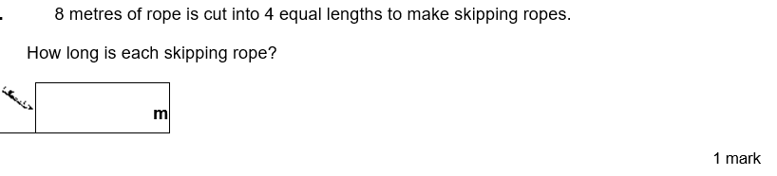
2)

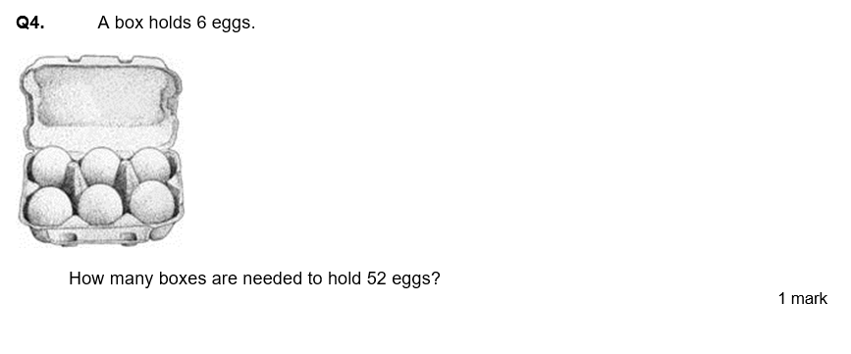
3)

Wellbeing focus – List some things that have made you smile this week! This can be however big or small!
1.
2.
3.
4.
5.

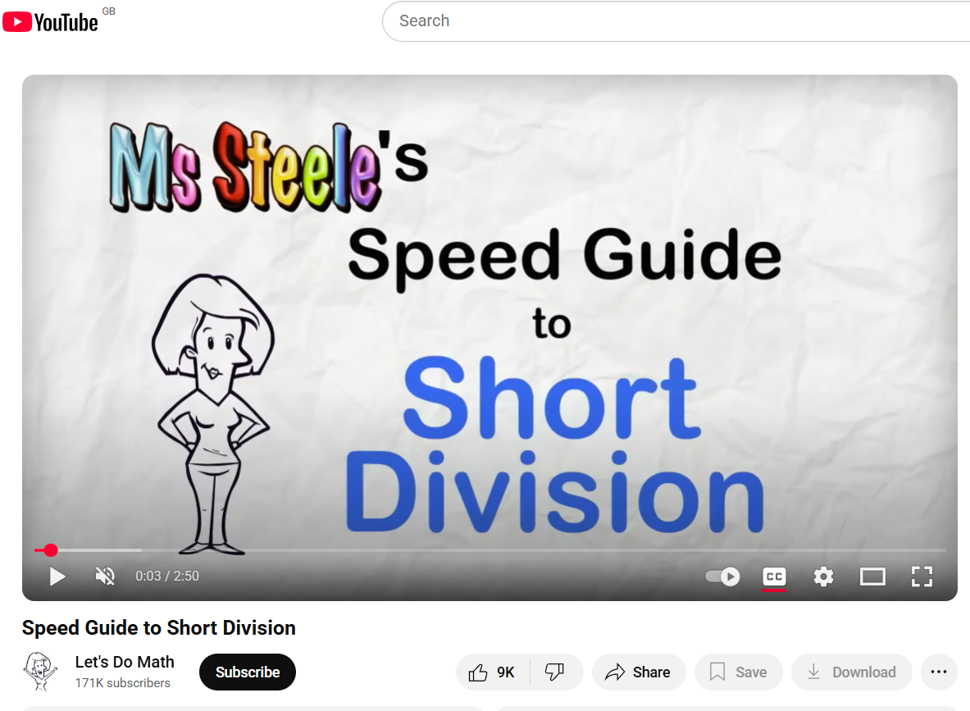
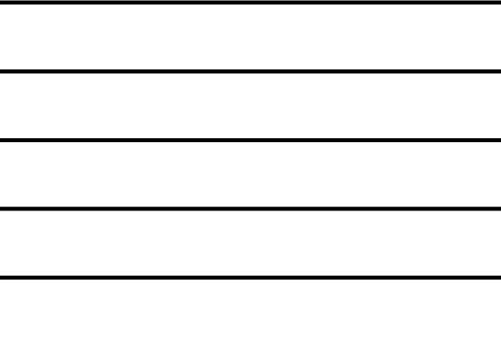
Helpful Resources:
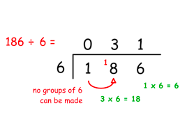

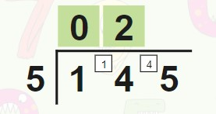

Remember – You can do this! If you are struggling, ask an adult or mark this on your work and we can go over it together in class.

