Tiger - Reception Class Homework
Weekly homework
Week 4 – 2nd October 2025
Dear parents,
Thank you for helping your child with their homework last week. It has been brilliant to see how hard they worked with their number formation. Well done, keep up the great work!

Fine Motor Skills
Learning to write is a hard work! To build up the strength and muscle memory needed takes practice and time. For their homework this week I would like your child to work on their fine motor skills. I would like them to complete their fine motor skills challenge booklet. Please encourage your child to take their time and follow each of the lines with care. The more accurate they are the better as this will really help to improve their brain/eye coordination. In addition to the booklet it would also be great if your child could carry out some of the activities from the fine motor skills guide that you received in their school readiness pack. For example, encouraging your child to follow lines and shapes with scissor and use their knife and fork at dinner time (rather than a spoon) will help them to become stronger and more dexterous

Phonics – Little Wandle

This week your child will have a new set of phoneme flashcards (see below for guidance with pronunciation and formation) Please work with your child to help them learn to recognise and read each one. It is also important for them to continue to revise the phoneme flashcards from last week too. Repetition is the key to securing this knowledge. Remember once your child is confident in reading each letter sound, please encourage them to practise writing each one too, focusing on accurate formation.

Your child also has another new Little Wandle ‘wordless book’. As I mentioned before, these wordless books are a crucial part of the process of learning to read and covers important aspects including comprehension, asking and answering questions and predicting what might happen next in a story. Thank you for recording the reading you have done in with your child’s reading record. This really does help us to be able to share your child’s ideas and progress with them. Remember, you don’t have to write lots, just a comment about any questions you may have asked and how your child responded or predictions that your child made about the book. Please do also comment on your child’s sharing book too.

Please remember to return all books on Monday so they can be used during group teaching reading sessions. Many thanks for your support with this.

Literacy – name writing continued

Don’t forget to encourage your child to write their name every day. By practising daily, they will be developing both muscle memory and confidence with the spelling of their name. Please remember

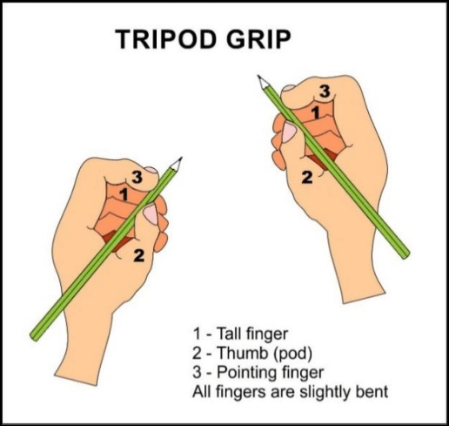

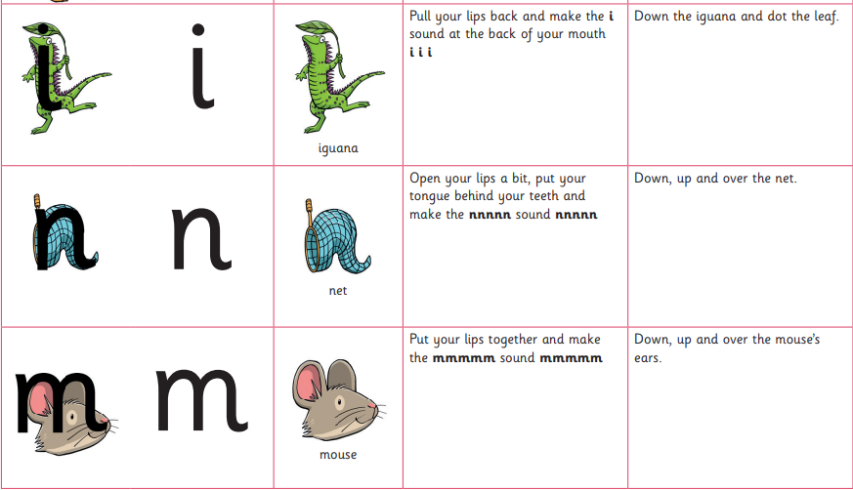
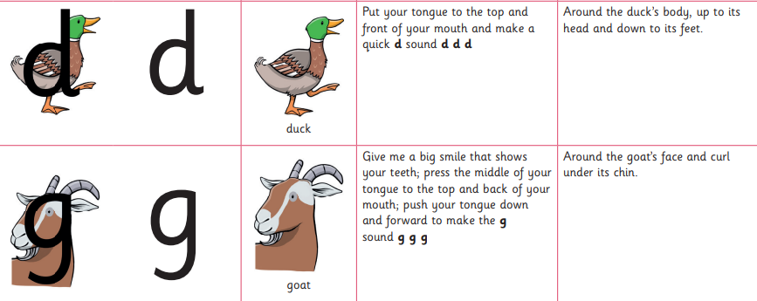
Keep up the good work!

As always, if you have any questions about your child’s learning, please do not hesitate to contact me via the school office.
Many thanks,
Mrs Allan

Next week in class we will be learning
Reading – continuing developing listening and comprehension skills
Writing – Grapheme formation – Christian name continued
Speaking – using descriptive/new vocabulary
Number recognition – number songs to 10
Number formation – numbers 0,1,2,3 and beyond continued – understanding the cardinal number
Understanding the World/ Science – The Human body
R.E. – How do Christians show thanks
Expressive Arts and Design – Collage self-portrait in the style of Julian Opie continued
Physical Development – Outdoor PE Intro to PE Unit 2– Following instructions and learning how to stop!
Indoor PE – Fundamentals - I can explore how my body moves differently when running at different speeds
Story focus of the week: Non-fiction books

