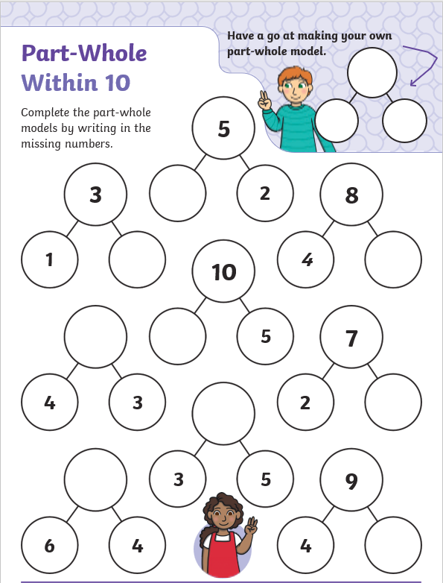
Tiger Class – Year One Homework 16th October 2025
Complete the Part-Whole models below. When you have found each answer please show five of the models as an addition sentence e.g. 1 + 2 = 3

