Teddy Bears’ Picnic Size Matching
16th October 2025
Reception - Tiger Class Homework
Use your brilliant scissor skills to cut out the picnic food. Look at the size of each item and then stick it on the right plate. Does it need to go on Big Bears’ or Little Bears’ plate. Explain to your grown up how you have sorted the food.
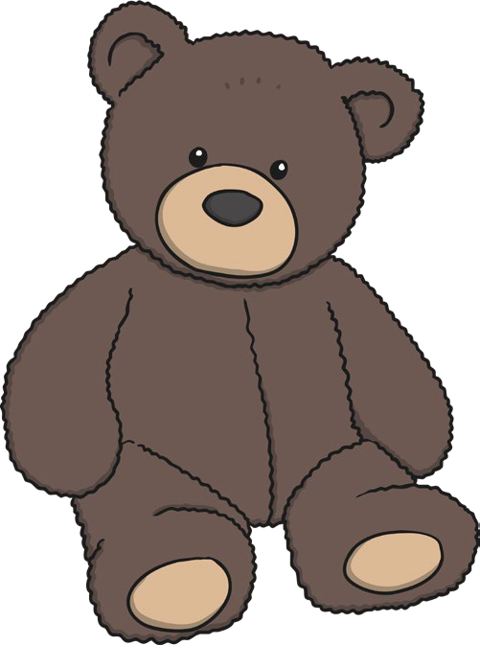
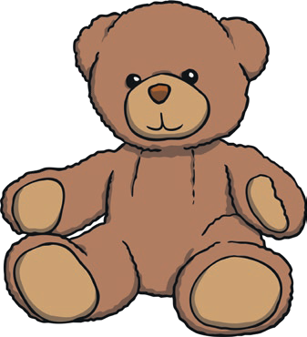



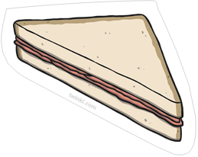
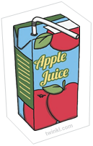
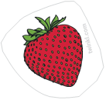
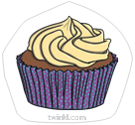

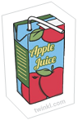

Challenge – draw two different sized piece of food and share them with the bears. Tell you grown up why you have given each piece to each bear.

