Axolotl Class Homework Autumn 1 week 2 – Y3
Homework due: Tuesday 23rd September 2025
Next week we are learning:
Maths | Literacy | Science | RE
We will be starting our unit on Place Value recapping roman numerals and before numbers up to 1000 and then moving onto a 10,000 | We will be will continuing our unit on Anglo Saxons by writing a non-chronology report | We will be continuing our topic on the digestive system | We will be starting our unit of Creation focussing on the impact on our lives and how we can protect it.

Log on to timestable.com to practise your maths skills:
Purple Mash also have some lovely Maths and spellings activities

Or use other websites/ways that you enjoy .

Spellings:
Practise spellings ready for weekly spelling test- see below for your child’s spelling group – These groups are subject to change as they are based on their current spelling ages.

Reading:
Read every day for 20 minutes. Please log this in Reading Records.

SPaG: Year 3 SPaG mat

Maths: Place Value

Challenges are optional – although please have a go if you can

Spellings:
Group 1 | Group 2  Homophones and near homophones | Group 3  Homophones and near homophones
people  that  says  their  they  where  as  came  went  can’t | meat  meet  berry  bury  peace  piece  break  brake  saw  sore | heel  heal  main  mane  medal  meddle  key  quay  check  cheque
……………………………………………………………………………………………………………………………………………………………………………………………………………………………………………………………………………………………………………………………………………………………………………………………………………………………………………………………………………………………………………………………………………………………………………………………………………………………………………………………………………………………………………………………………………………………………………………………………………………………………………………………………………………………………………………………………………………………………………………………………………………………………………………………………………………………………………………………………………………………………………………………………………………………………………………………………………………………………………………………………………………………………………………………………………………………………………………………………………………………………………..……………………………………………………………………………………………………………………………..

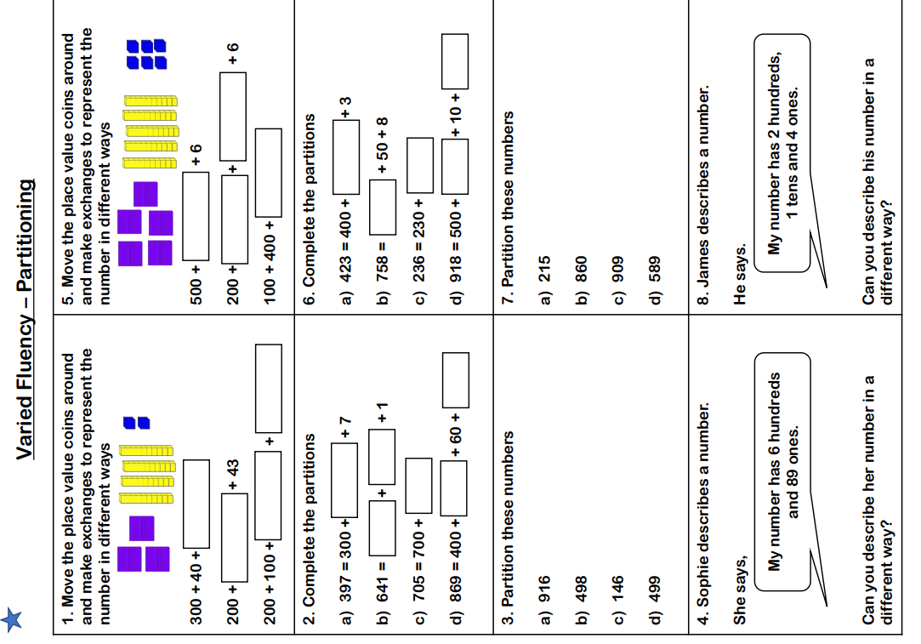

Challenge – optional

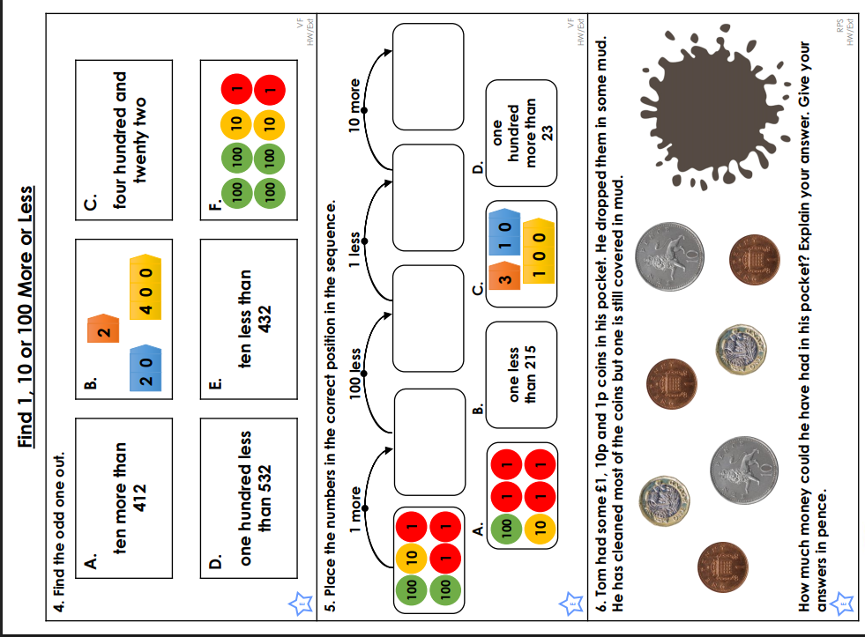

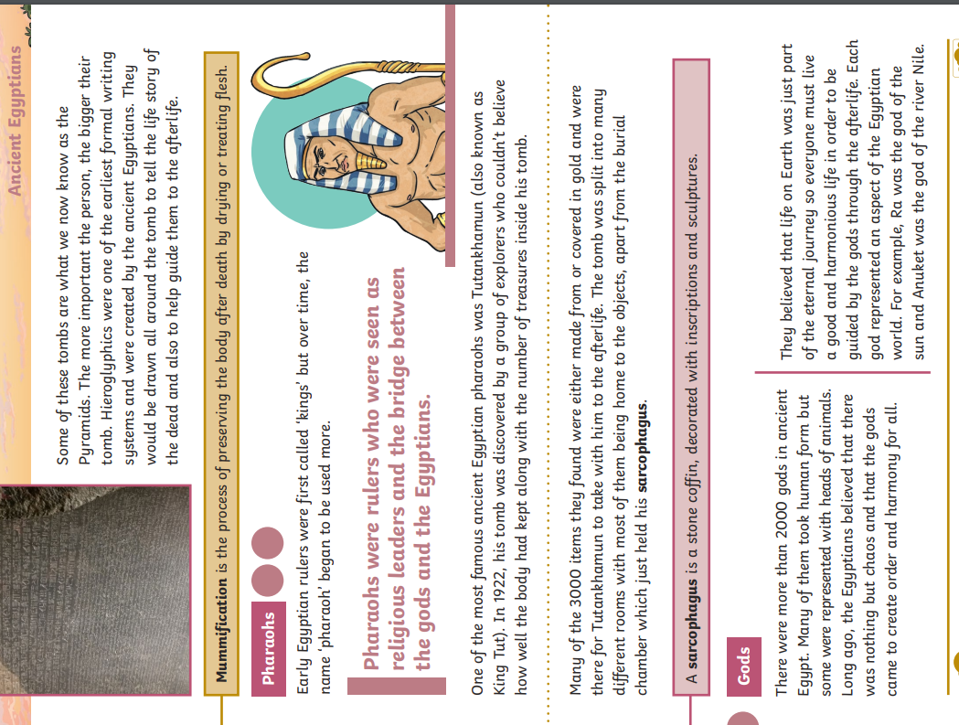
Challenge – optional



