Axolotl Class Homework Autumn 1 week 3 – Y4
Homework due: Tuesday 30th September 2025
Next week we are learning:
Maths | Literacy | Science | RE
We will be starting our unit on Place Value recapping roman numerals and before numbers up to 1000 and then moving onto a 10,000 | We will be will starting our unit on writing some linked to our story Anglo Saxon Boy | We will be continuing our topic on the digestive system | We will be starting our unit of Creation focussing on the impact on our lives and how we can protect it.

Log on to timestable.com to practise your maths skills:
Purple Mash also have some lovely Maths and spellings activities

Or use other websites/ways that you enjoy .

Spellings:
Practise spellings ready for weekly spelling test- see below for your child’s spelling group – These groups are subject to change as they are based on their current spelling ages.

Reading:
Read every day for 20 minutes. Please log this in Reading Records.

SPaG: Year 3 SPaG mat

Maths: Place Value

Challenges are optional – although please have a go if you can

Spellings:
Group 1 | Group 2  Words with the /ei/ sound spelt ei, eigh or ey | Group 3  ‘S’ sound spelt sc
called  all  we  be  me  see  my  where  were  with | eight  they  obey  vein  weigh  neighbour  eighth  neigh  beige  sleigh | science  scene  discipline  fascinate  crescent  scissors  scenery  descent  ascend  descend
……………………………………………………………………………………………………………………………………………………………………………………………………………………………………………………………………………………………………………………………………………………………………………………………………………………………………………………………………………………………………………………………………………………………………………………………………………………………………………………………………………………………………………………………………………………………………………………………………………………………………………………………………………………………………………………………………………………………………………………………………………………………………………………………………………………………………………………………………………………………………………………………………………………………………………………………………………………………………………………………………………………………………………………………………………………………………………………………………………………………………………..……………………………………………………………………………………………………………………………..
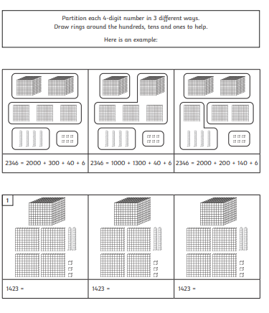
hallenge – optional

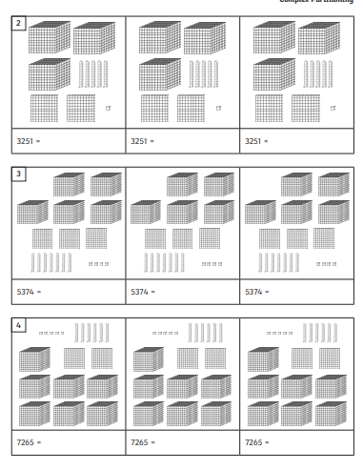

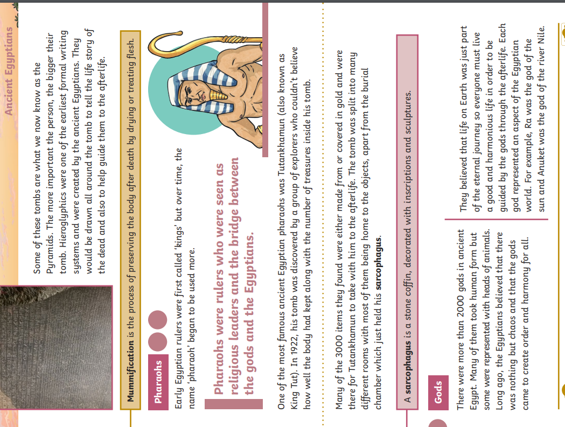
Challenge
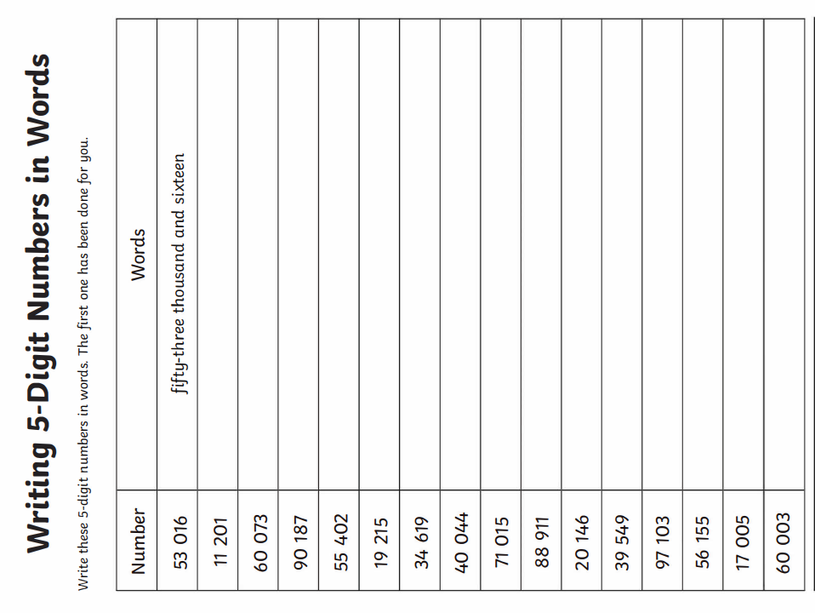
C


