Axolotl Class Homework Autumn 1 week 4 – Y3
Homework due: Tuesday7th October 2025
Next week we are learning:
Maths | Literacy | Science | RE
We will be finishing our unit on Place Value recapping roman numerals and before numbers up to 1000 and then moving onto a 10,000 | We will be will starting our unit on writing some linked to our story Anglo Saxon Boy | We will be continuing our topic on the digestive system | We will be starting our unit of Creation focussing on the impact on our lives and how we can protect it.

Log on to timestable.com to practise your maths skills:
Purple Mash also have some lovely Maths and spellings activities

Or use other websites/ways that you enjoy .

Spellings:
Practise spellings ready for weekly spelling test- see below for your child’s spelling group – These groups are subject to change as they are based on their current spelling ages.

Reading:
Read every day for 20 minutes. Please log this in Reading Records.

SPaG: Year 4 SPaG mat

Maths: Place Value
Rounding numbers to 10, 100 and 1000
10 look at the ones number
100 look at the tens number
1000 look at the hundreds number
4-0 slide to floor – rounds down
5-9 climbs the vine – rounds up

Challenges are optional – although please have a go if you can
Spellings:
Group 1 | Group 2 | Group 3
rain  pain  strain  sprain  sprained  raining  painful  train  stain  stainless | eight  arrive  breath  circle  fruit  guard  height  often  popular  eighth | actual  address  calendar disappear experience particular  thought  separate  difficult  weight
……………………………………………………………………………………………………………………………………………………………………………………………………………………………………………………………………………………………………………………………………………………………………………………………………………………………………………………………………………………………………………………………………………………………………………………………………………………………………………………………………………………………………………………………………………………………………………………………………………………………………………………………………………………………………………………………………………………………………………………………………………………………………………………………………………………………………………………………………………………………………………………………………………………………………………………………………………………………………………………………………………………………………………………………………………………………………………………………………………………………………………..……………………………………………………………………………………………………………………………..
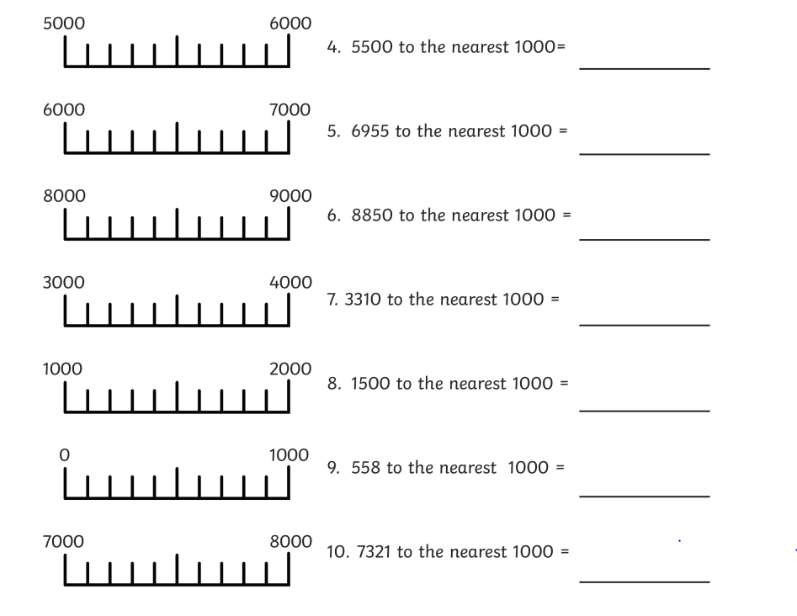
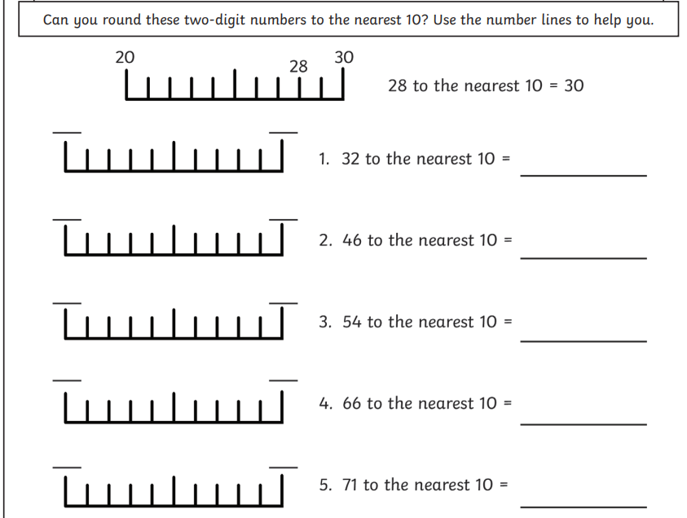
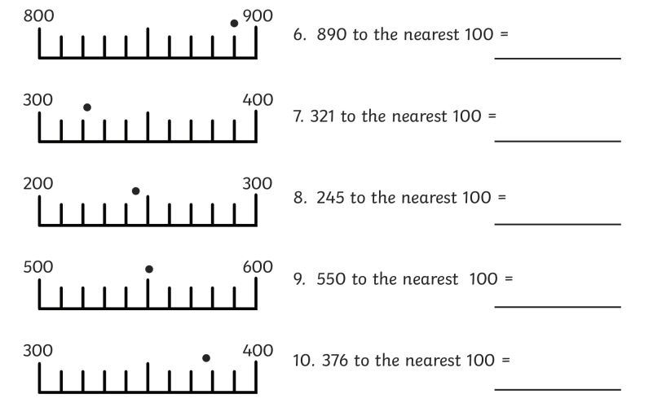
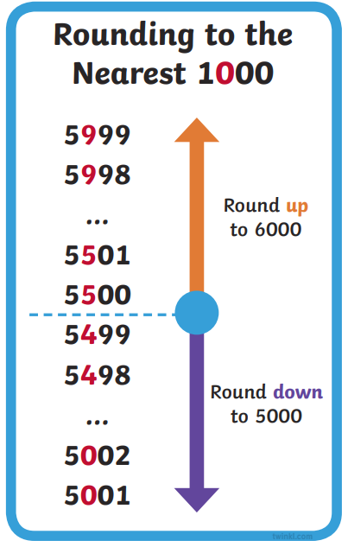
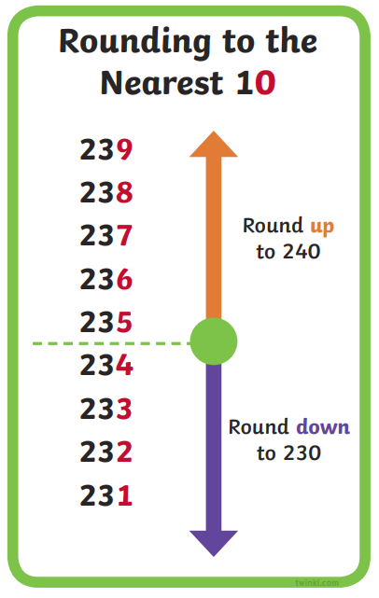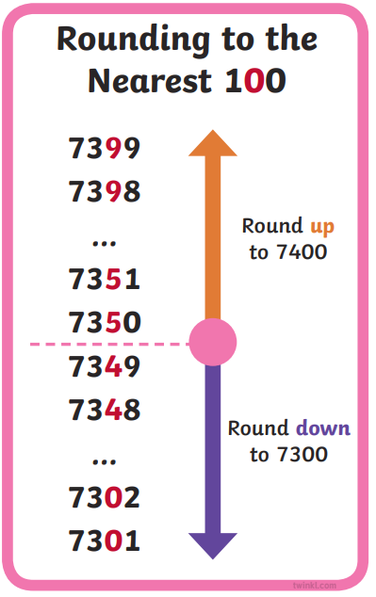

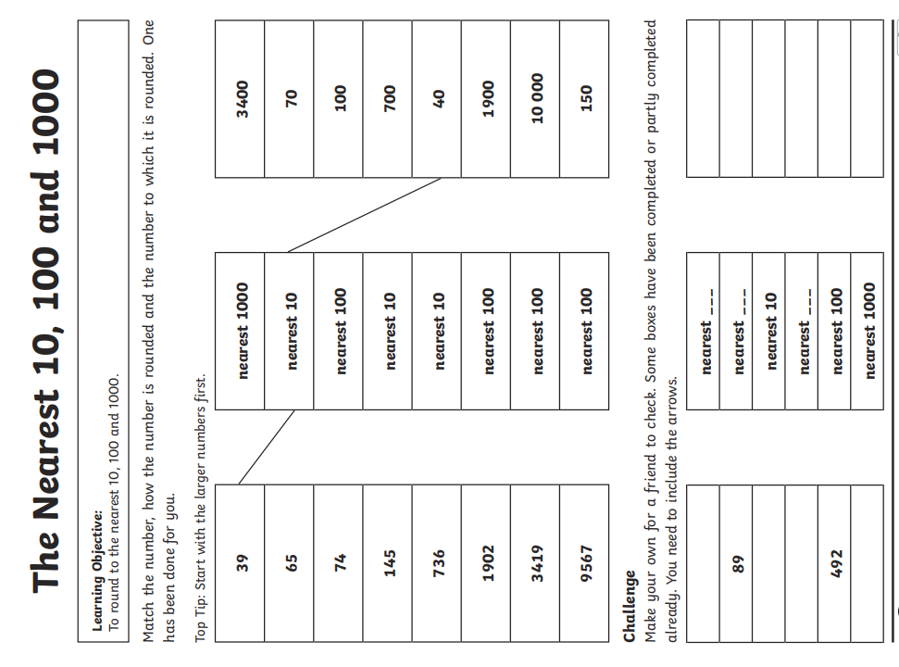
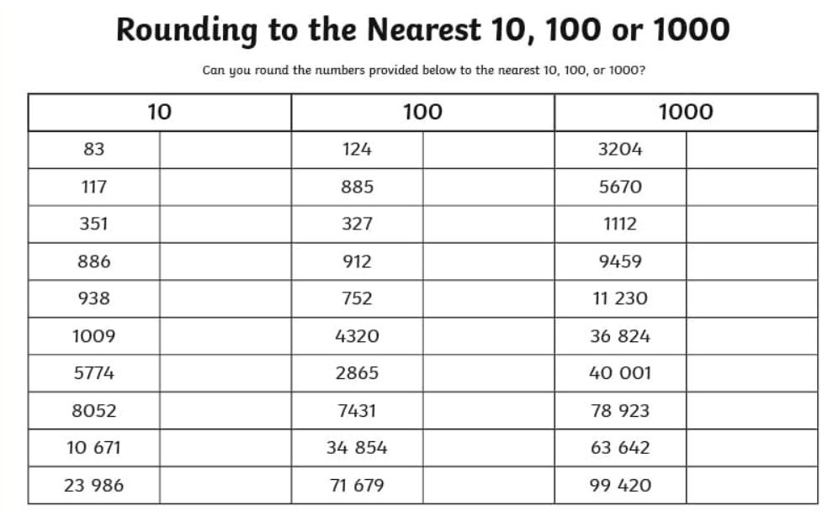
Challenge – optional please have a go if you can – remember the rules

Challenge – optional



