Axolotl Class Homework Autumn 1 week 5 – Y4
Homework due: Tuesday 14th October 2025
Next week we are learning:
Maths | Literacy | Science | RE
We will be finishing our unit on Place Value recapping roman numerals and before numbers up to 1000 and then moving onto a 10,000 | We will be will starting our unit on writing some linked to our story Anglo Saxon Boy | We will be continuing our topic on the digestive system | We will be starting our unit of Creation focussing on the impact on our lives and how we can protect it.

Log on to timestable.com to practise your maths skills:
Purple Mash also have some lovely Maths and spellings activities

Or use other websites/ways that you enjoy .

Spellings:
Practise spellings ready for weekly spelling test- see below for your child’s spelling group – These groups are subject to change as they are based on their current spelling ages.

Reading:
Read every day for 20 minutes. Please log this in Reading Records.

SPaG: Year 4 SPaG mat

Maths:

Adding and subtracting 1s, 10s, 100s and 1000s

Challenges are optional – although please have a go if you can
Spellings:
Group 1 | Group 2   | Group 3 
boat,  coat  wrote  note  coats  float  moat  voting  goat  goats | chef  chalet  machine  brochure  chute  parachute  moustache  quiche  chauffeur  chandelier | expansion extension comprehension tension  suspension occasion  dimension diversion permission discussion
……………………………………………………………………………………………………………………………………………………………………………………………………………………………………………………………………………………………………………………………………………………………………………………………………………………………………………………………………………………………………………………………………………………………………………………………………………………………………………………………………………………………………………………………………………………………………………………………………………………………………………………………………………………………………………………………………………………………………………………………………………………………………………………………………………………………………………………………………………………………………………………………………………………………………………………………………………………………………………………………………………………………………………………………………………………………………………………………………………………………………………..……………………………………………………………………………………………………………………………..
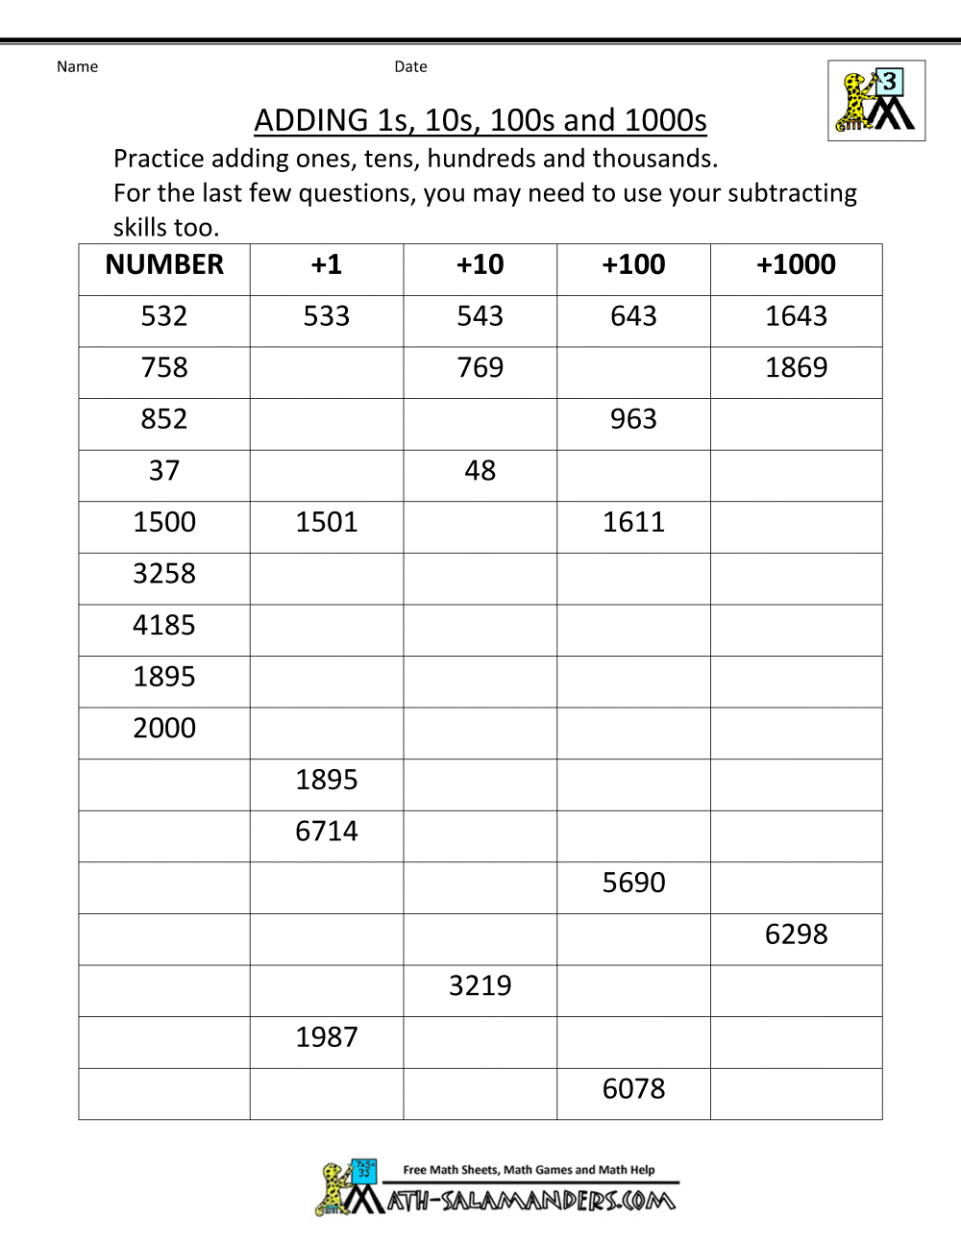
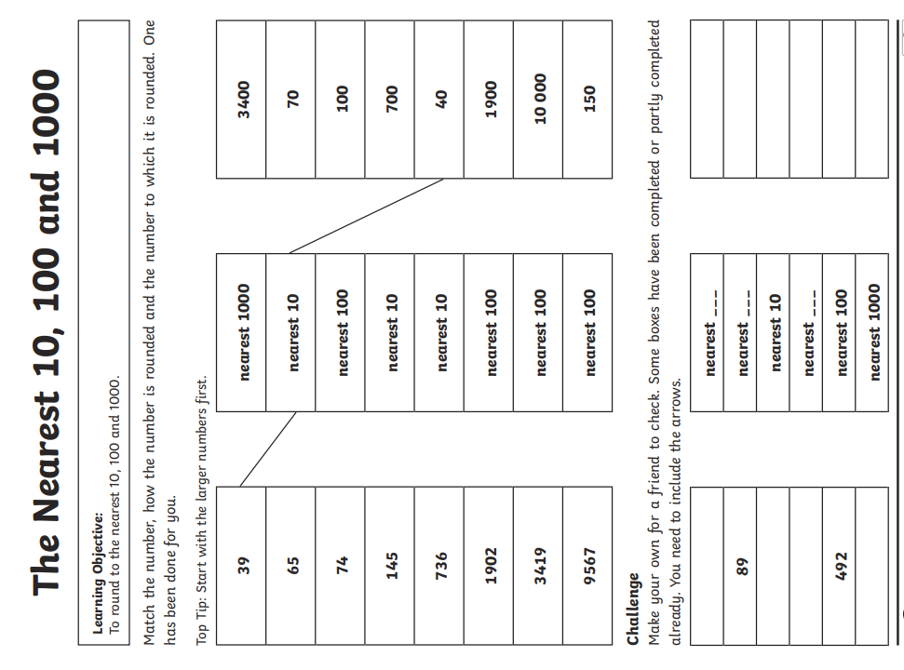
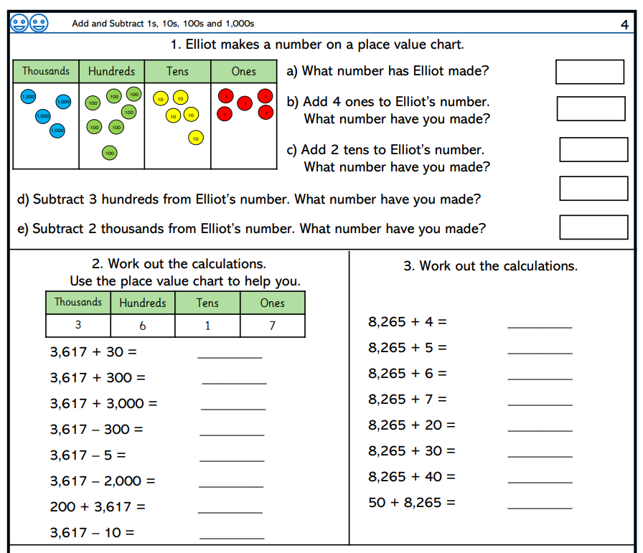

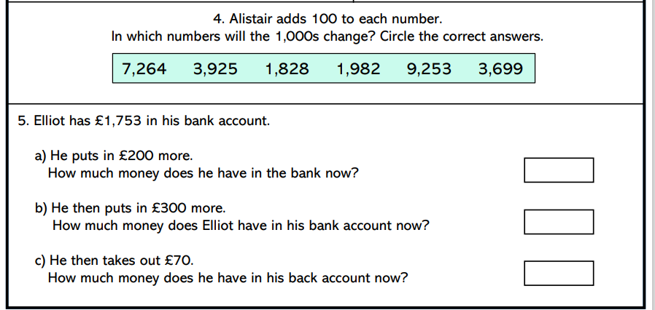
Challenge – optional please have a go if you can


