Axolotl Class Homework Autumn 1 week 6 – Y4
Homework due: Tuesday 21th October 2025
Next week we are learning:
Maths | Literacy | Science | RE
We will be starting our work on adding and subtracting | We will be will continuing our unit on writing some linked to our story Anglo Saxon Boy | We will be continuing our topic on the digestive system | We will be starting our unit of Creation focussing on the impact on our lives and how we can protect it.

Log on to timestable.com to practise your maths skills:
Purple Mash also have some lovely Maths and spellings activities

Or use other websites/ways that you enjoy .

Spellings:
Practise spellings ready for weekly spelling test- see below for your child’s spelling group – These groups are subject to change as they are based on their current spelling ages.

Reading:
Read every day for 20 minutes. Please log this in Reading Records.

SPaG: Year 4 SPaG mat

Maths:

Adding and subtracting across a boundary
Remember to use the partitioning method
165 + 8
8 partitioned can be 5 + 3
165 + 5 = 170 + 3 = 173

Challenges are optional – although please have a go if you can
Spellings:
Group 1  igh grapheme | Group 2  consolidation | Group 3  consolidation
light  bright  lightly  flight  rightly  brightness  knight  night  flightless  slight | Here  hear  groan  grown  bury  neighbour  peace  piece  arrive  often | Grate  fascinate  particular  diversion  extension  thought  tension comprehension  disappear  weight
……………………………………………………………………………………………………………………………………………………………………………………………………………………………………………………………………………………………………………………………………………………………………………………………………………………………………………………………………………………………………………………………………………………………………………………………………………………………………………………………………………………………………………………………………………………………………………………………………………………………………………………………………………………………………………………………………………………………………………………………………………………………………………………………………………………………………………………………………………………………………………………………………………………………………………………………………………………………………………………………………………………………………………………………………………………………………………………………………………………………………………..……………………………………………………………………………………………………………………………..
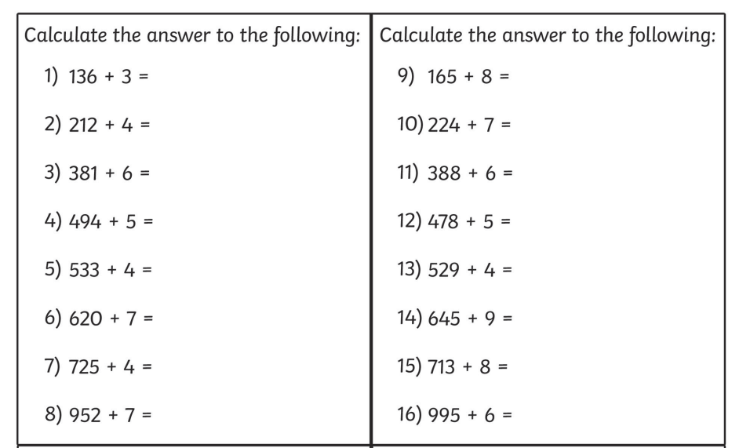

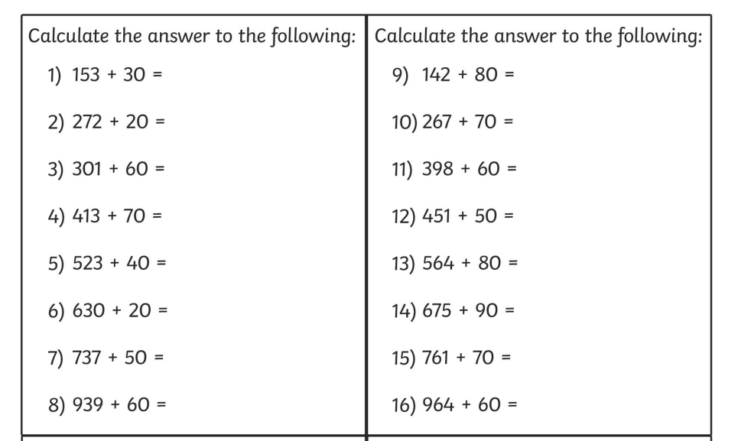

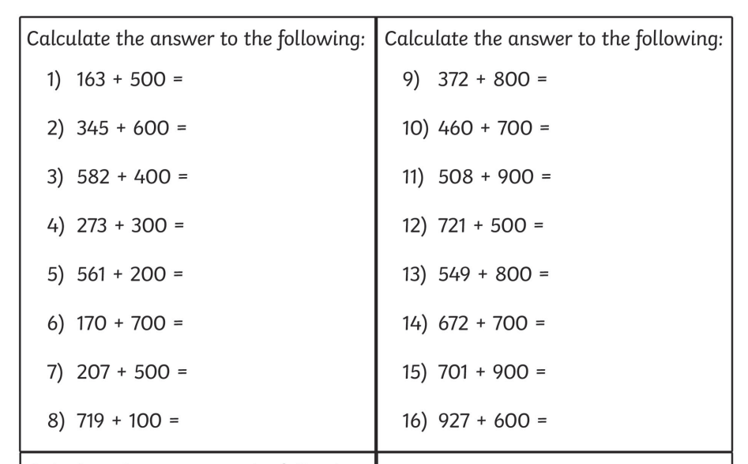
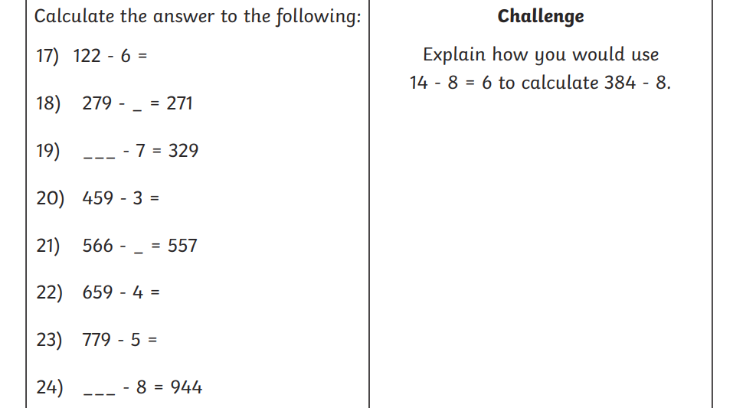
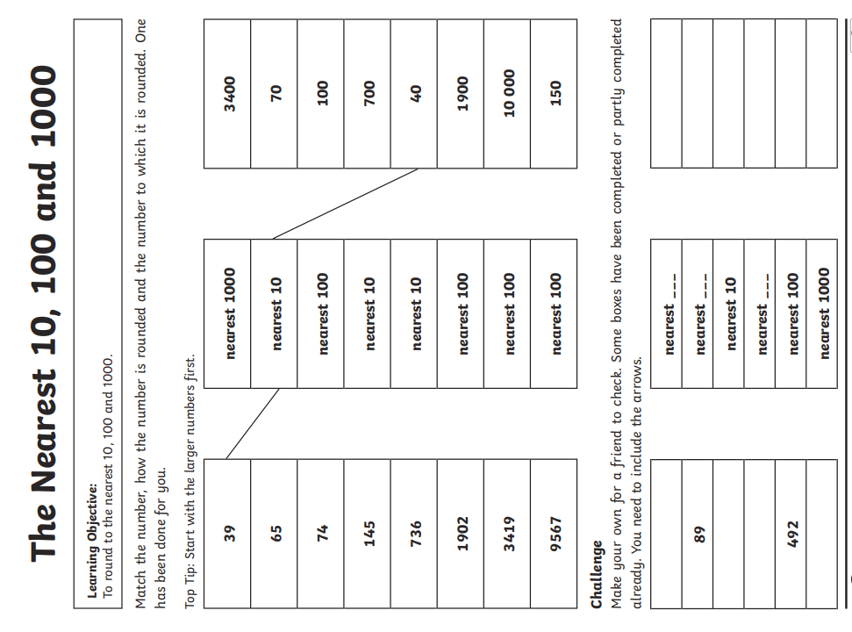
Challenge – optional please have a go if you can


