Name: ………………………………………………………..
Hedgehog Class Homework Autumn 1 week 7 – Y6
Homework due: Tuesday 21st October 2025
Next week we are learning:
Maths | Literacy | Science | RE
We are expanding our division knowledge into long division methods. | We will be starting to practise newspaper writing. | We will be introducing our new topic of electricity. | We will be exploring the sacraments of Confession and Penance.

Log on to timetables.com OR Hit the Button to practise your maths skills:
Purple Mash also have some lovely Maths and spellings activities

Or use other websites/ways that you enjoy .

Spellings:
Practise spellings ready for weekly spelling test- see below for your child’s spelling group – These groups are subject to change as they are based on their current spelling ages.

Reading:
Read every day for a minimum of 10 minutes. Please log this in Reading Records.

SPaG: Prefixes and Suffixes

Maths: Short division

Remember to look after yourself over the weekend and stay safe. If you are feeling overwhelmed, here are some great sites to help you feel a little better!

https://www.bbcchildreninneed.co.uk/schools/primary-school/mindfulness-hub/ ---------- https://www.gonoodle.com/ ----------- Smiling Mind (App)
Spellings:
Group A | Group B | Group C
answer  build  caught  centre  early  earth  enough  height  island  knowledge | answer  build  achieve  average  communicate  height  desperate  leisure  shoulder  enough | determined  foreign  secretary  community  amateur  conscious  twelfth  stomach  bruise  muscle
……………………………………………………………………………………………………………………………………………………………………………………………………………………………………………………………………………………………………………………………………………………………………………………………………………………………………………………………………………………………………………………………………………………………………………………………………………………………………………………………………………………………………………………………………………………………………………………………………………………………………………………………………………………………………………………………………………………………………………………………………………………………………………………………………………………………………………………………………………………………………………………………………………………………………………………………………………………………………………………………………………………………………………………………………………………………………………………………………………………………………………………………………………………………………………………………………………………………………………………………………………………………..……………………………………………………………………………………………………………………………..
1) Calculate the following, you must show your working out! Use remainders!
a) 96 ÷ 6 =

b) 144 ÷ 8 =

c) 432 ÷ 14 =

d) 289 ÷ 8 =

e) 6³ =

f) 569 ÷ 16 =

See next page
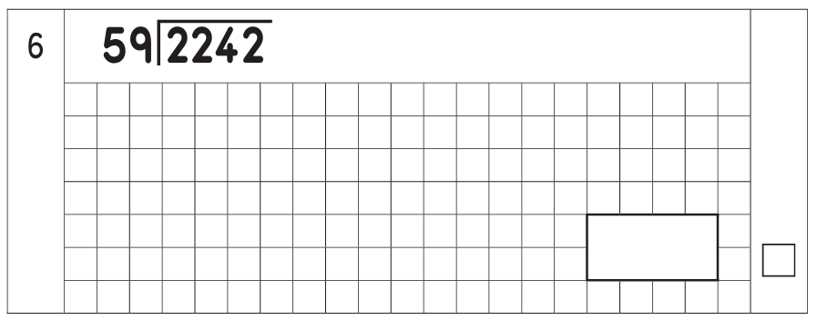
2)

Create your own long division question!
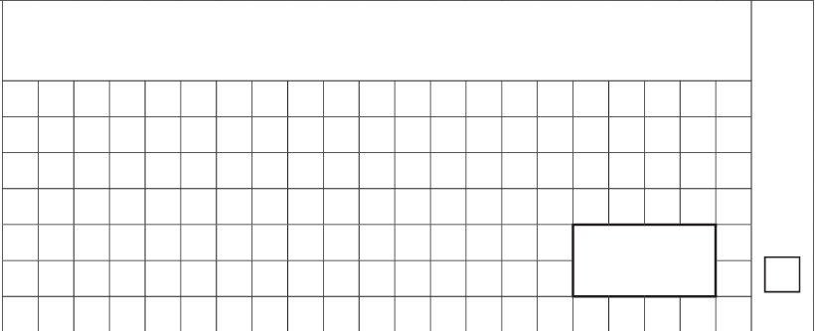

Wellbeing focus – List some things that you have struggled with this week.
1.
2.
3.
4.

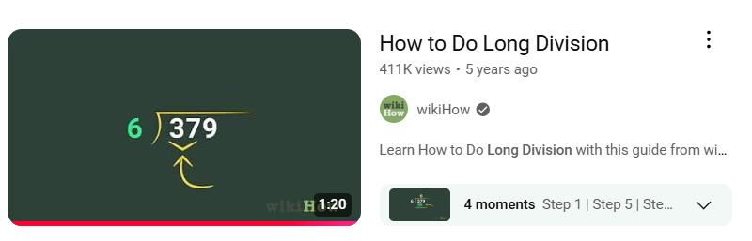
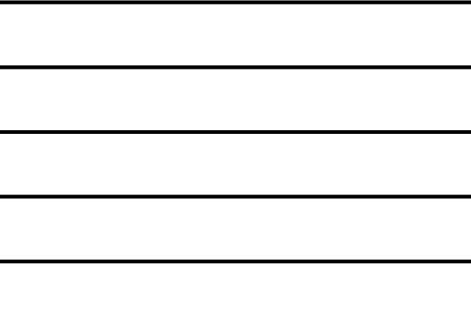
Helpful Resources:
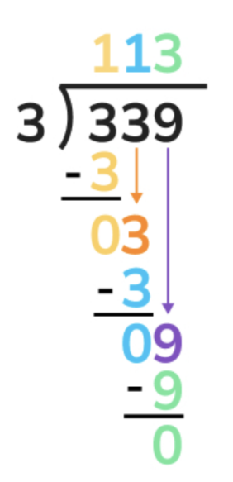

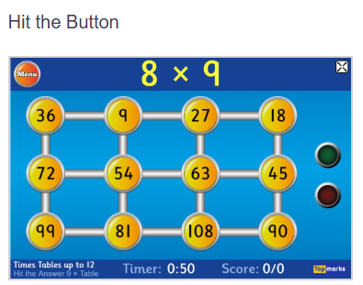

Remember – You can do this! If you are struggling, ask an adult or mark this on your work and we can go over it together in class.

