Tiger class – Year one homework 13th November 2025
Addition challenge
Use the number line or some objects (such as buttons or cubes) to help find the answer.
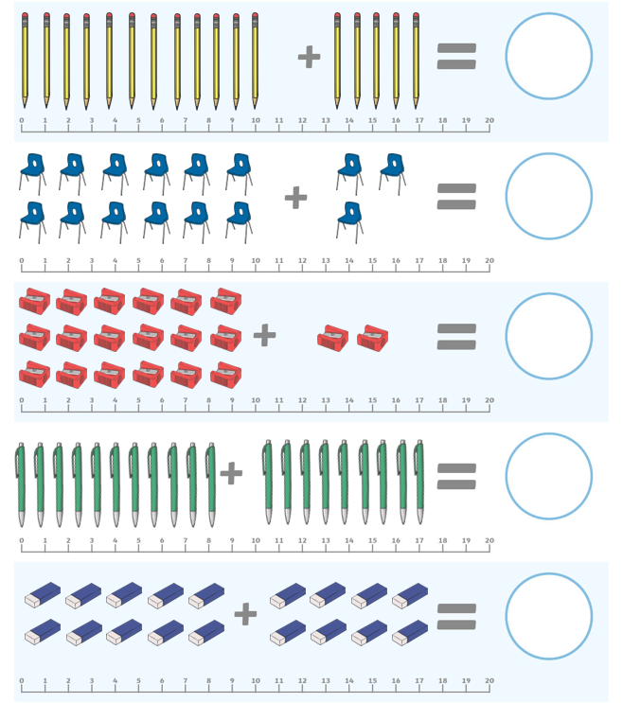

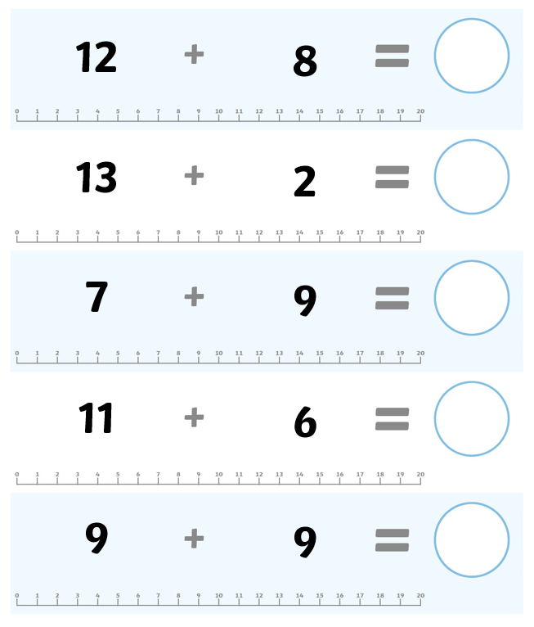

Challenge – try to solve these addition problems. Use your skills to work out what number should go in the circle. Use the number line or some resources/objects to help you.


