Eagle Class Homework Autumn 2 week 1 – Y5
Homework due: Tuesday 11th November 2025
Next week we are learning:
Maths | Literacy | Science | RE
We are looking at different methods of checking our addition and subtraction strategies such as rounding, | We will be looking at different poetic imagery and creating Remembrance poems. | We will explore evaporation to recover the solute form a solution. | We will explore how mitzvot guide Jewish communities in making moral choices.

Helpful Websites:
Log on to NumBots or hit the button to practice arithmetic skills.
https://play.numbots.com/#/account/school-login-type
https://www.topmarks.co.uk/maths-games/hit-the-button
Purple Mash also have some lovely Maths and spellings activities.

Spellings:
Practise spellings ready for weekly spelling test- see below for your child’s spelling group – These groups are subject to change as they are based on their current spelling ages.

Reading:
Read every day for 30 minutes. Please log this in Reading Records.

Maths: Strategies to check answers

Challenges are optional – although please have a go if you can

Spellings:
This week’s spellings are focused on words commonly misspelt in class.
Words marked with an asterisk (*) are common exception words or statutory spellings highlighted in the national curriculum.

Group 1 | Group 2 | Group 3
poppy  brave  peace  piece  remember* | remember*  peace  honour  wreath  symbol  there*  their*  they’re  themselves*  fought* | remembrance  memorial  sacrifice*  courageous  gratitude  courage  silence  peaceful  respectful  ceremony*

Challenge: Can you write two sentences that include one of your spelling words?

Strategies to check answers
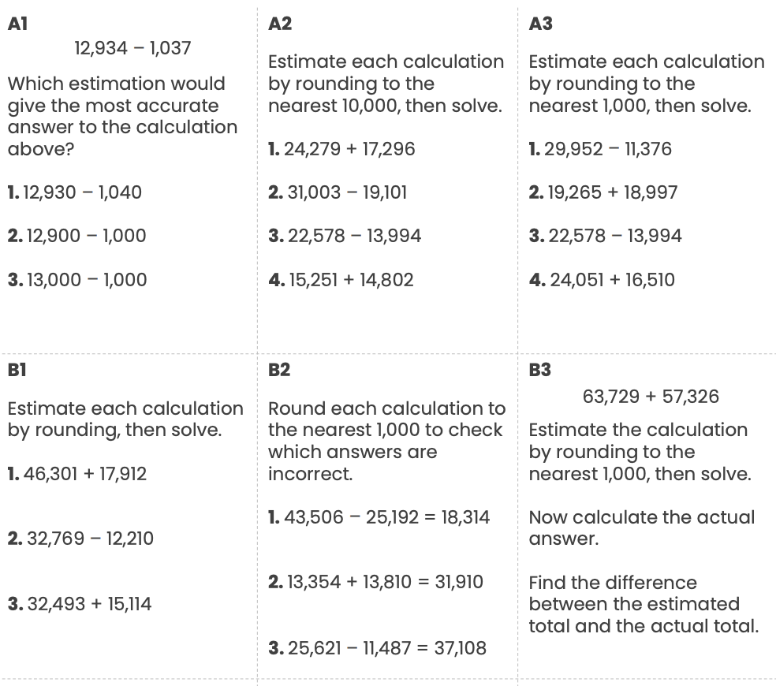

Reading Comprehension
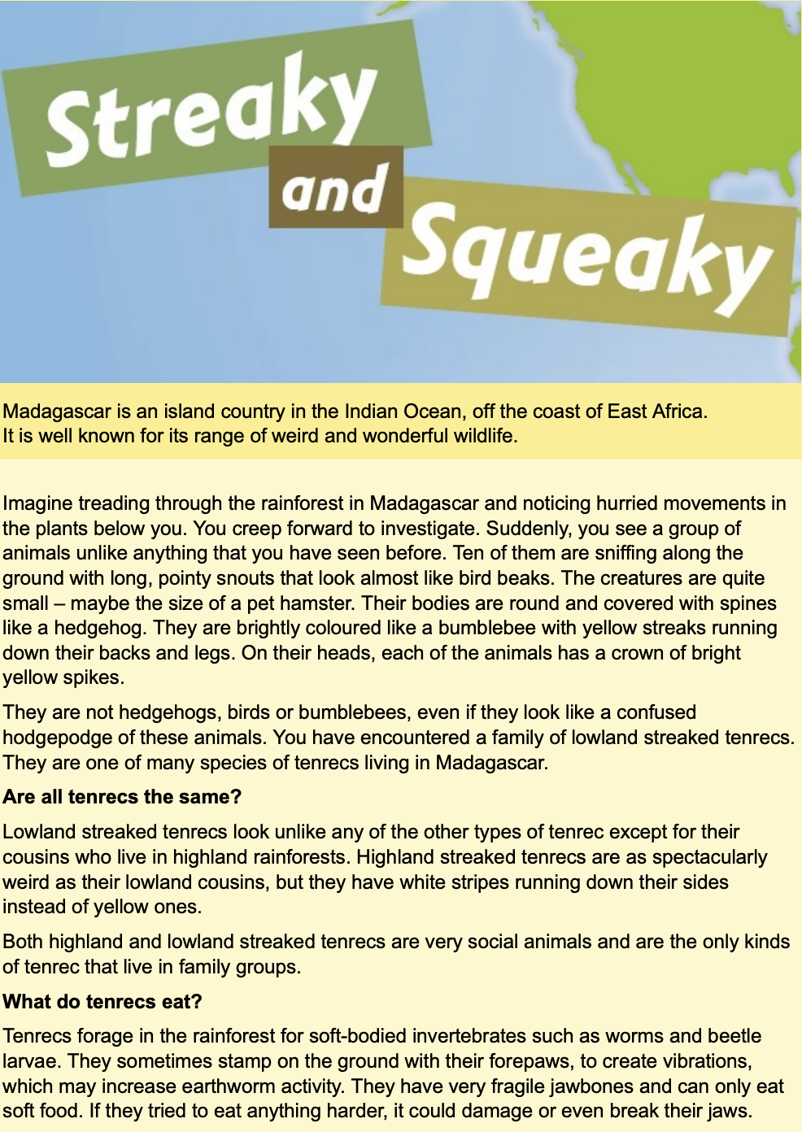
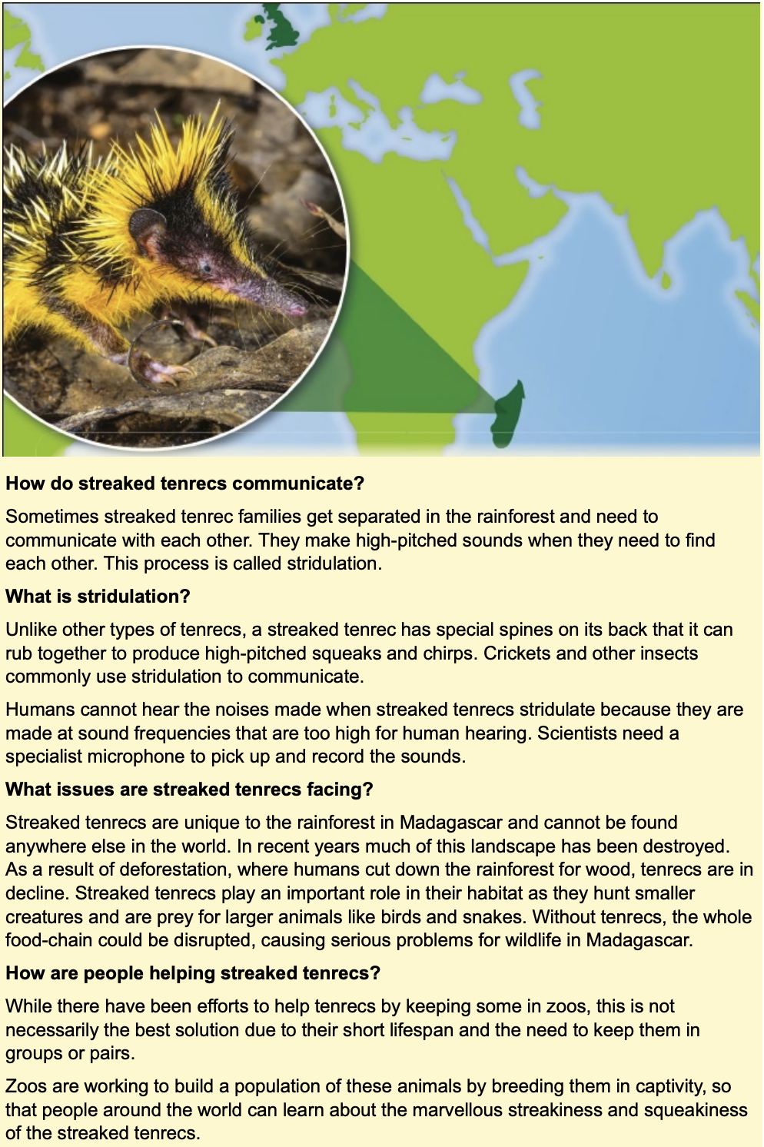
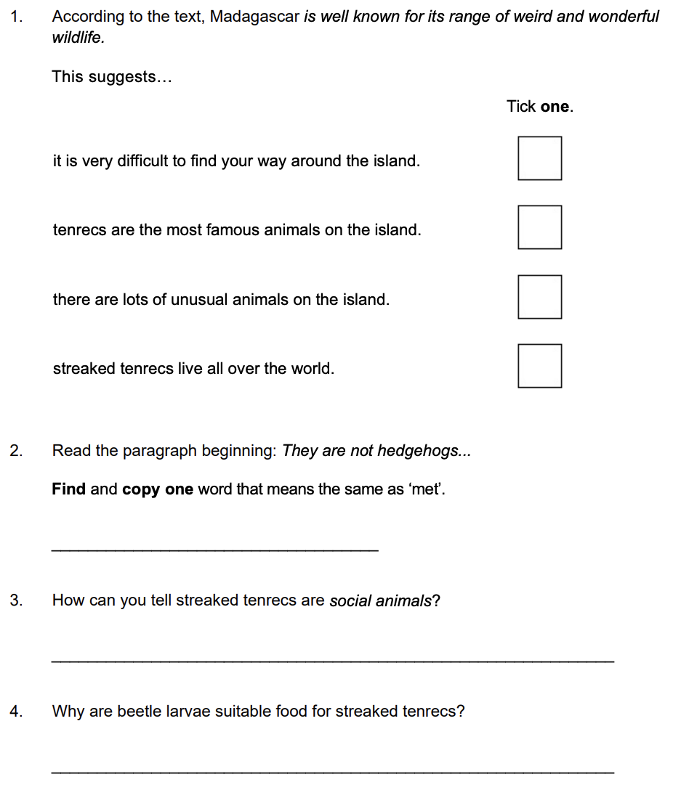

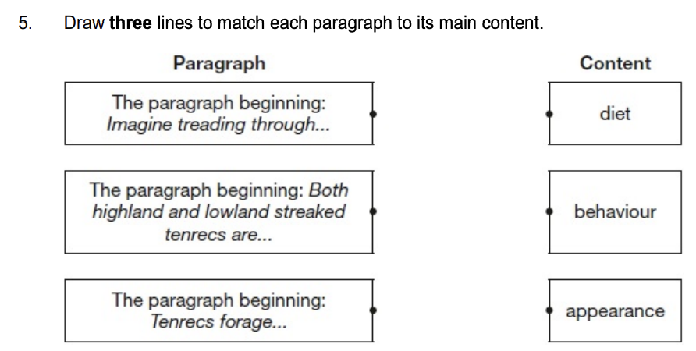

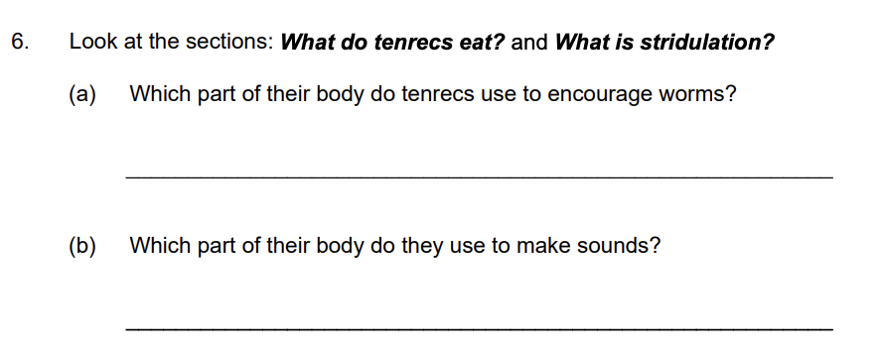
Challenge

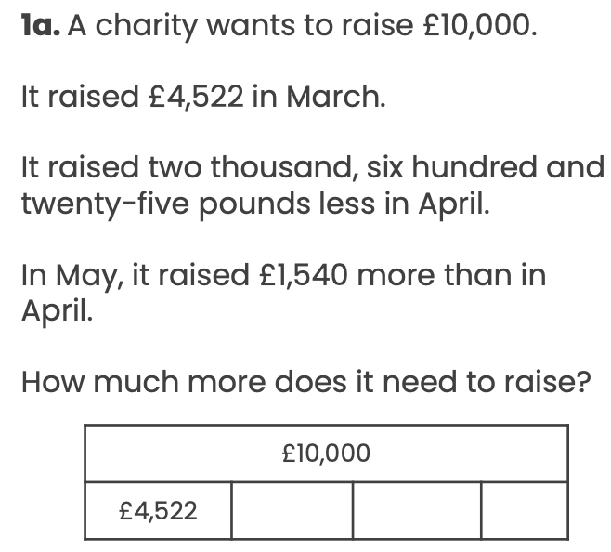

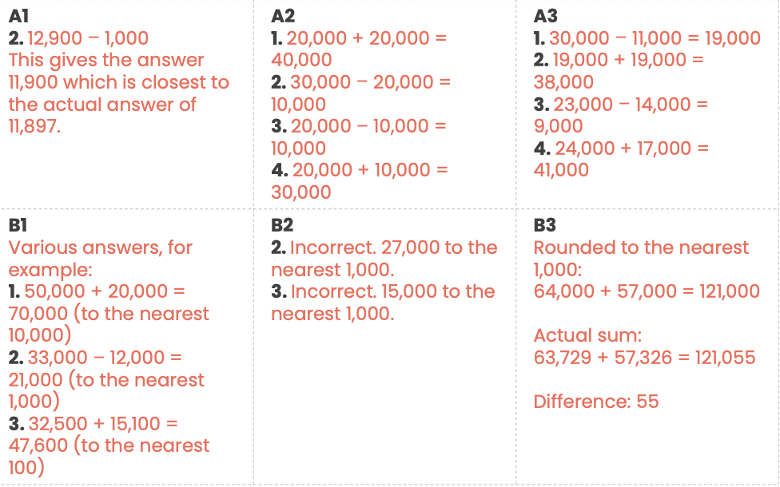
Answers – year 5


