Name: ………………………………………………………..
Hedgehog Class Homework Autumn 2 week 1 – Y6
Homework due: Tuesday 11th November 2025
Next week we are learning:
Maths | Literacy | Science | RE
We are expanding our knowledge on Fractions | We will be writing out structured poems. | We will be further investigating electricity. | We will be exploring Incarnation.

Log on to timetables.com OR Hit the Button to practise your maths skills:
Purple Mash also have some lovely Maths and spellings activities

Or use other websites/ways that you enjoy .

Spellings:
Practise spellings ready for weekly spelling test- see below for your child’s spelling group – These groups are subject to change as they are based on their current spelling ages.

Reading:
Read every day for a minimum of 10 minutes. Please log this in Reading Records.

SPaG: Clauses

Maths: Fractions

Remember to look after yourself over the weekend and stay safe. If you are feeling overwhelmed, here are some great sites to help you feel a little better!

https://www.bbcchildreninneed.co.uk/schools/primary-school/mindfulness-hub/ ---------- https://www.gonoodle.com/ ----------- Smiling Mind (App)
Spellings:
Group A | Group B | Group C
answer  build  caught  phone  early  earth  enough  height  island  knowledge | answer  build  believe  average  communicate  height  desperate  leisure  shoulder  tough | determined  foreign  secretary  community  fallacy  conscious  twelfth  stomach  action  muscle
……………………………………………………………………………………………………………………………………………………………………………………………………………………………………………………………………………………………………………………………………………………………………………………………………………………………………………………………………………………………………………………………………………………………………………………………………………………………………………………………………………………………………………………………………………………………………………………………………………………………………………………………………………………………………………………………………………………………………………………………………………………………………………………………………………………………………………………………………………………………………………………………………………………………………………………………………………………………………………………………………………………………………………………………………………………………………………………………………………………………………………………………………………………………………………………………………………………………………………………………………………………………..……………………………………………………………………………………………………………………………..
Task 1: For this weeks homework, you will need to use a device to access this site: https://phet.colorado.edu/sims/html/fractions-intro/latest/fractions-intro_en.html
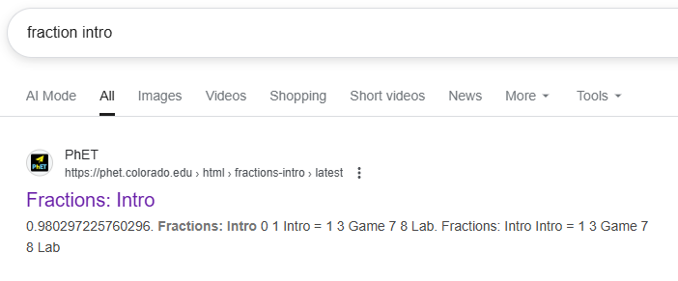
Or, you can search ‘Fractions: Intro PHeT’ and it should be the first result.

You can choose which level you complete, but please do at least 20 minutes of the programme.
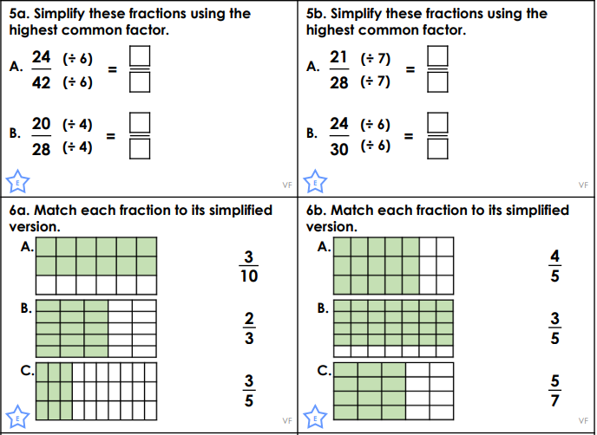
If you do not have access to a device – Finish task 2 and get an adult to write me a note
Task 2:

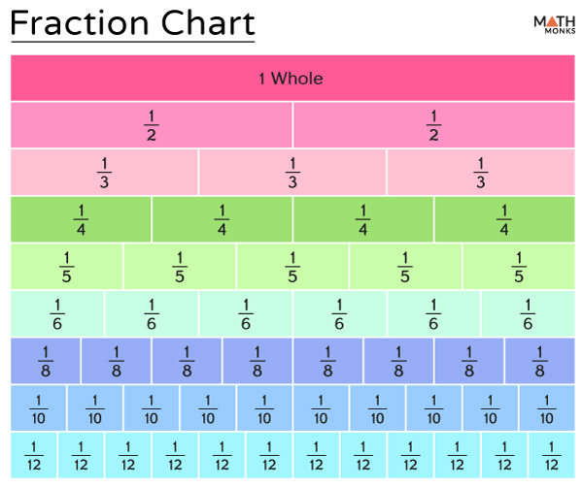
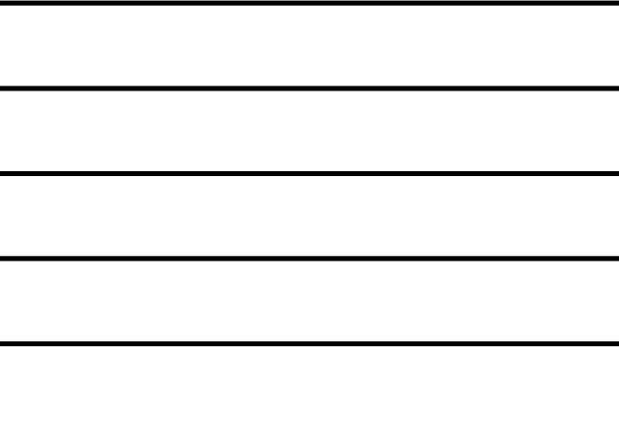
Helpful Resources:
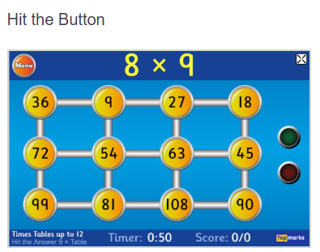

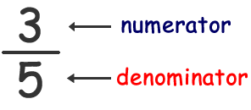

Remember – You can do this! If you are struggling, ask an adult or mark this on your work and we can go over it together in class.

