Name: ………………………………………………………..
Hedgehog Class Homework Autumn 2 week 2 – Y6
Homework due: Tuesday 18th November 2025
Next week we are learning:
Maths | Literacy | Science | RE
We are expanding our knowledge on Fractions | We will be writing out structured poems. | We will be further investigating electrical circuits. | We will be exploring The Advent Story.

Log on to timetables.com OR Hit the Button to practise your maths skills:
Purple Mash also have some lovely Maths and spellings activities

Or use other websites/ways that you enjoy .

Spellings:
Practise spellings ready for weekly spelling test- see below for your child’s spelling group – These groups are subject to change as they are based on their current spelling ages.

Reading:
Read every day for a minimum of 10 minutes. Please log this in Reading Records.

SPaG: Clauses

Maths: Fractions

Remember to look after yourself over the weekend and stay safe. If you are feeling overwhelmed, here are some great sites to help you feel a little better!

https://www.bbcchildreninneed.co.uk/schools/primary-school/mindfulness-hub/ ---------- https://www.gonoodle.com/ ----------- Smiling Mind (App)
Spellings:
Group A | Group B | Group C
caught  achieve  pressure  occasionally  women  heard  group  century  possess  bicycle | vehicle  achieve  frequently  especially  calendar  aggressive  group  community  correspond  reign | interrupt  frequently  omniscient  environment  community  desperate  communicate  excellence  especially  thoughtfully
…………………………………………………………………………………………………………………………………………………………………………………………………………………………………………………………………………………………………………………………………………………………………………………………………………………………………………………………………………………………………………………………………………………………………………………………………………………………………………………………………………………………………………………………………………………………………………………………………………………………………………………………………………………………………………………………………………………………………………………………………………………………………………………………………………………………………………………………………………………………………………………………………………………………………………………………………………………………………………………………………………………………………………………………………………………………………………………………………………………………………………………………
Task 1: For this weeks homework, you will need to use a device to access this site: https://phet.colorado.edu/sims/html/fractions-intro/latest/fractions-intro_en.html
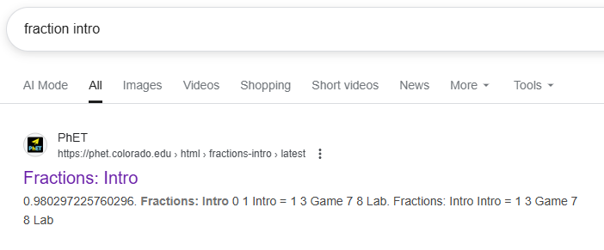
Or, you can search ‘Fractions: Intro PHeT’ and it should be the first result.

You can choose which level you complete, but please do at least 20 minutes of the programme.
If you do not have access to a device – Finish task 2 and get an adult to write me a note
Task 2: Label this fraction! What is the denominator? What is the numerator?
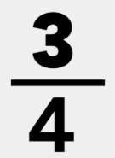

See next page!
Task 3: 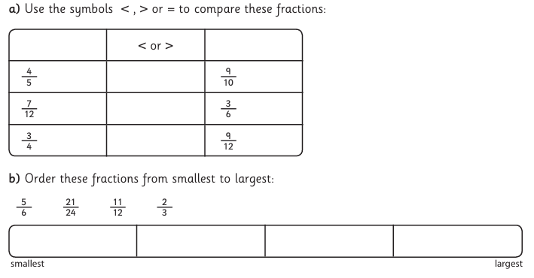
Task 4:
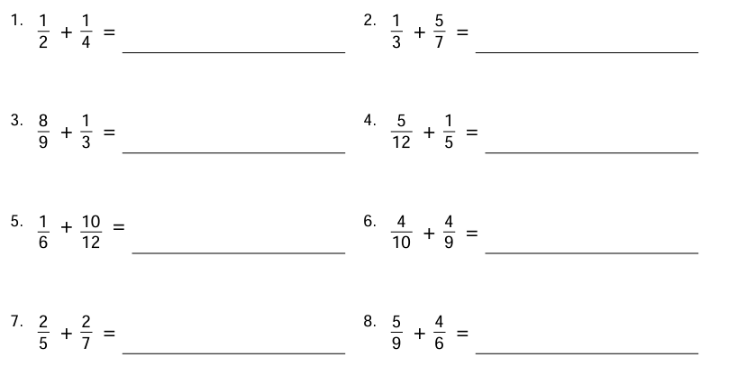

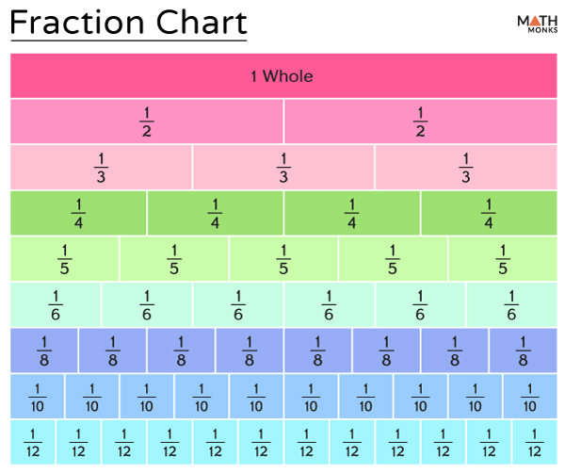
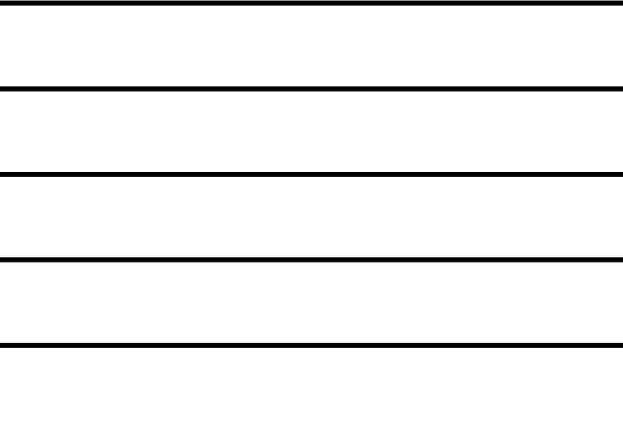
Helpful Resources:
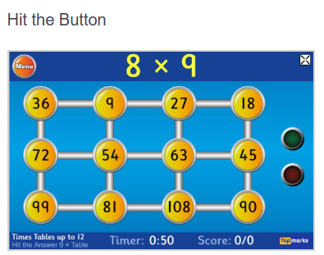

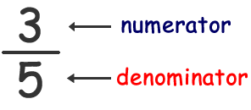

Remember – You can do this! If you are struggling, ask an adult or mark this on your work and we can go over it together in class.

