Eagle Class Homework Autumn 2 week 2 – Y5
Homework due: Tuesday 18th November 2025
Next week we are learning:
Maths | Literacy | Science | RE
We are focusing on problem solving questions within addition and subtraction. | We will be exploring literacy devices that help build suspense and tension in narratives. | We will explore reversible and irreversible reactions. | We will explore how mitzvot guide Jewish communities in making moral choices.

Helpful Websites:
Log on to NumBots or hit the button to practice arithmetic skills.
https://play.numbots.com/#/account/school-login-type
https://www.topmarks.co.uk/maths-games/hit-the-button
Purple Mash also have some lovely Maths and spellings activities.

Spellings:
Practise spellings ready for weekly spelling test- see below for your child’s spelling group – These groups are subject to change as they are based on their current spelling ages.

Reading:
Read every day for 30 minutes. Please log this in Reading Records.

Maths: Inverse operations as a checking strategy

Challenges are optional – although please have a go if you can

Spellings:
This week’s spellings are focused on words linked to suspense and tension narratives,
Words marked with an asterisk (*) are common exception words or statutory spellings highlighted in the national curriculum.

Group 1 | Group 2 | Group 3
sword  giant  raven  echo  shadow | disappear*  guard*  guide*  strange*  suddenly  wreck  altar  bleak  creature  clutch | ancient*  determined*  desperate*  solemn*  consequence*  conscience*  recognise*  examine*  although*  meanwhile*

Challenge: Can you write two sentences that include one of your spelling words?

Strategies to check answers (inverse operation)
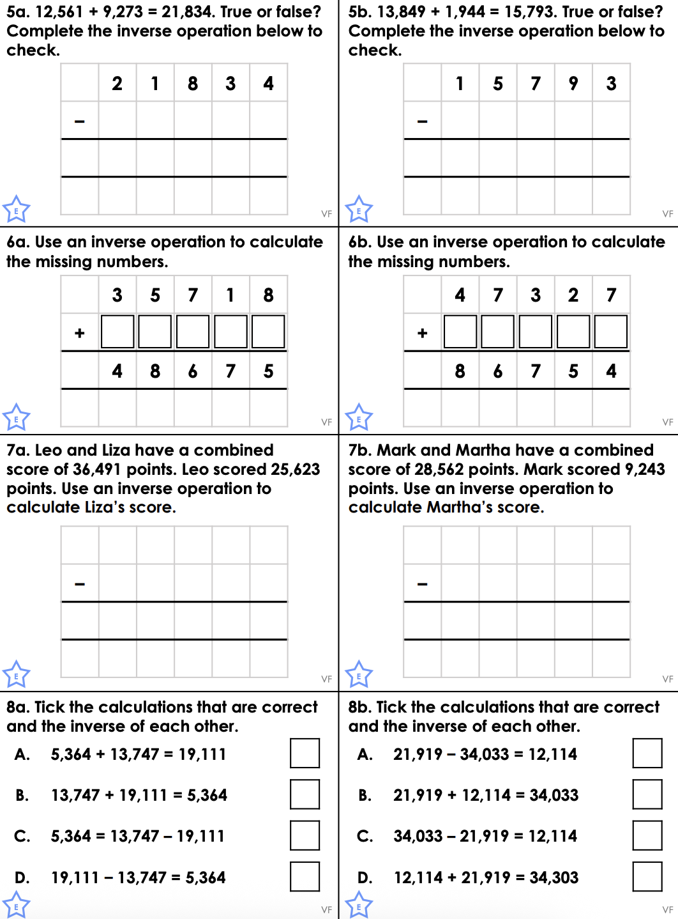
Reading Comprehension (Identifying examples)
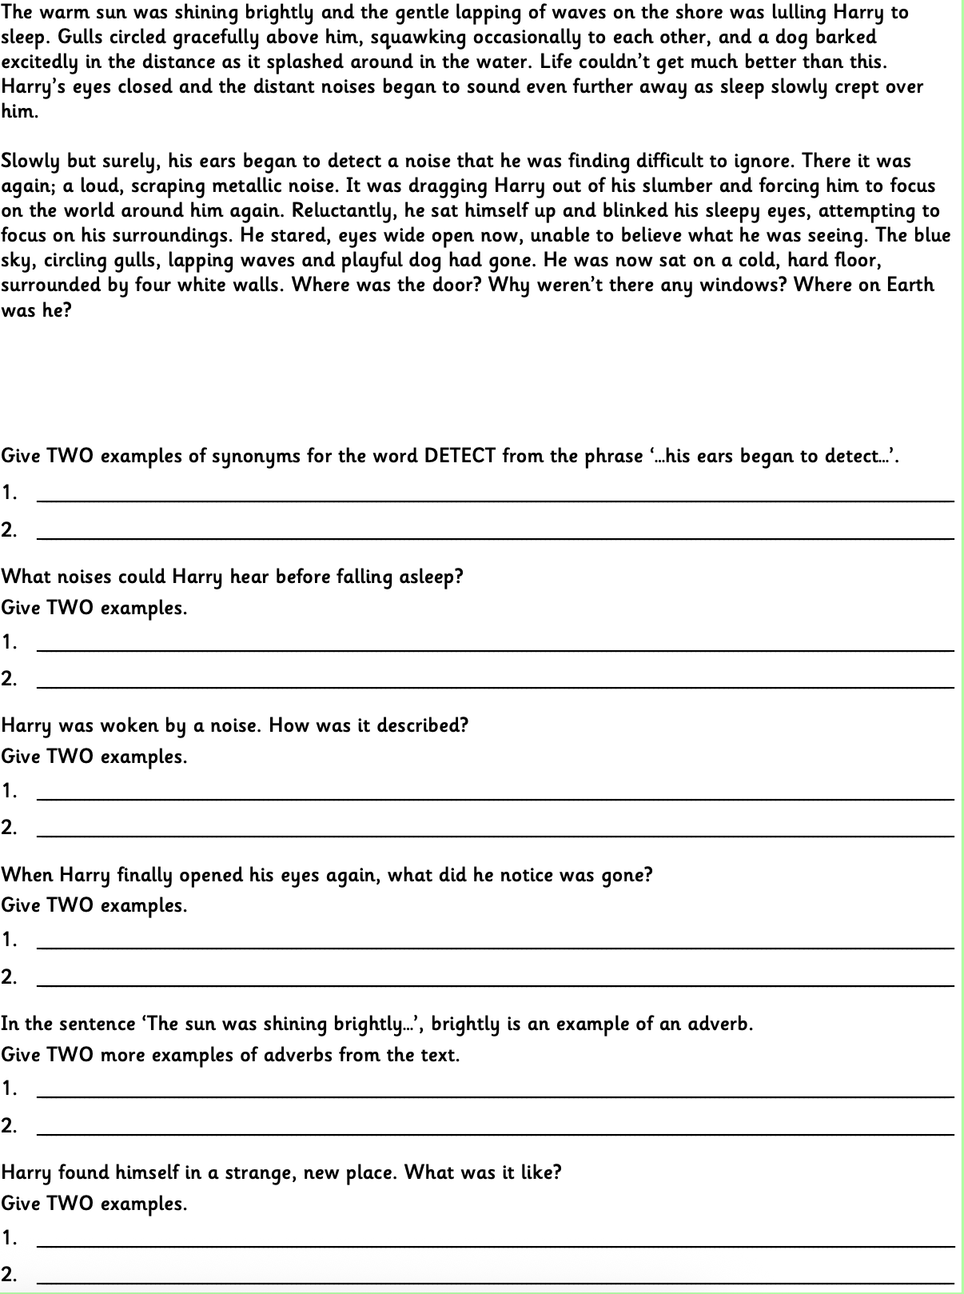
Challenge


