Eagle Class Homework Autumn 2 week 3 – Y4
Homework due: Tuesday 25th November 2025

Next week we are learning:
Maths | Literacy | Science | RE
We are focusing on problem solving questions within addition and subtraction. | We will be exploring literacy devices that help build suspense and tension in narratives. | We will explore reversible and irreversible reactions. | We will explore how mitzvot guide Jewish communities in making moral choices.

Helpful Websites:
Log on to NumBots or hit the button to practice arithmetic skills.
https://play.numbots.com/#/account/school-login-type
https://www.topmarks.co.uk/maths-games/hit-the-button
Purple Mash also have some lovely Maths and spellings activities.

Spellings:
Practise spellings ready for weekly spelling test- see below for your child’s spelling group – These groups are subject to change as they are based on their current spelling ages.

Reading:
Read every day for 30 minutes. Please log this in Reading Records.

Maths: multi-step problems

Challenges are optional – although please have a go if you can

Spellings:
This week’s spellings are focused on words linked to suspense and tension narratives,
Words marked with an asterisk (*) are common exception words or statutory spellings highlighted in the national curriculum.

Group 1  Words with/ur/ sound spelt with ear | Group 2  Words with a /shuhn/ sound, spelt with ‘ssion’ | Group 3  Words with ’silent’ letters
earth*  early*  learn*  heard*  search  rehearse | expression  discussion  confession  permission  admission  transmission  possession*  profession  depression  impression | wrestle  wrapper  island  aisle  debris  mortgage  castle  yacht*  guarantee*  guilty

Challenge: Can you write two sentences that include one of your spelling words?

Multi-step Problems

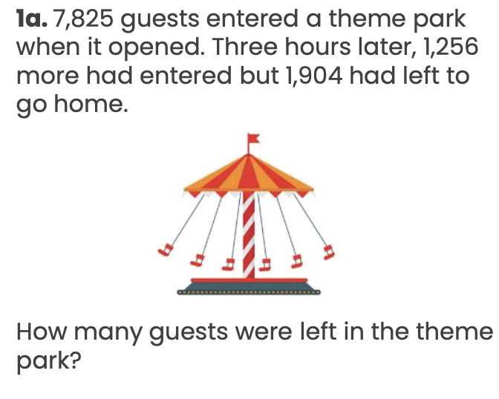

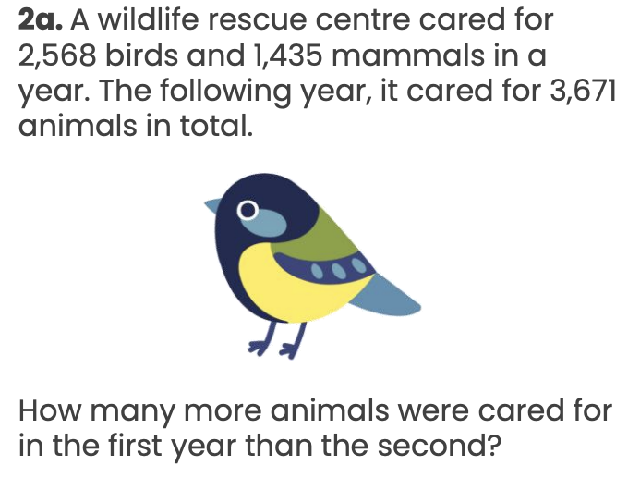

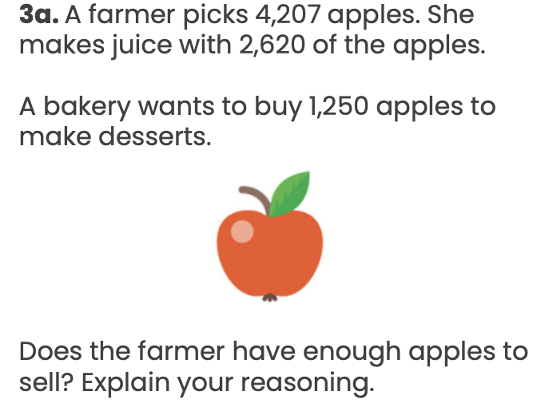

Reading Comprehension (find and copy)
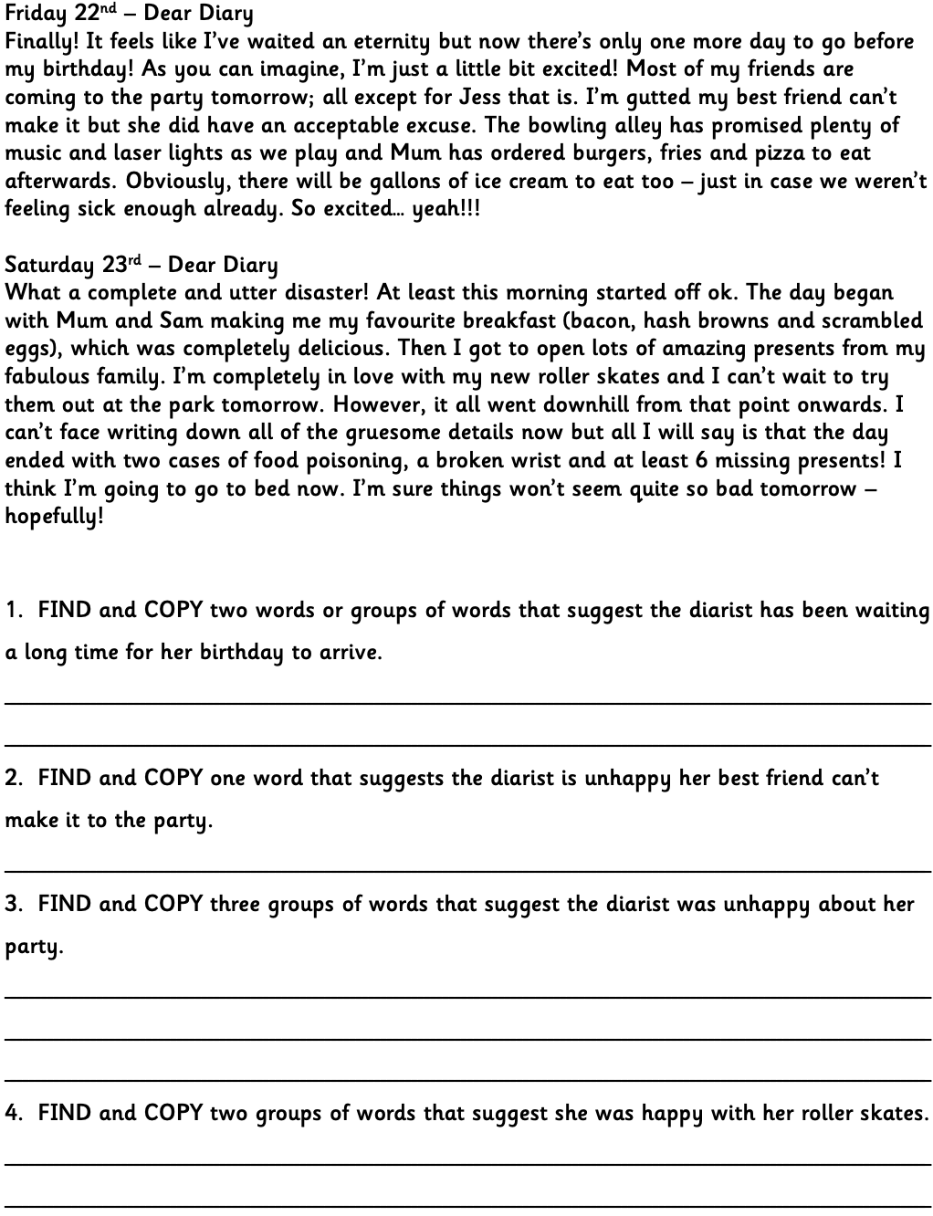

Challenge



