Eagle Class Homework Autumn 2 week 4 – Y4
Homework due: Tuesday 2nd December 2025
Next week we are learning:
Maths | Literacy | Science | RE
We are starting our multiplication and division unit. | We will be exploring conjunctions. | We will explore reversible and irreversible reactions. | We will explore how mitzvot guide Jewish communities in making moral choices.

Helpful Websites:
Log on to NumBots or hit the button to practice arithmetic skills.
https://play.numbots.com/#/account/school-login-type
https://www.topmarks.co.uk/maths-games/hit-the-button
Purple Mash also have some lovely Maths and spellings activities.

Spellings:
Practise spellings ready for weekly spelling test- see below for your child’s spelling group – These groups are subject to change as they are based on their current spelling ages.

Reading:
Read every day for 30 minutes. Please log this in Reading Records.

Maths: Efficient calculations

Challenges are optional – although please have a go if you can

Spellings:
This week’s spellings are focused on words linked to suspense and tension narratives,
Words marked with an asterisk (*) are common exception words or statutory spellings highlighted in the national curriculum.

Group 1  Words where ‘kn’ and ‘gn’ make a /n/ sound at the beginning of words | Group 2  Words ending in ‘-ture’ | Group 3  Words ending in  ‘-cious’
knock*  know*  knee*  gnome  gnat  gnaw | furniture  picture*  nature*  adventure*  capture  future  sculpture  fracture  mixture  temperature* | delicious  atrocious  conscious  ferocious  gracious  luscious  malicious  precious  spacious  suspicious

Challenge: Can you write two sentences that include one of your spelling words?

Efficient Calculations

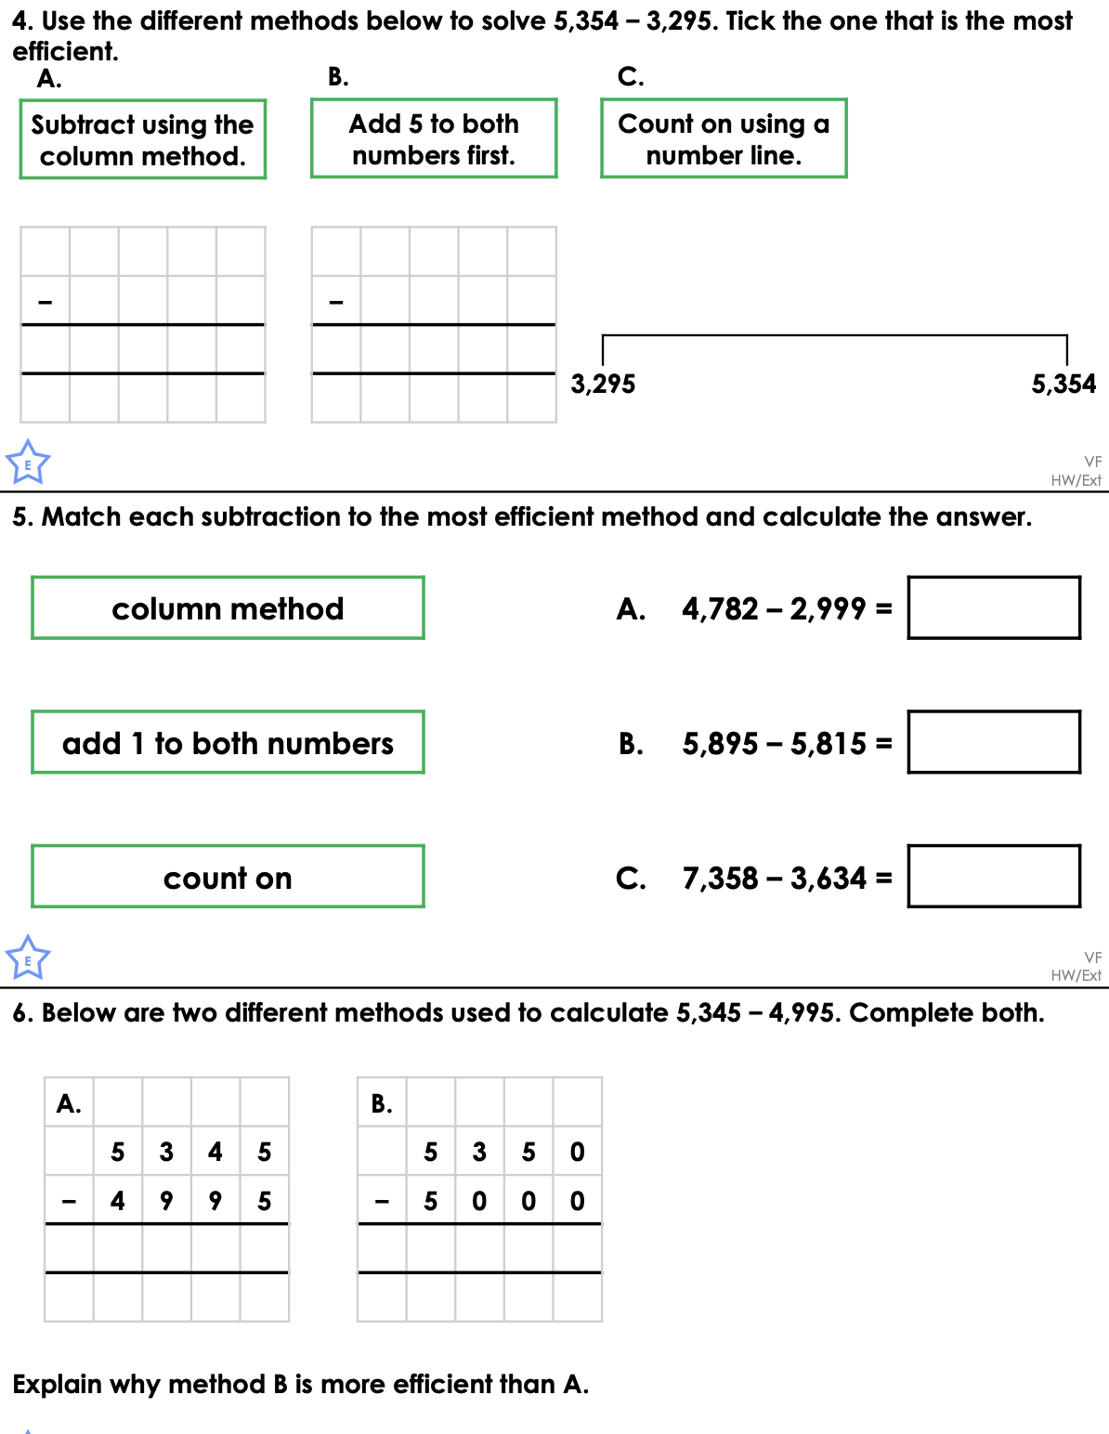
Reading Comprehension (finding evidence)
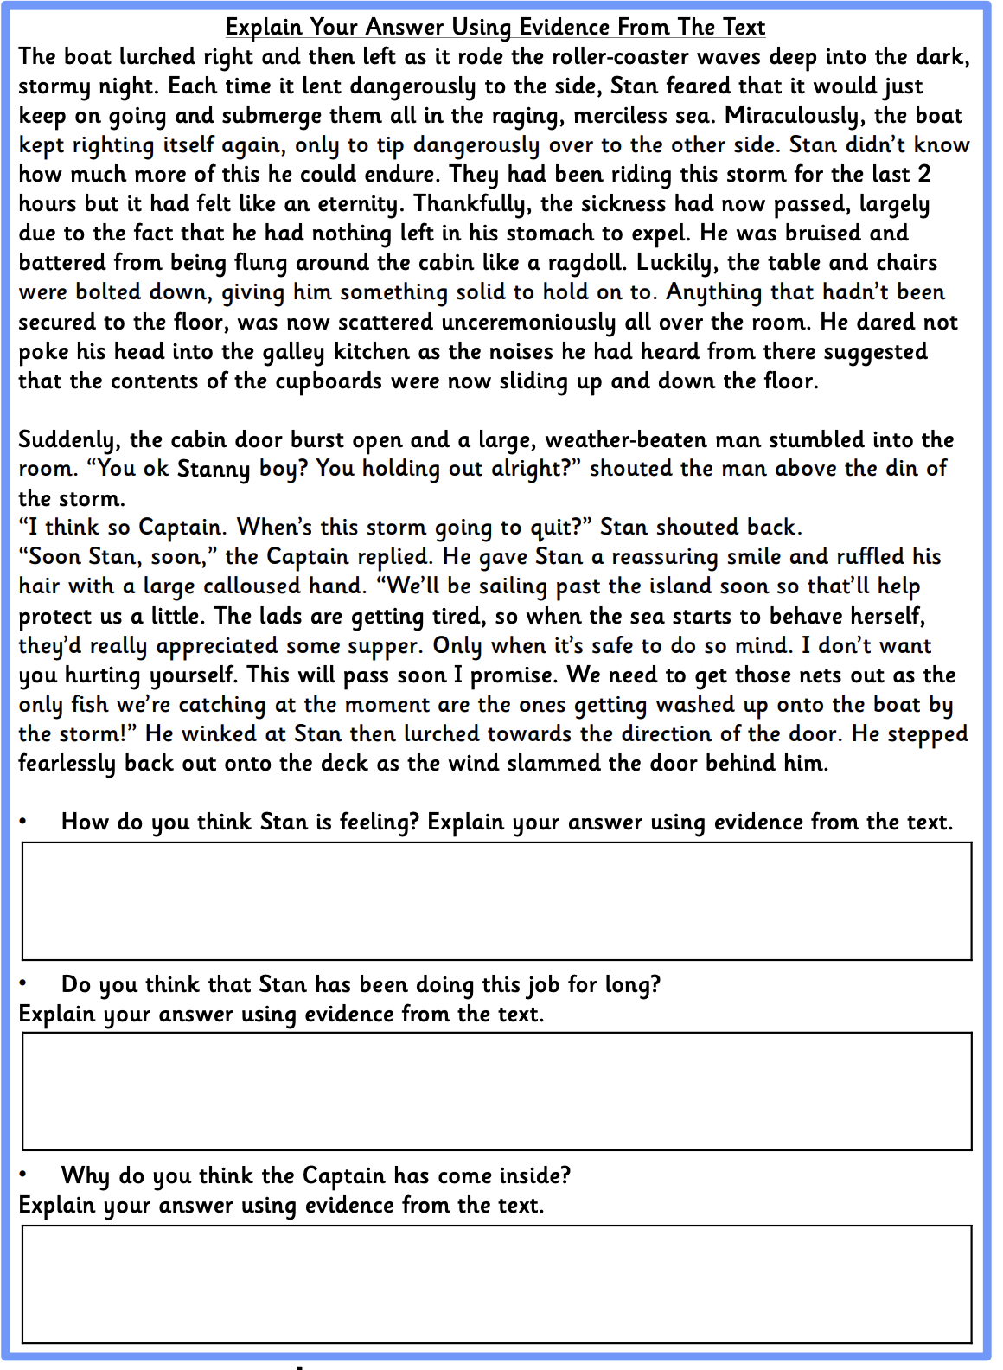
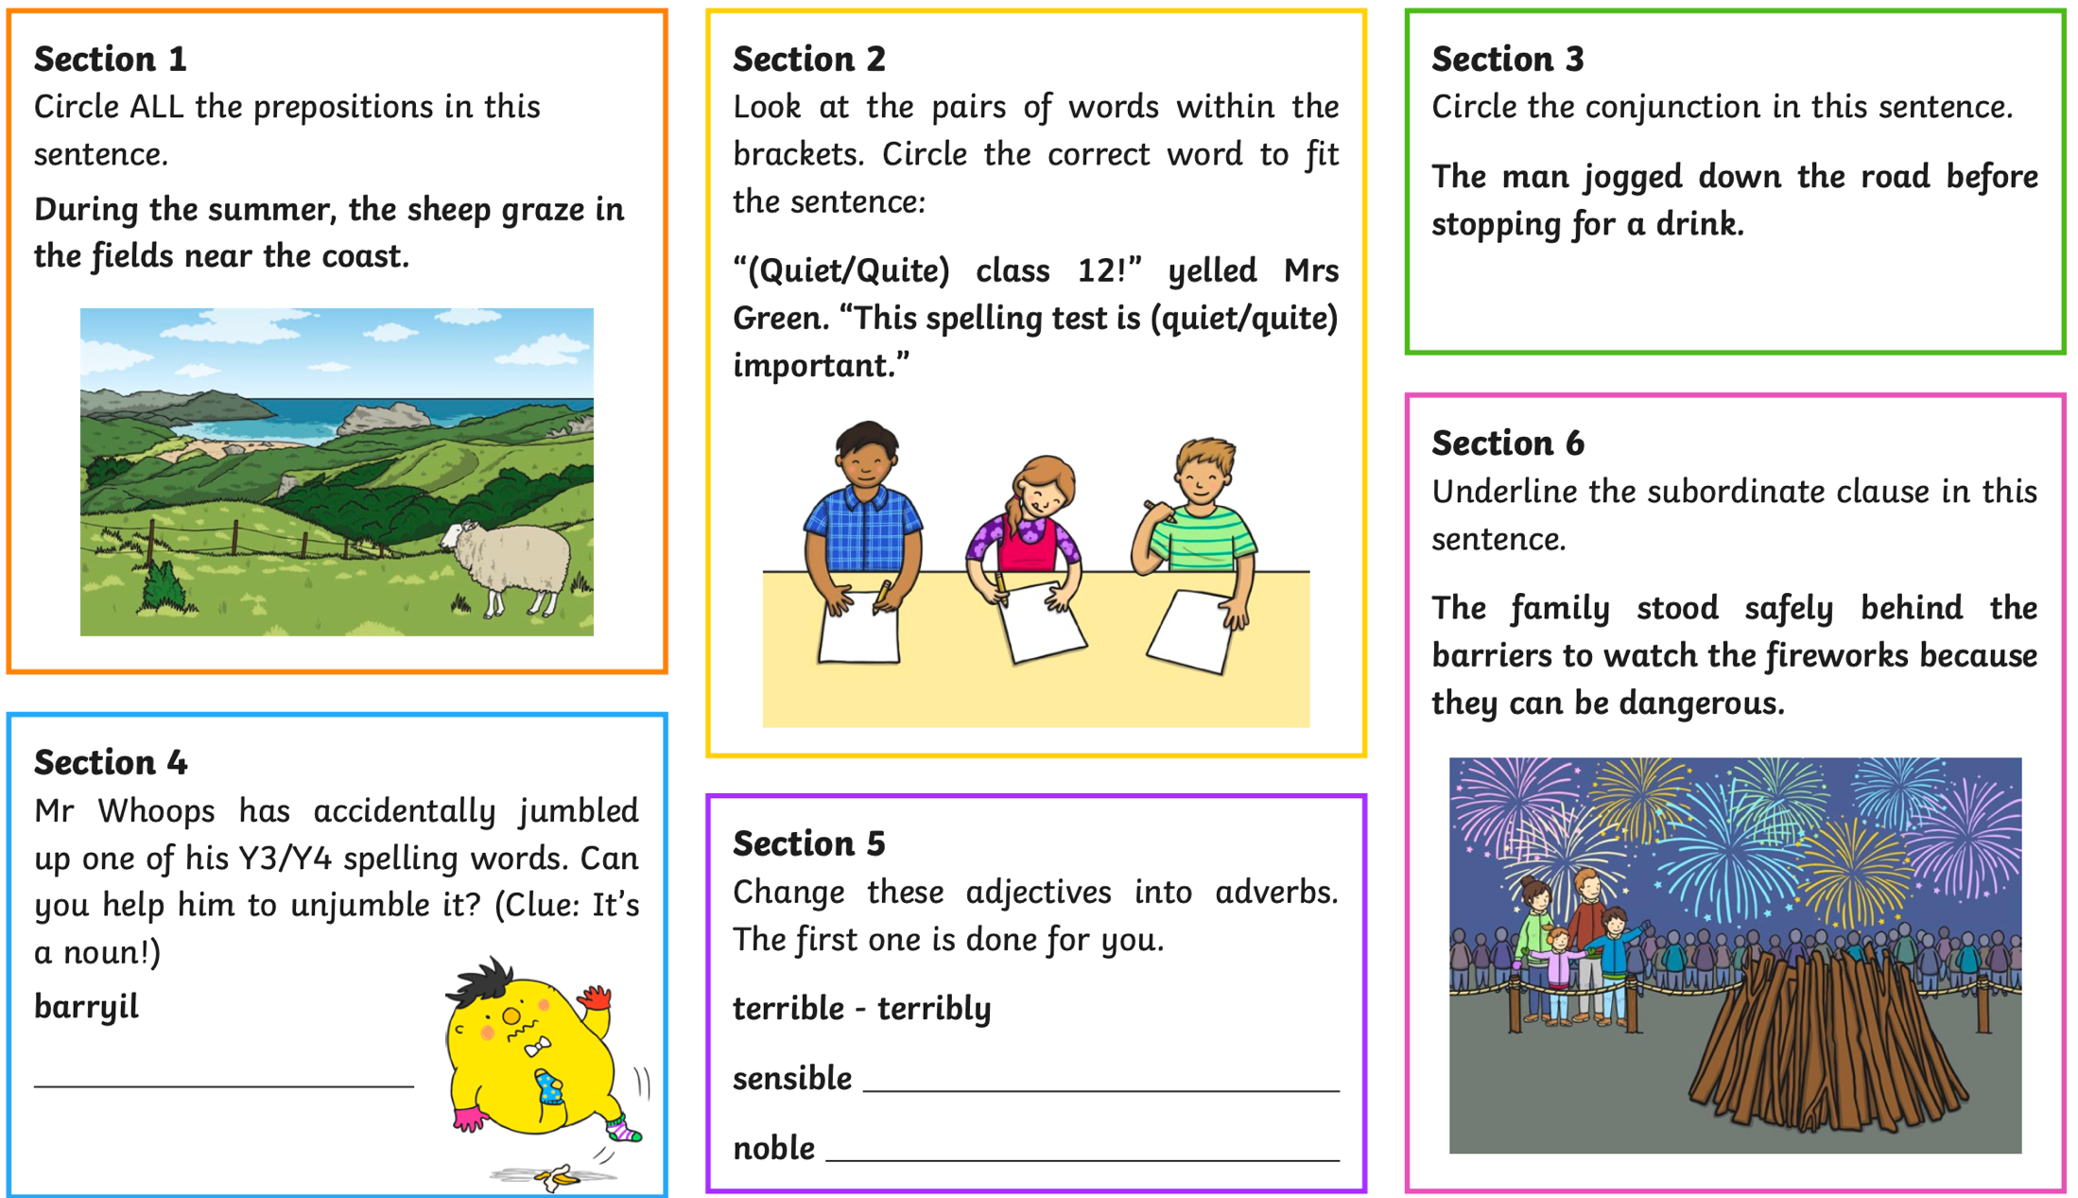
Challenge


