Rabbit Class Homework Autumn 2 week 1
Homework due: Tuesday 11th of November 2025
Next week we are learning:
Maths | Literacy | Science | RE
We will be continuing our work on adding and subtracting numbers. This week looking at the written formal methods as well as mental strategies. | We will be continuing our work on ‘Katie in London’ and creating an alternate ending for the story. | We will be starting our unit of work based around light and electricity. | We will be exploring the importance of Christmas for Christians.

Log on to timestable.com to practise your maths skills:
Purple Mash also have some lovely Maths and spellings activities

Or use other websites/ways that you enjoy 😊.

Spellings:
Practise spellings ready for weekly spelling tests- see below for your child’s spelling group – These groups are subject to change as they are based on their current spelling ages. Spelling tests will be every Friday.

Reading:
Read every day for 20 minutes. Please log this in Reading Records.

SPaG: SPaG mat

Maths: Adding and Subtracting 1s and 10s

Spellings:
Group 1 | Group 2
table  apple  bottle  little  middle  able  wobble  multiple  dazzle  riddle | rain  wait  train  paid  afraid  oil  join  coin  point  soil

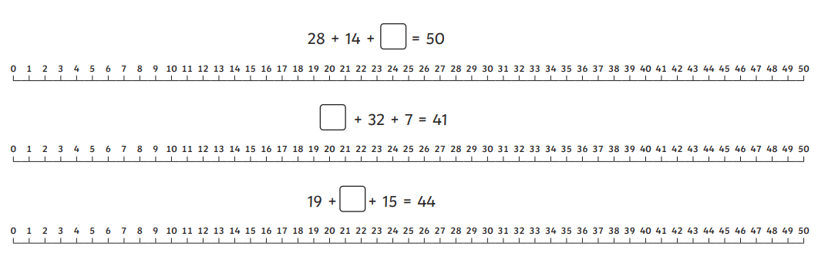
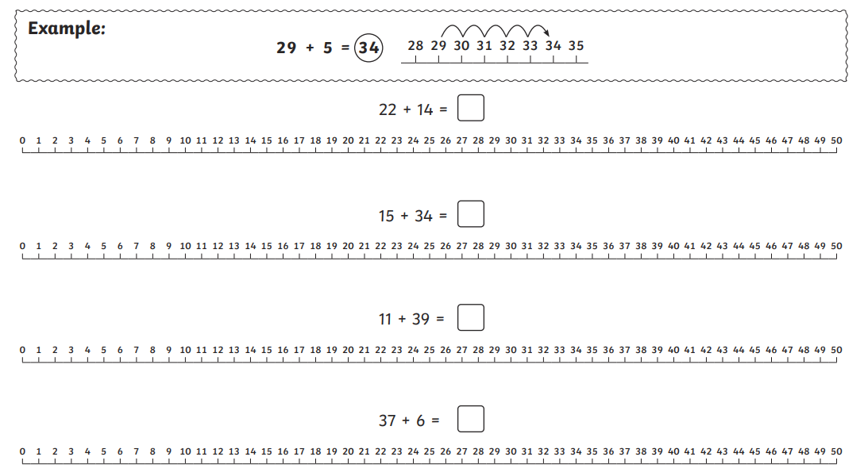

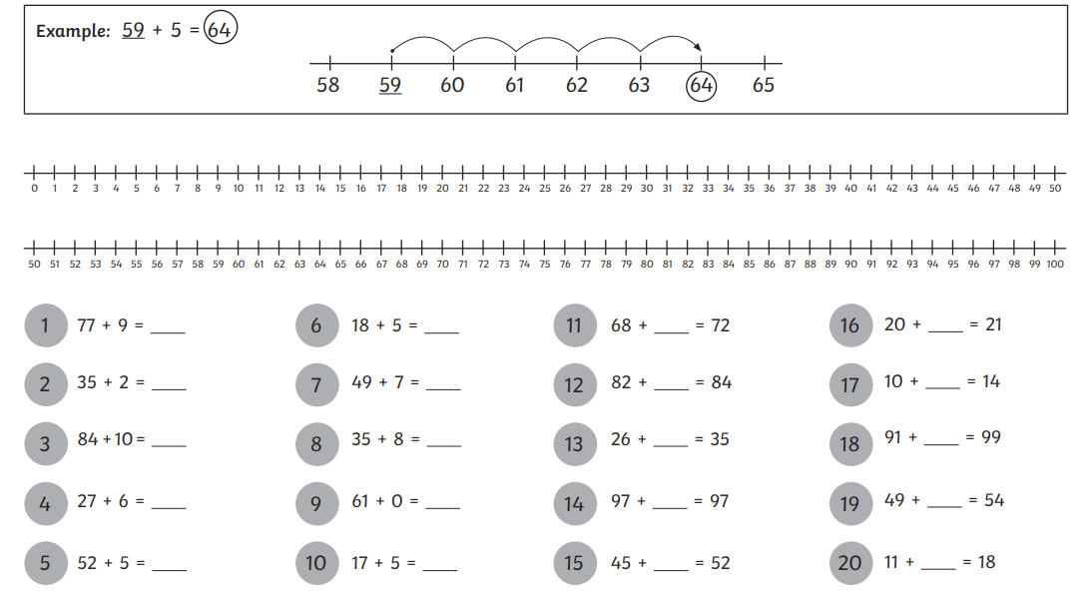
Optional Challenge



