Rabbit Class Homework Autumn 2 week 3
Homework due: Tuesday 2nd of December 2025
Next week we are learning:
Maths | Literacy | Science | RE
We will be continuing to work on our multiplication unit. Focusing on 3 and 4 times tables. | We will be continuing work on our story ‘What happened to you?’ focusing on using speech marks and question marks. | We will be continuing our unit of work based around light. We will be completing an experiment on reflective materials. | We will be learning about the good samaritan and how Christians show compassion.

Log on to timestable.com to practise your maths skills:
Purple Mash also have some lovely Maths and spellings activities

Or use other websites/ways that you enjoy 😊.

Spellings:
Practise spellings ready for weekly spelling tests- see below for your child’s spelling group – These groups are subject to change as they are based on their current spelling ages. Spelling tests will be every Friday.

Reading:
Read every day for 20 minutes. Please log this in Reading Records.

SPaG: SPaG mat

Maths: Adding and Subtracting 1s and 10s

Spellings:
Group 1 | Group 2
pencil  fossil  nostril  pupil  metal  pedal  capital hospital animal  oval | goal  coach  own  snow  grow  toe  goes  go  no  so

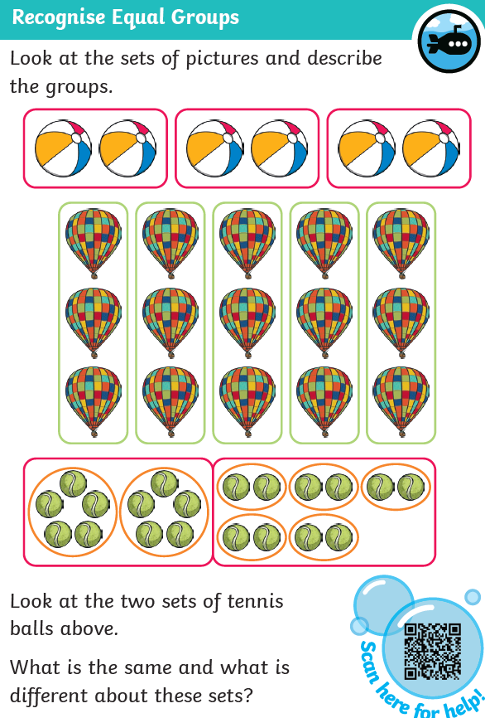
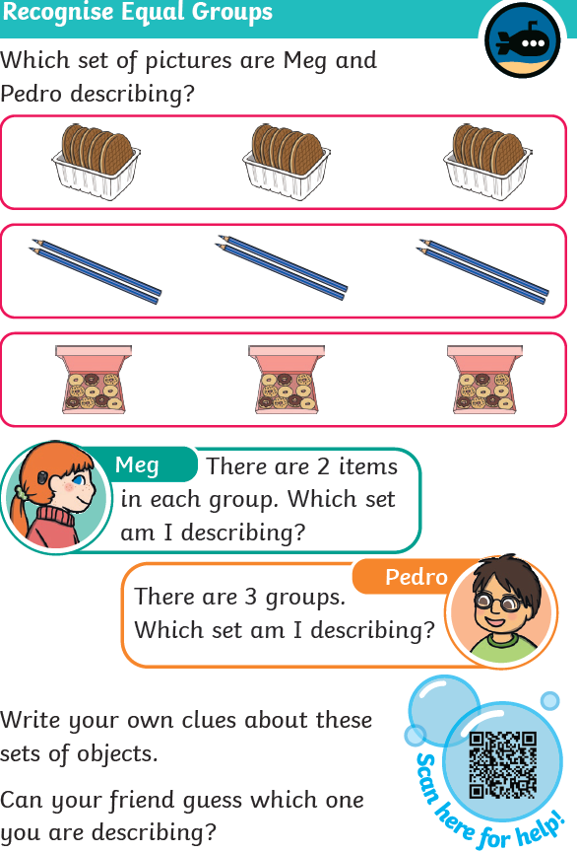

Challenge - Optional


