Rabbit Class Homework Autumn 2 week 3 –
Homework due: Tuesday 2nd December 2025
Next week we are learning:
Maths | Literacy | Science | RE
We will be continuing to work on our multiplication unit. Focusing on 3 and 4 times tables. | We will be continuing work on our story ‘What happened to you?’ focusing on using speech marks and question marks | We will be continuing our unit of work based around light. We will be completing an experiment on reflective materials. | We will be learning about the good Samaritan and how Christians show compassion.

Log on to timestable.com to practise your maths skills:
Purple Mash also have some lovely Maths and spellings activities
Timestable.co.uk
Or use other websites/ways that you enjoy .

Spellings:
Practise spellings ready for weekly spelling test- see below for your child’s spelling group – These groups are subject to change as they are based on their current spelling ages.

Reading:
Read every day for 20 minutes. Please log this in Reading Records.

SPaG: SPaG mat

Maths: arithmetic - please do these as quick as you can - an area that some struggled with was the time frame of an arithmetic test. 25 minutes!

Challenges are optional – although please have a go if you can

Spellings:
Group 2
recap
difficult
famous
extreme
guide
heart
history
popular
minute
natural
believe
…………………………………………………………………………………………………………………………………………………………………………………………………………………………………………………………………………………………………………………………………………………………………………………………………………………………………………………………………………………………………………………………………………………………………………………………………………………………………………………………………………………………………………………………………………………………………………………………………………………………………………………………………………………………………………………………………………………………………………………………………………………………………………………………………………………………………………………………………………………………………………………………………………………………………………………………………………………………………………………………………………………………………………

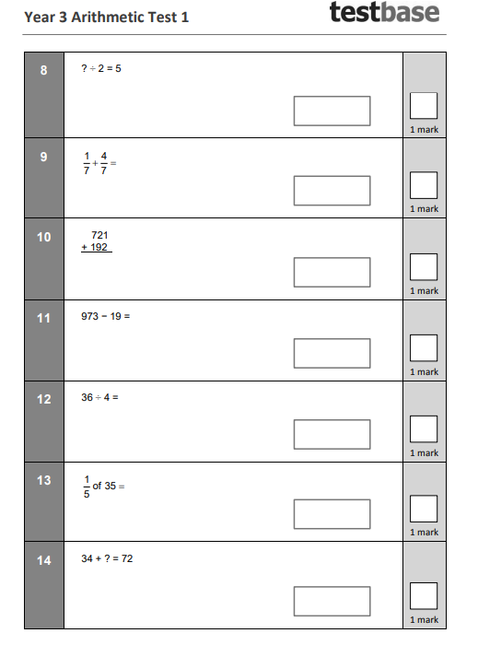
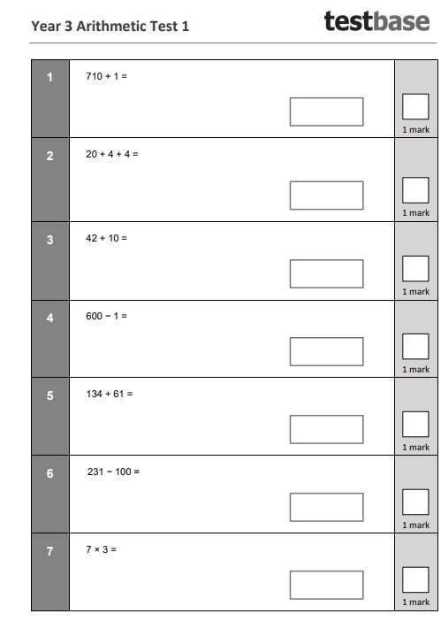
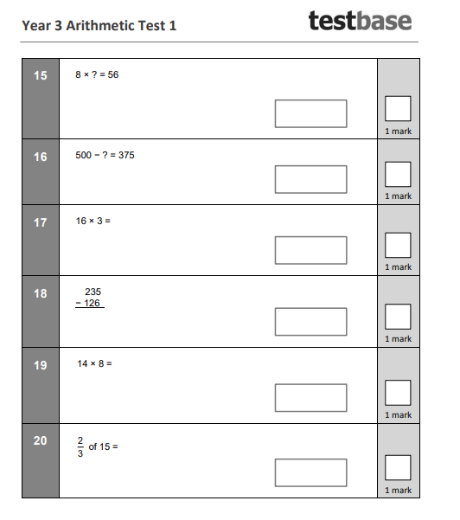
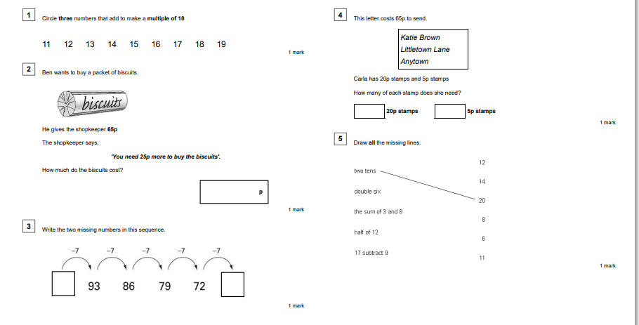
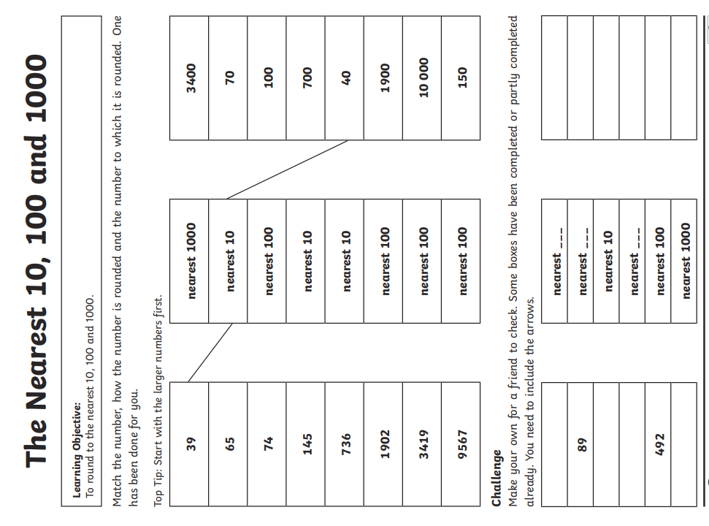
Challenge – optional please have a go if you can





