Tiger - Reception Class Homework
Weekly homework
Week 5– 4th December 2025
Dear parents,
It is great to listen to the children talk about their sentence writing at home and how they are getting on with their individual phonics daily practice. Please continue to encourage your child to this every day, it really does make a difference.
The children are doing really well with our Nativity rehearsals. Thank you to those of you who have already sent in your child’s costume. Just a gentle reminder that these need to be in by Monday 8th December. Thank you for your support with this.

Phonics
Please continue to do daily work on your child’s their individual phonics assessment. As mentioned before, this will really help with their recognition skills, fluency and confidence.
Extension task: please encourage your child to practise writing each sound using the Little Wandle format to ensure accurate formation.

Maths

In class the children have been learning all about the 2D shapes circles and triangles. For their homework this week I would like the children to complete their circles and triangles Christmas bauble challenge. Once they have identified and coloured each shape, I would like them to complete the ‘properties’ of each shape statements.
EXTENSION TASK: Ask your child to be a circle and triangle detective. Can they spot these shapes in their home or local environment? Make a list of the item they spot and what shape it is e.g. clock – circle, cheese – triangle etc.

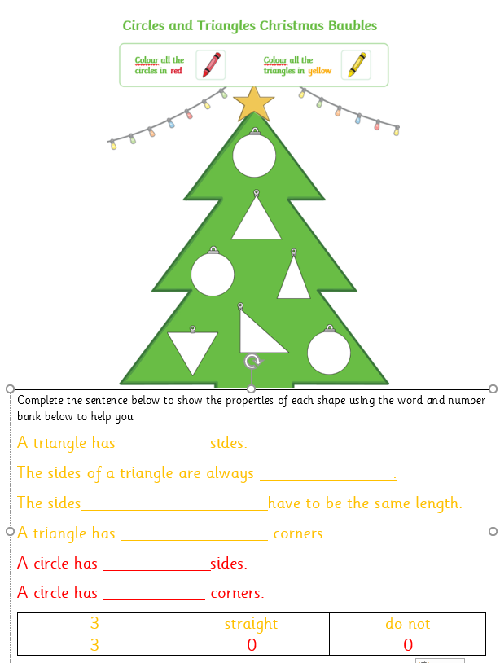

Reading – Little Wandle

This week your child will be bringing home their next Little Wandle book. This book will have words that are made up of the phonemes that your child has been learning in class. Please encourage your child to sound out each word and then blend them back together. If your child is finding it tricky to blend the sounds together, please just say the word and then ask them to repeat it back to you, whilst looking at the graphemes on the page. Please makes sure you record the reading you have done in with your child’s reading record. This really does help us to be able to share your child’s ideas and progress with them. As mentioned before, you don’t have to write lots, just a comment about any questions you may have asked and how your child responded or predictions that your child made about the book. Please do also comment on your child’s sharing book too.

Please remember to return all books on Monday so they can be used during group teaching reading sessions. Many thanks for your support with this.

Well done everyone!

As always, if you have any questions about your child’s learning, please do not hesitate to contact me via the school office.
Many thanks,
Mrs Allan

Next week in class we will be learning
Next week in class will be
Reading – decoding, prosody and comprehension
Phonics – recap all sounds and tricky words to date. Introduce new phonemes.
Writing – diary writing/ cross curricular topic writing
Maths – Shape – properties of a four-sided shape
Understanding the World R.E. –
The Christmas Story – Oh come let us Adore him – the story of the birth of Jesus
Nativity Rehearsal
Art – Baby Jesus in the Manager – colour mixing and application using different tools
Physical Development – Outdoor PE Games - I can develop underarm throwing towards a target.
Indoor PE – Fitness - I can develop my understanding of how exercise can make you feel.

