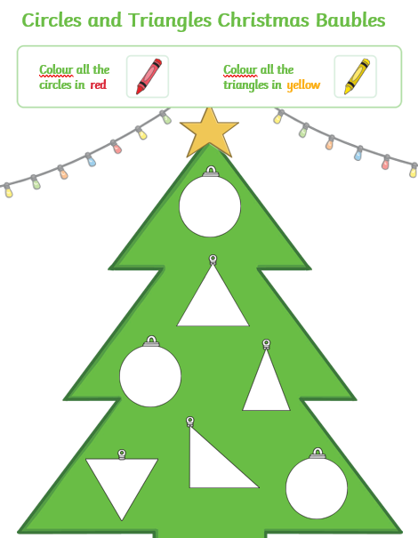

Complete the sentence below to show the properties of each shape using the word and number bank below to help you
A triangle has sides.
The sides of a triangle are always .
The sides have to be the same length.
A triangle has corners.
A circle has sides.
A circle has corners.
3 | straight | do not
3 | 0 | 0

