Eagle Class Homework Autumn 2 week 5 – Y5
Homework due: Tuesday 9th December 2025
Next week we are learning:
Maths | Literacy | Science | RE
We will be looking at multiples and common multiples. | We will be writing our Viking narrative pieces focusing on tension. | We will explore reversible and irreversible reactions. | We will be exploring different ways different ways Purim is celebrated and the symbolism of some traditions.

Helpful Websites:
Log on to NumBots or hit the button to practice arithmetic skills.
https://play.numbots.com/#/account/school-login-type
https://www.topmarks.co.uk/maths-games/hit-the-button
Purple Mash also have some lovely Maths and spellings activities.

Spellings:
Practise spellings ready for weekly spelling test- see below for your child’s spelling group – These groups are subject to change as they are based on their current spelling ages.

Reading:
Read every day for 30 minutes. Please log this in Reading Records.

Maths: subtracting fractions

Challenges are optional – although please have a go if you can

Spellings:
This week’s spellings are focused on words linked to suspense and tension narratives,
Words marked with an asterisk (*) are common exception words or statutory spellings highlighted in the national curriculum.

Group 1  contractions | Group 2  Words ending in ‘-ation’ | Group 3  Words containing the letter string ‘ough’
can’t  didn’t  couldn’t  hasn’t  it’s | Information*  adoration  sensation*  preparation*  admiration*  foundation  qualification  experimentation  exploration*  examination | bought*  thought*  nought  brought*  fought*  sought  drought*  plough  trough  wrought

Challenge: Can you write two sentences that include one of your spelling words?

Subtracting fractions

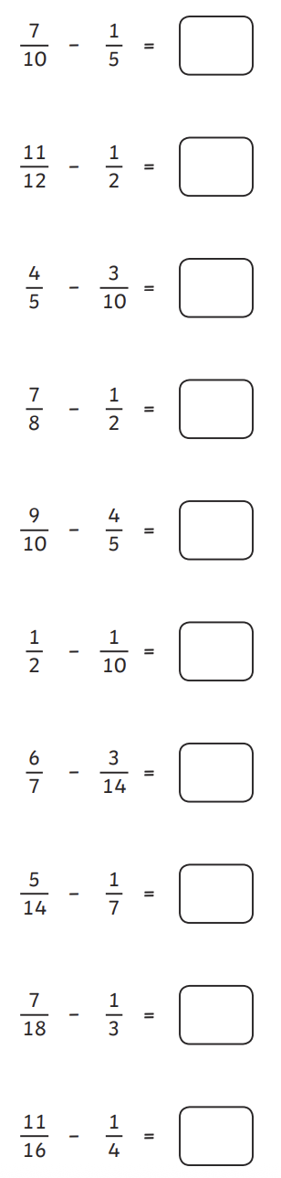

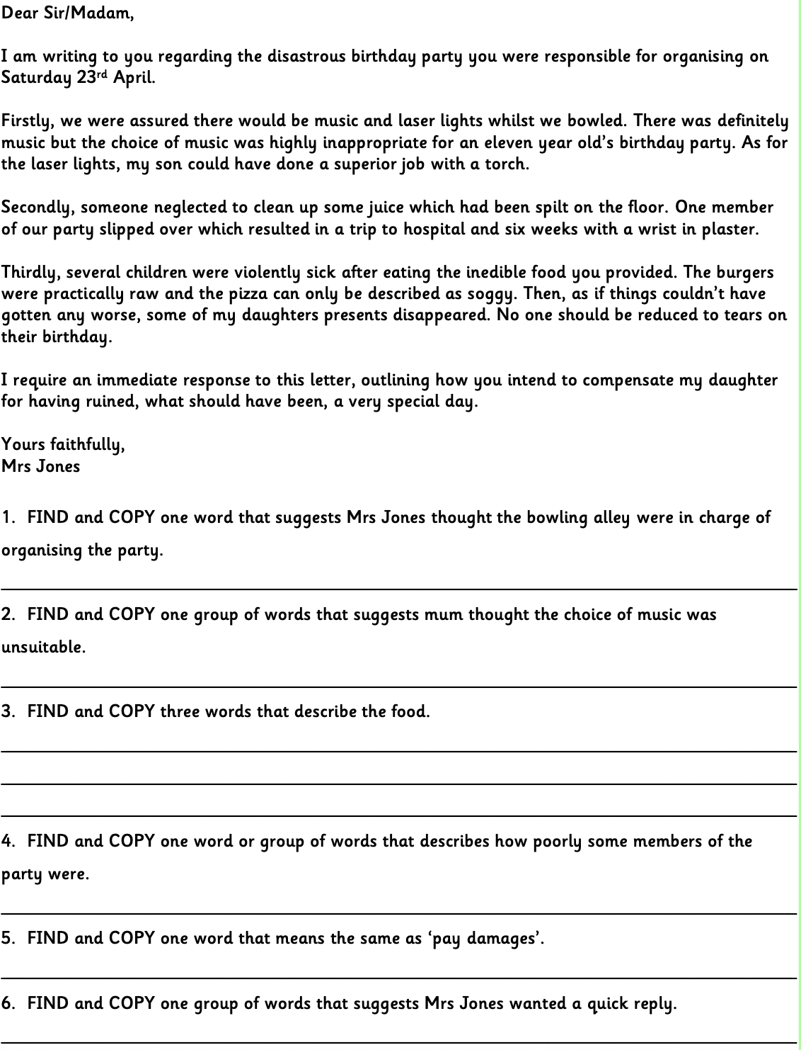
Reading Comprehension (find and copy skill)

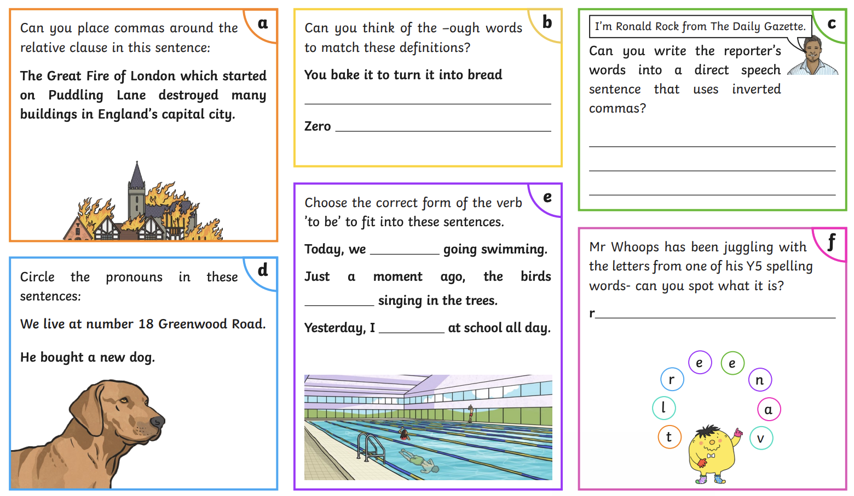

Challenge



