Axolotl Class Homework Autumn 2 week 4 – Y3
Homework due: Tuesday 2nd December 2025
Next week we are learning:
Maths | Literacy | Science | RE
We will be starting our unit on multiplication and division after unpicking our results of our arithmetic and reasoning paper to see common errors and misconnections | We will be will finishing our unit on a persuasive text/poster linked to the Anglo Saxons. Then working on SPaG elements | We will be continuing our unit of work based around working scientifically refining our skills. | We will be continuing our unit of our work in Gospel and Incarnation.

Log on to timestable.com to practise your maths skills:
Purple Mash also have some lovely Maths and spellings activities
Timestable.co.uk
Or use other websites/ways that you enjoy .

Spellings:
Practise spellings ready for weekly spelling test- see below for your child’s spelling group – These groups are subject to change as they are based on their current spelling ages.

Reading:
Read every day for 20 minutes. Please log this in Reading Records.

SPaG: Year 3 SPaG mat

Maths: arithmetic - please do these as quick as you can - an area that some struggled with was the time frame of an arithmetic test. 25 minutes!

Challenges are optional – although please have a go if you can

Spellings:
Group 1  CEW | Group 2  recap | Group 3  Recap
was  with  where  were  to  too  two  she  he  we | difficult  famous  extreme  guide  heart  history  popular  minute  natural  believe | notice  ordinary  certain  suppose  breathe  increase  recent  quarter  group  island
……………………………………………………………………………………………………………………………………………………………………………………………………………………………………………………………………………………………………………………………………………………………………………………………………………………………………………………………………………………………………………………………………………………………………………………………………………………………………………………………………………………………………………………………………………………………………………………………………………………………………………………………………………………………………………………………………………………………………………………………………………………………………………………………………………………………………………………………………………………………………………………………………………………………………………………………………………………………………………………………………………………………………………………………………………………………………………………………………………………………………………..…………………………………………………………………………………………………………………………….…………………………..

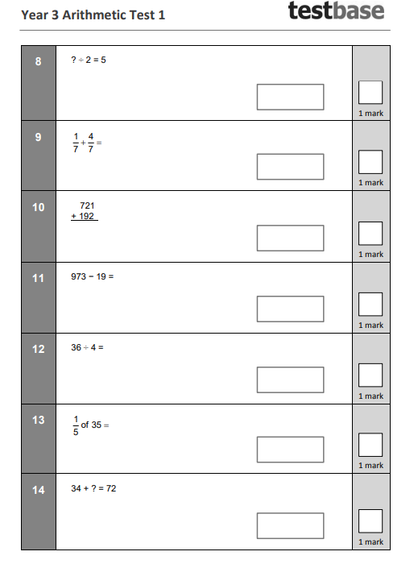
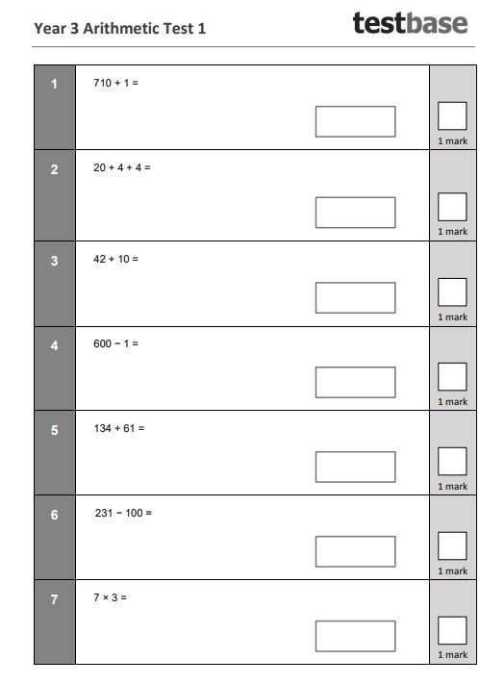
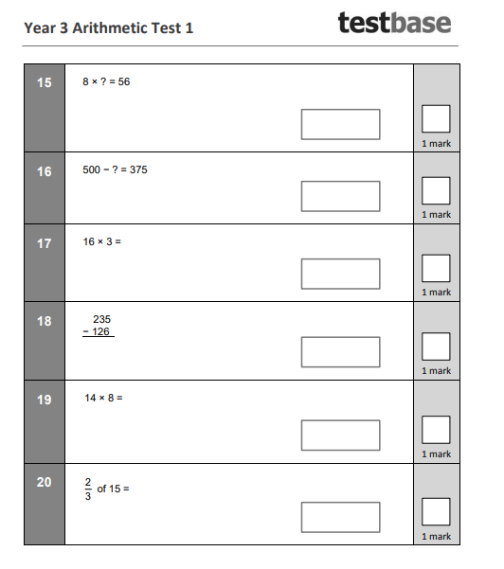
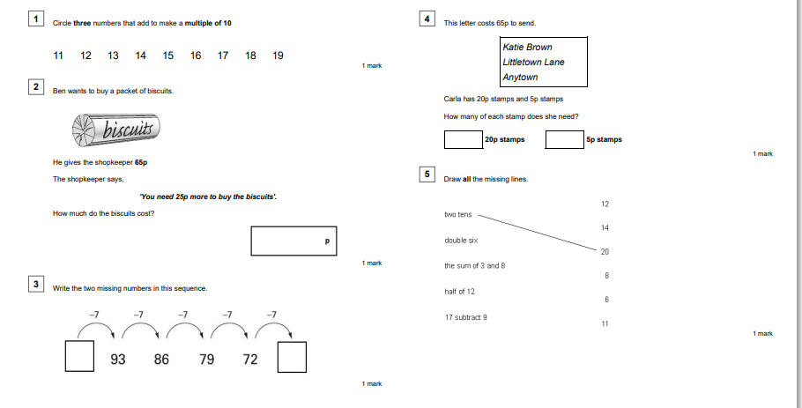
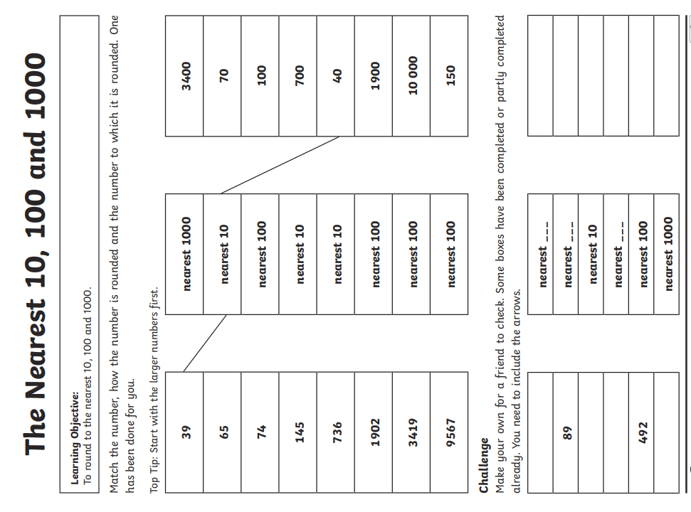
Challenge – optional please have a go if you can





