Axolotl Class Homework Autumn 2 week 3 – Y3
Homework due: Tuesday 25th November 2025
Next week we are learning:
Maths | Literacy | Science | RE
We will be finishing our work on adding and subtracting numbers looking at the written formal methods as well as mental strategies | We will be will finishing our unit on a persuasive text/poster linked to the Anglo Saxons | We will be continuing our unit of work based around working scientifically refining our skills. | We will be starting our unit on Gospel and Incarnation

Log on to timestable.com to practise your maths skills:
Purple Mash also have some lovely Maths and spellings activities
Timestable.co.uk
Or use other websites/ways that you enjoy .

Spellings:
Practise spellings ready for weekly spelling test- see below for your child’s spelling group – These groups are subject to change as they are based on their current spelling ages.

Reading:
Read every day for 20 minutes. Please log this in Reading Records.

SPaG: Year 3 SPaG mat

Maths:

Adding and subtracting across a boundary
Written formal methods see videos to help the children remember if needed

https://www.youtube.com/watch?v=hwxyheQNXBU
https://www.youtube.com/watch?v=t347YcQBGf8&t=9s

Challenges are optional – although please have a go if you can

Spellings:
Group 1  CEW | Group 2  The /Λ/ sound spelt ou | Group 3  -ation is added to a verb to form a noun. A silent e is dropped before adding - ation. When a word ends in a ‘y’, change to ‘i’ before the suffix –ation is added.
wild  who  whole  father  eye  half  hold  any  every  old | young  touch  double  trouble  country  rough  enough  tough  cousin  couple | Information  adoration  sensation  preparation admiration foundation qualification experimentation exploration examination
……………………………………………………………………………………………………………………………………………………………………………………………………………………………………………………………………………………………………………………………………………………………………………………………………………………………………………………………………………………………………………………………………………………………………………………………………………………………………………………………………………………………………………………………………………………………………………………………………………………………………………………………………………………………………………………………………………………………………………………………………………………………………………………………………………………………………………………………………………………………………………………………………………………………………………………………………………………………………………………………………………………………………………………………………………………………………………………………………………………………………………..…………………………………………………………………………………………………………………………….…………………………..

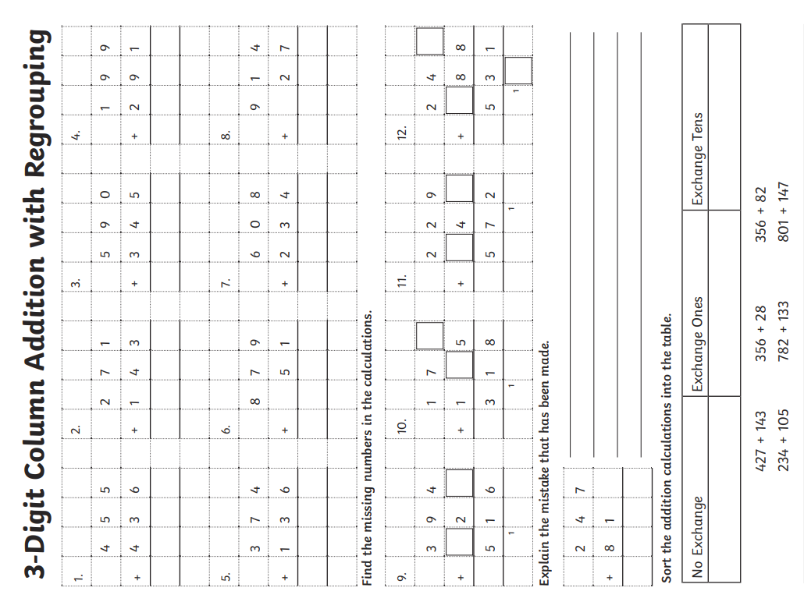

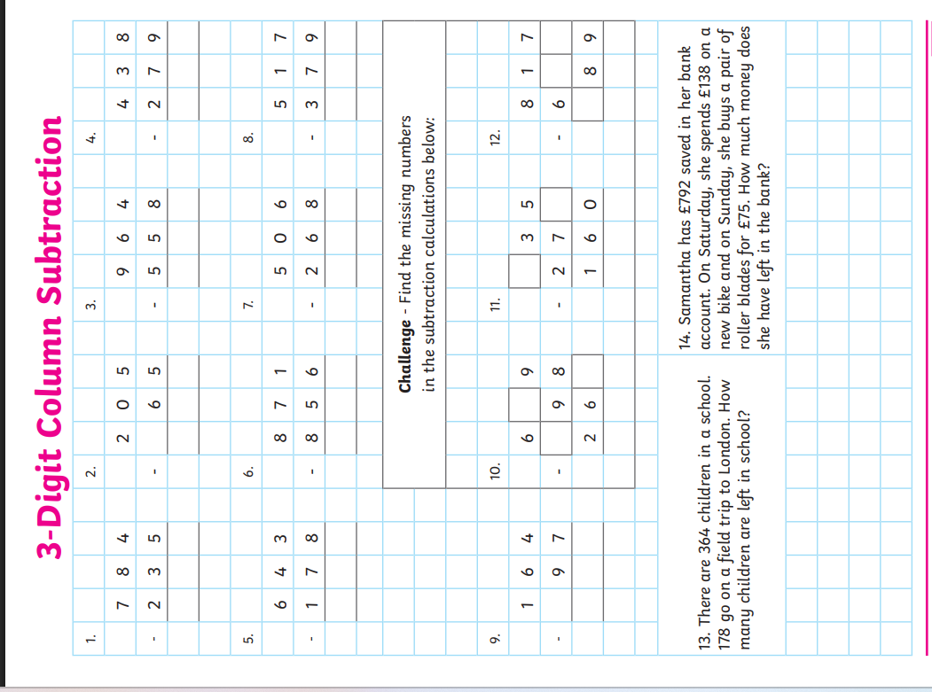
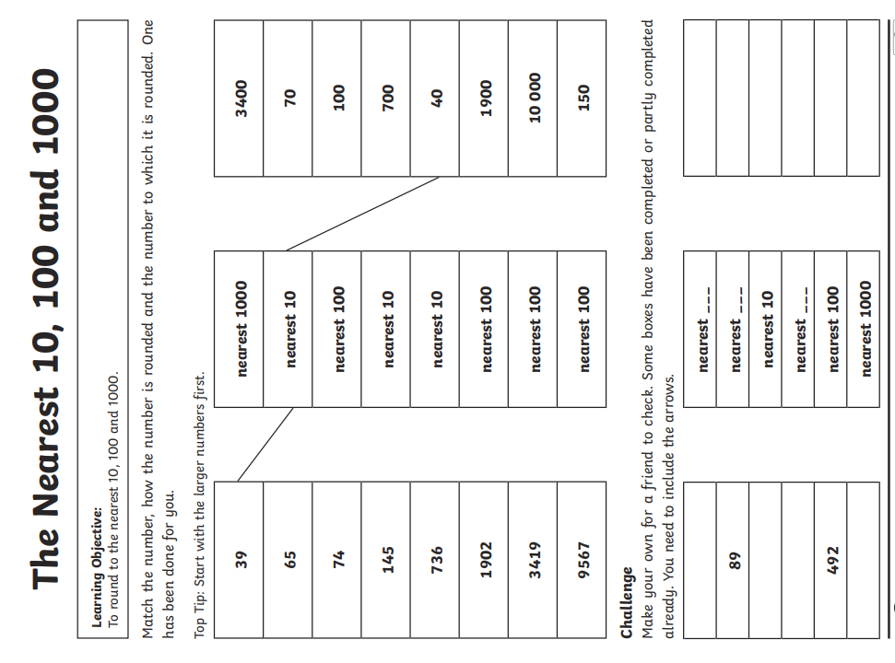
Challenge – optional please have a go if you can



