Axolotl Class Homework Autumn 2 week 1 – Y3
Homework due: Tuesday 11th November 2025
Next week we are learning:
Maths | Literacy | Science | RE
We will be continuing our work on adding and subtracting numbers looking at the written formal methods as well as mental strategies | We will be will starting our unit on a persuasive text/poster linked to the Anglo Saxons | We will be starting our unit of work based around working scientifically refining our skills. | We will be continuing our unit of People of God with links to Noah and the covenant as well before our work in Gospel as Incarnation

Log on to timestable.com to practise your maths skills:
Purple Mash also have some lovely Maths and spellings activities
Timestable.co.uk
Or use other websites/ways that you enjoy .

Spellings:
Practise spellings ready for weekly spelling test- see below for your child’s spelling group – These groups are subject to change as they are based on their current spelling ages.

Reading:
Read every day for 20 minutes. Please log this in Reading Records.

SPaG: Year 3 SPaG mat

Maths:

Adding and subtracting across a boundary
Written formal methods see videos to help the children remember if needed

https://www.youtube.com/watch?v=hwxyheQNXBU
https://www.youtube.com/watch?v=t347YcQBGf8&t=9s

Challenges are optional – although please have a go if you can
Spellings:
Group 1  CEW | Group 2  Cian ending | Group 3  Mis and dis prefix
again  before  children  many  person  should  would  could  behind  kind | musician  electrician  magician  optician  politician  mathematician  physician  technician  dietician  beautician | disagree  disappear  disobey  disappoint  disinfect  disconnect  misspell  misfortune  misbehave  mislead
……………………………………………………………………………………………………………………………………………………………………………………………………………………………………………………………………………………………………………………………………………………………………………………………………………………………………………………………………………………………………………………………………………………………………………………………………………………………………………………………………………………………………………………………………………………………………………………………………………………………………………………………………………………………………………………………………………………………………………………………………………………………………………………………………………………………………………………………………………………………………………………………………………………………………………………………………………………………………………………………………………………………………………………………………………………………………………………………………………………………………………..…………………………………………………………………………………………………………………………….…………………………..
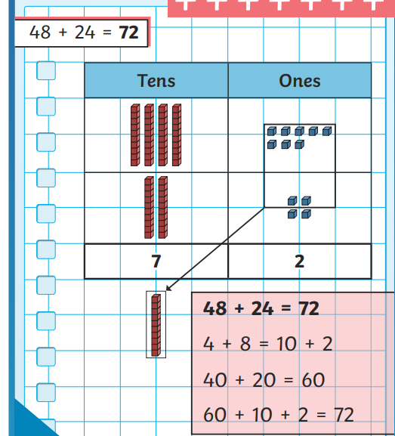

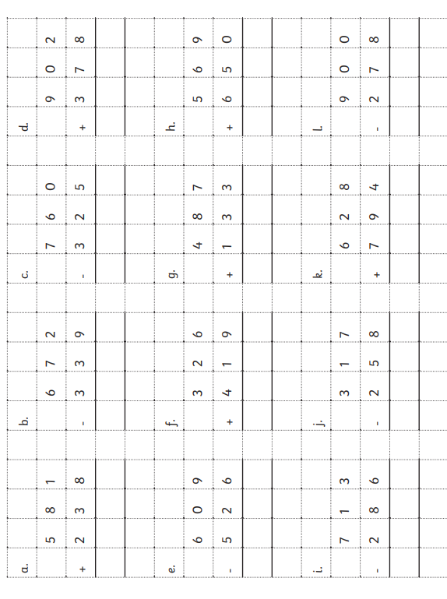

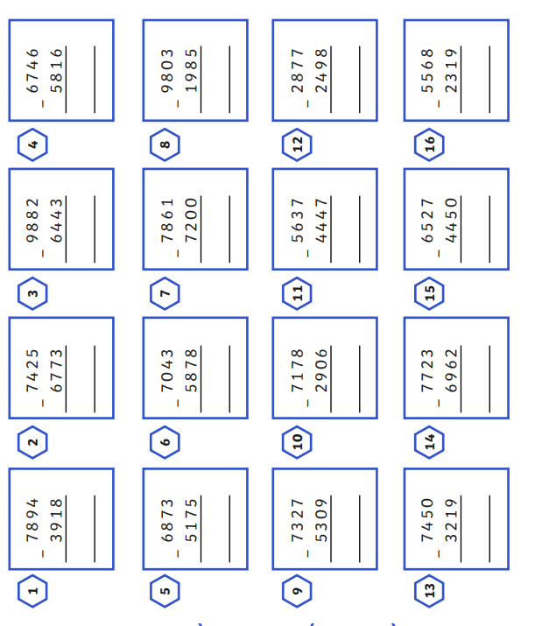
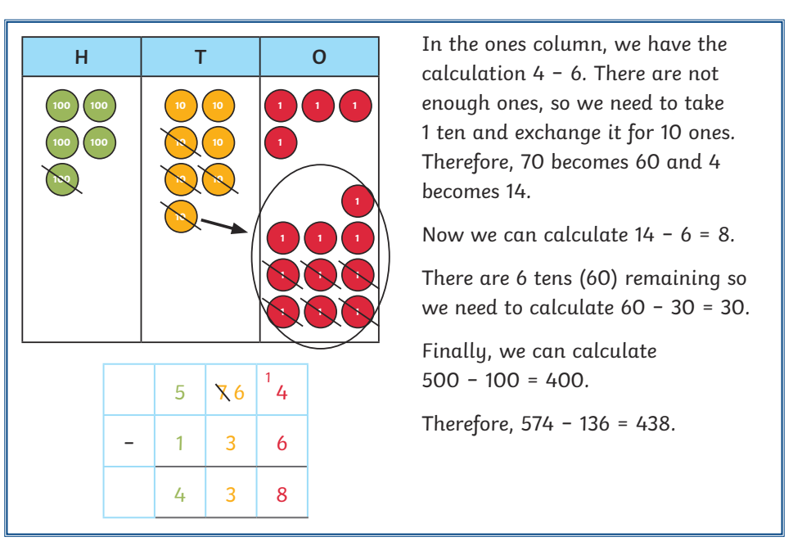#

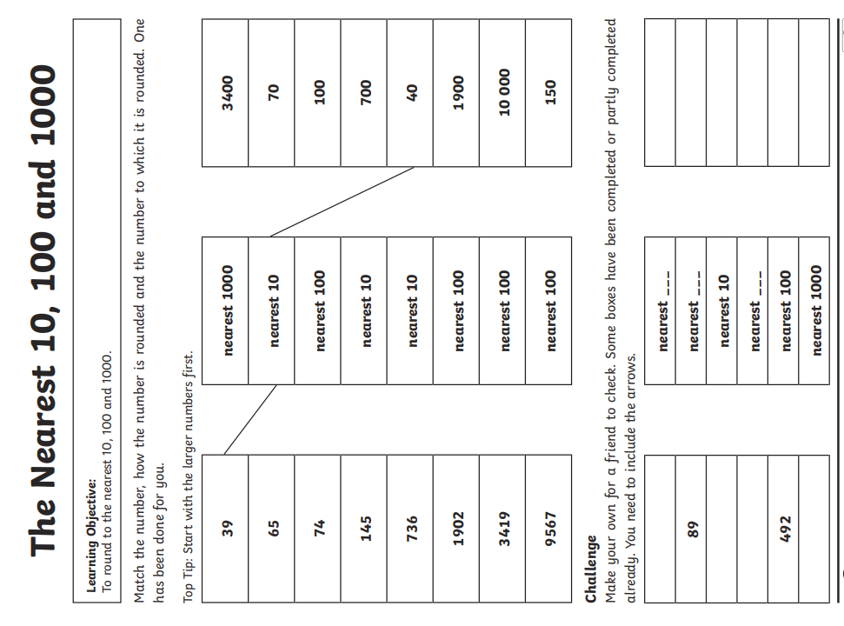
Challenge – optional please have a go if you can


