Axolotl Class Homework Autumn 2 week 2 – Y4
Homework due: Tuesday 18th November 2025
Next week we are learning:
Maths | Literacy | Science | RE
We will be finishing our work on adding and subtracting numbers looking at the written formal methods as well as mental strategies before completing some autumn term assessments | We will be will continuing our unit on a persuasive text/poster linked to the Anglo Saxons | We will be continuing our unit of work based around working scientifically refining our skills. | We will be continuing our unit of People of God with links to Noah and the covenant as well before our work in Gospel as Incarnation

Log on to timestable.com to practise your maths skills:
Purple Mash also have some lovely Maths and spellings activities
Timestable.co.uk
Or use other websites/ways that you enjoy .

Spellings:
Practise spellings ready for weekly spelling test- see below for your child’s spelling group – These groups are subject to change as they are based on their current spelling ages.

Reading:
Read every day for 20 minutes. Please log this in Reading Records.

SPaG: Year 3 SPaG mat

Maths:
Inverse calcaultions and fact families such as
40 + 60 = 100, 60 + 40 = 100
100 – 60 = 40, 100 – 40 = 60
60 = 100 – 40 and 40 = 100 – 60

Challenges are optional – although please have a go if you can

Spellings:
Group 1  CEW | Group 2  The /I/ sound spelt y elsewhere than at the end of words | Group 3  The prefix il – means ‘not’ or ‘without’. It can give the opposite meaning to a word when added.
break  busy  child  even  every  hour  our  grass  class  pass | myth  gym  egypt  pyramid  mystery  crystal  symbol  syrup  cygnet  lyric | illegal  illegible  illuminate  illogical  illiterate  illicit  illumination illusion  illusive  illustration
……………………………………………………………………………………………………………………………………………………………………………………………………………………………………………………………………………………………………………………………………………………………………………………………………………………………………………………………………………………………………………………………………………………………………………………………………………………………………………………………………………………………………………………………………………………………………………………………………………………………………………………………………………………………………………………………………………………………………………………………………………………………………………………………………………………………………………………………………………………………………………………………………………………………………………………………………………………………………………………………………………………………………………………………………………………………………………………………………………………………………………..…………………………………………………………………………………………………………………………….…………………………..
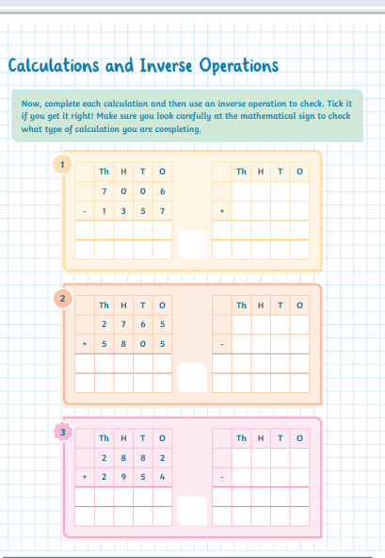
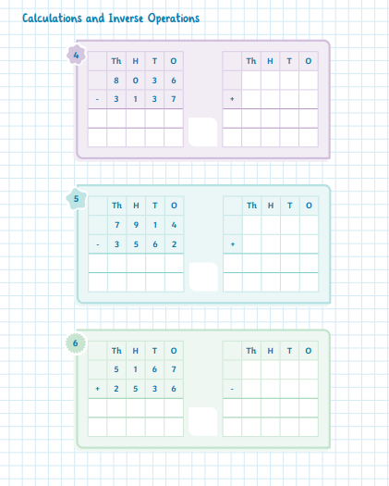
#

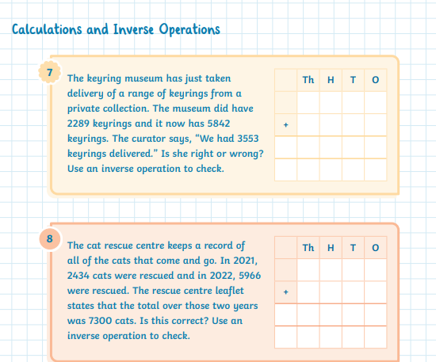

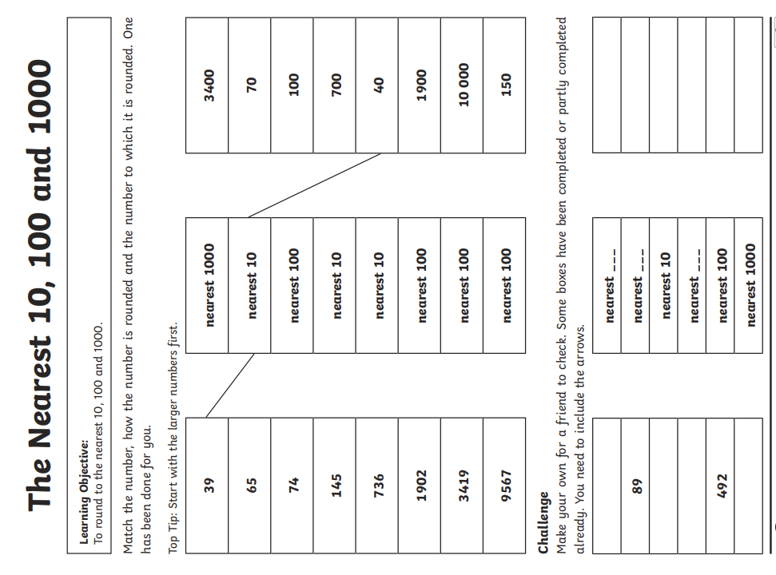
Challenge – optional please have a go if you can



