Tiger - Reception Class Homework
Weekly homework
Week 6– 11th December 2025
Dear parents,
I can’t believe how fast this term has flown by! All the children have worked so hard and it has been wonderful to see how enthusiastic they have been with their learning.
This will be the last homework before the Christmas break so your child does not need to return their folders until after the holiday. Whilst I appreciate that the children (and the adults!) need a break over the holidays, it is still really important that they still regularly revise their phonics sounds and words. In between all your festivities, please do try to find time for your child to read and write them all. Thank you so much.

Phonics
Please continue to do daily work on your child’s their individual phonics assessment. As mentioned before, this will really help with their recognition skills, fluency and confidence.
Extension task: please encourage your child to practise writing each sound using the Little Wandle format to ensure accurate formation.

Maths

In class the children have been continuing to demonstrate their understanding of the value of number and participating in lots of activities to help them to understand Counting Principles.
The one to one principle – means that children count red and yellow bricks) every object just once and call out the number name as they do so (1 -2 -3) The stable order principle – means that children understand when counting that numbers have an order: 1 then 2 then 3 then 4….etc. The cardinal principle – means that the final number said is the total number of objects in that group.
For their homework this week, I would like the children to say the number in the box and then count that number of objects (therefore finishing on the cardinal number) Please ask your child to colour the correct number of objects to represent the number.
EXTENSION TASK: Ask your child to draw their own sets of objects (between 10-20) and write the number that represent the number next to it e.g.
12

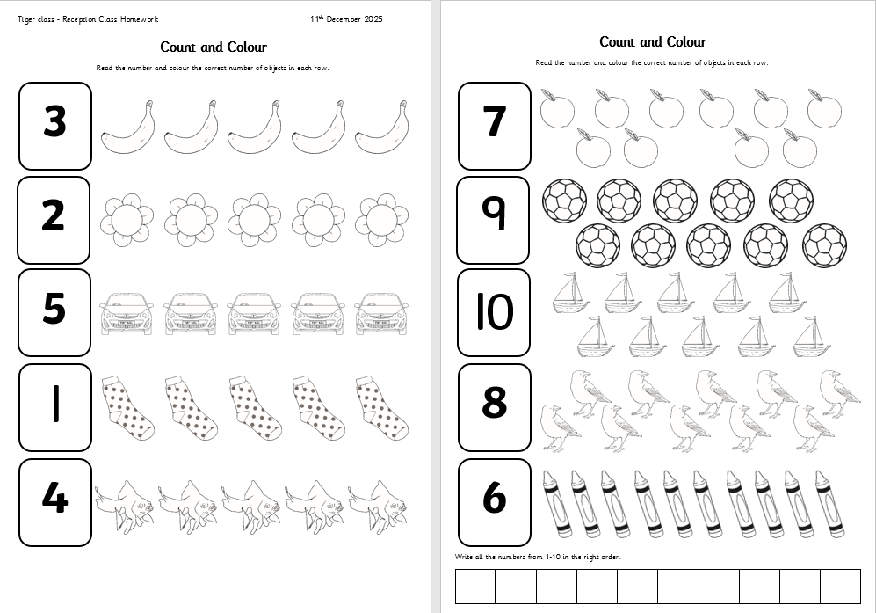

Reading – Little Wandle

This week your child will be bringing home their next Little Wandle book. This book will have words that are made up of the phonemes that your child has been learning in class. Please encourage your child to sound out each word and then blend them back together. If your child is finding it tricky to blend the sounds together, please just say the word and then ask them to repeat it back to you, whilst looking at the graphemes on the page. Please makes sure you record the reading you have done in with your child’s reading record. This really does help us to be able to share your child’s ideas and progress with them. As mentioned before, you don’t have to write lots, just a comment about any questions you may have asked and how your child responded or predictions that your child made about the book. Please do also comment on your child’s sharing book too. Both books can be kept until after the Christmas break. Thank you.
As always, if you have any questions about your child’s learning, please do not hesitate to contact me via the school office.
Many thanks,
Mrs Allan

Next week in class we will be learning
Next week in class will be
Reading – decoding, prosody and comprehension
Phonics – recap all sounds and tricky words to date. Introduce new phonemes.
Writing – diary writing/ cross curricular topic writing
Maths – cardinal numbers
Understanding the World R.E. –
The Christmas Story – ‘Jesus the light of the world’
Nativity Performance
Art – Jesus the Light of the World
Christmas Activities!
Physical Development – Outdoor PE Games - I can develop underarm throwing towards a target.
Indoor PE – Fitness - I can develop my understanding of how exercise can make you feel.

