Tiger – Year One Class Homework
Weekly homework
Week 6– 11th December 2025
Dear parents,
I can’t believe how fast this term has flown by! All the children have worked so hard and it has been wonderful to see how enthusiastic they have been with their learning.
This will be the last homework before the Christmas break so your child does not need to return their folders until after the holiday. Whilst I appreciate that the children (and the adults!) need a break over the holidays, it is still really important that they still regularly revise their phonics sounds and words. In between all your festivities, please do try to find time for your child to read and write them all. Thank you so much.

Phonics
Please continue to do daily work on your child’s their individual phonics assessment. As mentioned before, this will really help with their recognition skills, fluency and confidence.
Extension task: please encourage your child to practise writing each sound using the Little Wandle format to ensure accurate formation.

Phonics
This week your child will be bring home a full set of tricky word flashcards. Being able to read and write these tricky words will help your child with their spelling when completing their sentence writing.
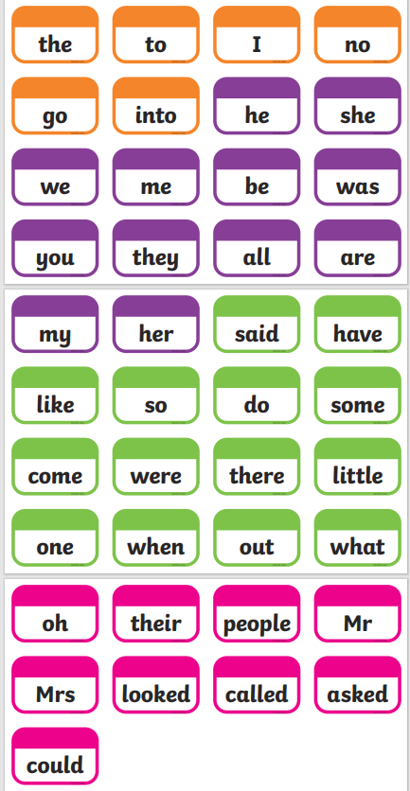

Phonics – Little Wandle Books

This week your child will be bringing home another Little Wandle Book. Please ask your child to read this book to you. As always, please also encourage them point out familiar phonemes, digraphs, trigraphs and punctuation and grammar. In our reading sessions in class we also discuss prosody and comprehension as well as decoding, so please focus on these aspects too with your child.
As always they will also bring home a sharing book that can be read to them by a grown up. Both books can be kept until after the Christmas break. Thank you.

As always, if you have any questions about your child’s learning, please do not hesitate to contact me via the school office.
Many thanks,
Mrs Allan

Next week in class will be
Reading – decoding, prosody and comprehension
Phonics – alternative spelling patterns
Writing –cross curricular topic writing (RE ) and Christmas!
Maths – number bonds continued
Understanding the World R.E. –
The Christmas Story – ‘Jesus the light of the world’
Nativity Performance
Art – Jesus the Light of the World
Christmas Activities!
Physical Development – Outdoor PE Games - I can develop underarm throwing towards a target.
Indoor PE – Fitness - I can develop my understanding of how exercise can make you feel.

